NEWS RELEASE

October 25, 2016

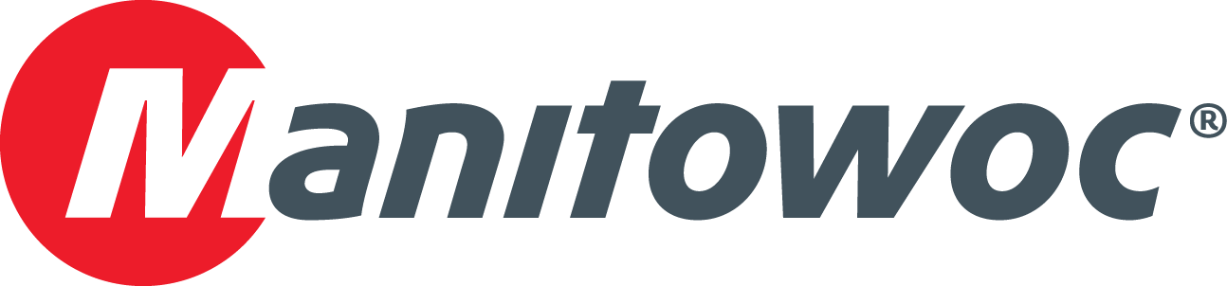

**Grove GMK5200-1 adds versatility to Raymond Excavating’s fleet**

* Marysville, Michigan-based Raymond Excavating has expanded its fleet with a new five-axle, 240 USt Grove GMK5200-1 all-terrain crane.
* Grove dealer Walter Payton Power Equipment supplied the GMK5200-1 to Raymond, building on a partnership of more than 13 years.
* The purchase comes 48 years after Raymond’s first acquisition of a Grove-branded crane: a truck-mounted TM215.

Raymond Excavating has taken delivery of a Grove GMK5200-1 all-terrain crane in an effort to respond to customer needs in the east, central and southeast parts of Michigan. The Marysville-based company received the crane in March of 2016 and immediately put it to work to assist with a variety of lifting jobs, including placement of HVAC units, large concrete box culvers and installation of communication towers that stand as tall as 200 ft.

The move comes 48 years after Raymond purchased its first Grove, a 15 USt TM215 truck-mounted crane, which enabled the business to introduce lifting services to its customers. Today, all of Raymond’s nine cranes are either Grove or National Crane-branded, and owner and president Dave Burgess said that he has relied on Manitowoc for returns on his crane investments over the years.

“We count on cranes that can meet our capacity needs while being able to easily travel on regional roads in this part of Michigan,” he said. “The GMK5200-1 delivers on both fronts: its 240 USt capacity is plenty for most of our customers’ needs and its mobility allows us to access job sites where other cranes might have a harder time fitting.”

Mike Meagher, crane specialist at Walter Payton Power Equipment, which supplied the crane to Raymond, said the excavating and crane rental company takes pride in the longevity of the business, which was founded in 1954 by Raymond Burgess—father of Dave Burgess—who is retired but still maintains an office on the premises.

“There are many relationships between Raymond Excavating and its customers that go back to when the company was started,” Meagher said. “Those relationships are at the heart of its business model of dependable and consistent service. The family works together to ensure the quality that their longtime customers have come to expect.”

Brandon Burgess, vice president of Raymond Excavating since 2012 and son of Dave Burgess, recalled the reliable support his company has received over the last 13 years from Riverdale, Illinois-based Walter Payton.

“Our experience with Walter Payton has been that of a true partnership,” he said. “We always have good results when crane technicians are needed. Many times we can reach them by cell phone and solve a problem quickly that way, or at least buy us some time until they can get to the crane.”

Released in 2015, the five-axle Grove GMK5200-1 was one of the first ever mobile cranes to feature the VIAB turbo clutch module, which eliminates fluid overheating and clutch burning as it delivers improved fuel economy. The VIAB module also enables class-leading maneuverability and driver comfort by working in tandem with the crane’s integrated retarder, resulting in wear-free braking and starting.

Other features on the GMK5200-1 include interchangeable counterweight slabs, a self-rigging auxiliary hoist and a 210 ft main boom that offers a stronger reach and load chart than many competing five-axle cranes.

Raymond Excavating is a locally owned and operated company that specializes in several areas of construction, including road building, sewer and water mains, pipelines, and other residential, commercial and industrial projects. While the company lays claim to six subsidiaries, the majority of Raymond Excavating’s jobs are within a 100-mile radius of Marysville, in the eastern part of Michigan.

“We are a very busy, hard-working family for sure,” reiterated Dave Burgess. “But we don’t work that way because we have to, we work that way because we love it.”

Walter Payton Power Equipment, a Grove, National Crane and Manitowoc dealer and service center, is the largest crane and heavy equipment distributor in the Midwest with full-service facilities in Riverdale, Lebanon and Evansville in Indiana; Louisville, Kentucky; and Taylor, Michigan. Through its factory-trained parts and service teams, the company strives to deliver “the best customer experience in the industry.”

-END-

CONTACT

**Prem Naithani**

Sales, Manitowoc

T +91 99 58 989 346

[prem.naithani@manitowoc.com](mailto:prem.naithani@manitowoc.com)

ABOUT THE MANITOWOC COMPANY, INC.

Founded in 1902, The Manitowoc Company, Inc. is a leading global manufacturer of cranes and lift solutions with manufacturing, distribution, and service facilities in 20 countries. Manitowoc is recognized as one of the premier innovators and providers of crawler cranes, tower cranes, and mobile cranes for the heavy construction industry, which are complemented by a slate of industry-leading aftermarket product support services. In 2015, Manitowoc’s revenues totaled $1.9 billion, with over half of these revenues generated outside the United States.

MANITOWOC CRANES

2401 South 30th Street - PO Box 70 - Manitowoc, WI 54221-0070

T +1 920 684 6621

[**www.manitowoc.com­**](http://www.manitowoc.com/)