PRESS RELEASE

October 19, 2016

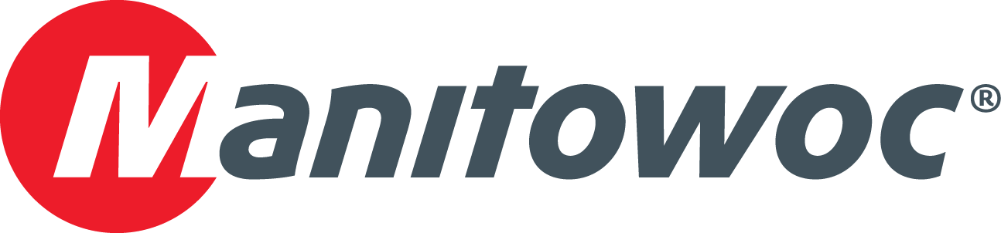

**Manitowoc delivers 100th Grove GMK5250L**

Only one year after its introduction, Manitowoc has delivered its 100th Grove GMK5250L. German rental company Armbruster Autokran-Vermietung, which is based in Pliezhausen, will add the groundbreaking all-terrain crane to its fleet of 14 machines.

“We proudly welcome the 100th GMK5250L to our fleet and we are excited to provide our customers a real added value,” said General Manager Bernd Armbruster, during the handover celebration in Wilhelmshaven, where the GMK5250L is manufactured.

The 250 t GMK5250L features a 70 m main boom and is equipped with Manitowoc’s standardized, operator-friendly Crane Control System (CCS). The crane features the innovative VIAB turbo clutch, which offers several benefits, including wear-free starting and braking, and reduced fuel consumption.

-END-

CONTACT

**Prem Naithani**

Sales, Manitowoc

T +91 99 58 989 346

[prem.naithani@manitowoc.com](mailto:prem.naithani@manitowoc.com)

ABOUT THE MANITOWOC COMPANY, INC.   
Founded in 1902, The Manitowoc Company, Inc. is a leading global manufacturer of cranes and lift solutions with manufacturing, distribution, and service facilities in 20 countries. Manitowoc is recognized as one of the premier innovators and providers of crawler cranes, tower cranes, and mobile cranes for the heavy construction industry, which are complemented by a slate of industry-leading aftermarket product support services. In 2015, Manitowoc’s revenues totaled $1.9 billion, with over half of these revenues generated outside of the United States.

MANITOWOC CRANES

2401 South 30th Street - PO Box 70 - Manitowoc, WI 54221-0070

T +1 920 684 6621

[**www.manitowoc.com**](http://www.manitowoc.com)**­**