­­NEWS RELEASE

August 1, 2016

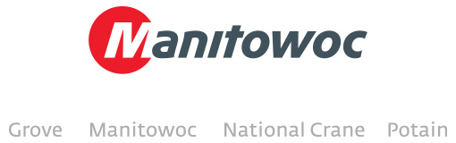

**MLC300 lifts where other cranes can’t at North America’s largest convention center**

A Manitowoc MLC300 crawler crane owned by Central Contractors Service, a division of the ALL Family of companies, is constructing a new hotel at McCormick Place in Chicago, Illinois. Paul Urbanski, sales manager at Central, said that the 330 USt MLC300 was the best choice for the job thanks to the low ground bearing pressure made possible by its Variable Positioning Counterweight (VPC).

Contractors originally planned to use another 300 USt crawler crane, but the job site’s close proximity to a foundation wall made that choice impractical – the crane needed to be situated directly over a 30 ft-deep basement cavity, so a lifting solution with similar capacity but lower ground bearing pressure was necessary. The MLC300 is lifting 50 USt trusses and 5 USt steel bundles to heights of more than 70 ft as it helps construct the new hotel that will host guests of McCormick Place, the largest convention center in North America. The project began in January of 2016 and is scheduled to finish this summer.

-END-

CONTACT PUNE GURGAON

**Prem Naithani** **Manitowoc India Pvt. Ltd. Manitowoc India Pvt. Ltd.**

Sales, Manitowoc 72-76, Industrial Estate, Mundhwa 2nd floor, plot no. 117, sector 44,

T: +91 99 58 989 346 Pune 411036, Maharashtra Gurgaon 122003, Haryana

[Prem.Naithani@manitowoc.com](mailto:Prem.Naithani@manitowoc.com) T +91 20 66445500 T +91 124 4780100

ABOUT THE MANITOWOC COMPANY, INC.   
Founded in 1902, The Manitowoc Company, Inc. is a leading global manufacturer of cranes and lift solutions with 49 manufacturing, distribution, and service facilities in 20 countries. Manitowoc is recognized as one of the premier innovators and providers of crawler cranes, tower cranes, and mobile cranes for the heavy construction industry, which are complemented by a slate of industry-leading aftermarket product support services. In 2015, Manitowoc’s revenues totaled $1.9 billion, with over half of these revenues generated outside of the United States.

MANITOWOC CRANES

2401 South 30th Street - PO Box 70 - Manitowoc, WI 54221-0070

T +1 920 684 6621

[**www.manitowoccranes.com**](http://www.manitowoccranes.com)**­**