­CAPTION RELEASE

July 18, 2018

**Manitowoc delivers five new Grove GMK4090 to Mammoet**

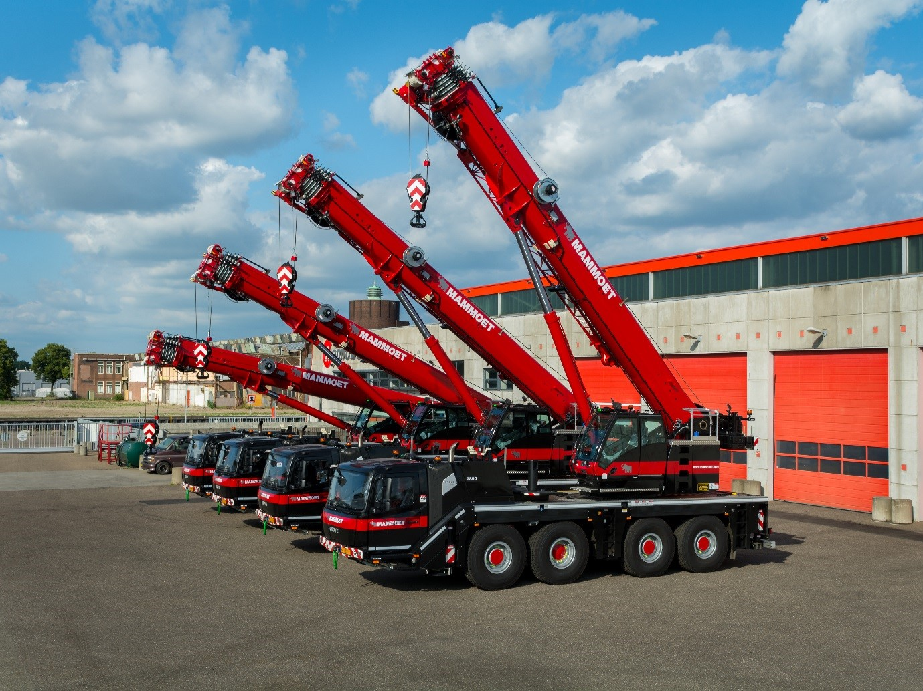

Dutch heavy-duty logistics company Mammoet has purchased five new Grove GMK4090 all-terrain cranes from the Manitowoc factory in Wilhelmshaven, Germany. The GMK4090 was launched in Q3 2017 and Mammoet has purchased some of the first cranes to come off the production line.

“We purchased the four-axle, all-terrain cranes due to their multifunctionality and one-man operation ability in the 70 t to 90 t class,” said Wouter van Noort, managing director of Mammoet. “In the Netherlands, nearly all cranes drive with a two-axle trailer so that the full counterweight can be transported on the crane and trailer. These four-axle cranes take away the need for further trailers and do away with additional transportation costs.”

Developed as the successor of the GMK4080-1, the GMK4090 was designed with the help of Voice of the Customer (VOC) research. As a result, the crane puts flexibility and maneuverability as its main focuses. With its best-in-class taxi load chart and compact footprint, the crane is ideal for a variety of applications. Various counterweight options also give it versatility in roading, which can increase efficiency and return on investment for many owners.

Mammoet received the cranes between April and May 2018. The cranes will now be added to the company’s already established fleet, which operates not only in the Netherlands but also Belgium and Germany.

-END-

CONTACT

**Insa Heim**

Marketing Communication Manager, Manitowoc Crane Group Germany

T +49 4421 294 4170

[insa.heim@manitowoc.com](mailto:insa.heim@manitowoc.com)

ABOUT THE MANITOWOC COMPANY, INC.

Founded in 1902, The Manitowoc Company, Inc. is a leading global manufacturer of cranes and lifting solutions with manufacturing, distribution, and service facilities in 20 countries. Manitowoc is recognized as one of the premier innovators and providers of crawler cranes, tower cranes, and mobile cranes for the heavy construction industry, which are complemented by a slate of industry-leading aftermarket product support services. In 2017, Manitowoc’s net sales totaled $1.6 billion, with over half generated outside the United States.

THE MANITOWOC COMPANY, INC.

One Park Plaza – 11270 West Park Place – Suite 1000 – Milwaukee, WI 53224, USA

T +1 414 760 4600

[**www.manitowoc.com**](http://www.manitowoccranes.com/)**­**