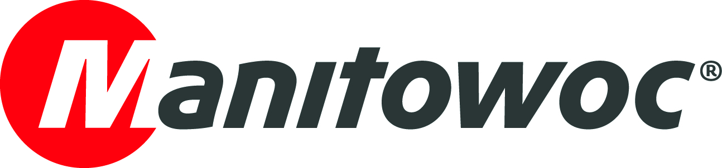
PICTURE CAPTION RELEASE
March 14, 2017

Indian rental giant Sanghvi Movers orders 18 Grove cranes

India’s largest crane rental company Sanghvi Movers Limited, has ordered 18 Grove GMK6300L all-terrain cranes.

“This is our first major investment in new all-terrain cranes,” said Chris Sanghvi, chairman and managing director of the company. “The machine has an impressive reach of 80 m and is equipped with a robust Mercedes engine which will be easy to service across India. After considering several options, the GMK6300L was the best choice for us.”

The GMK6300L has a 300 t capacity and offers some of the strongest lift capabilities in its class. The 80 m boom also has a 38 m hydraulic fly jib to boost reach further. Sanghvi Movers is ranked 6th in the IC 50 listing of the world’s largest crane owning companies, as published by International Cranes & Specialized Transport magazine. It already operates a fleet of 60 Manitowoc crawler cranes. The company’s positive experience with Manitowoc influenced the decision to choose Grove cranes as the best replacement for a number of older mobile telescopic units.

The first of the new cranes are expected arrive in India in mid-2017.
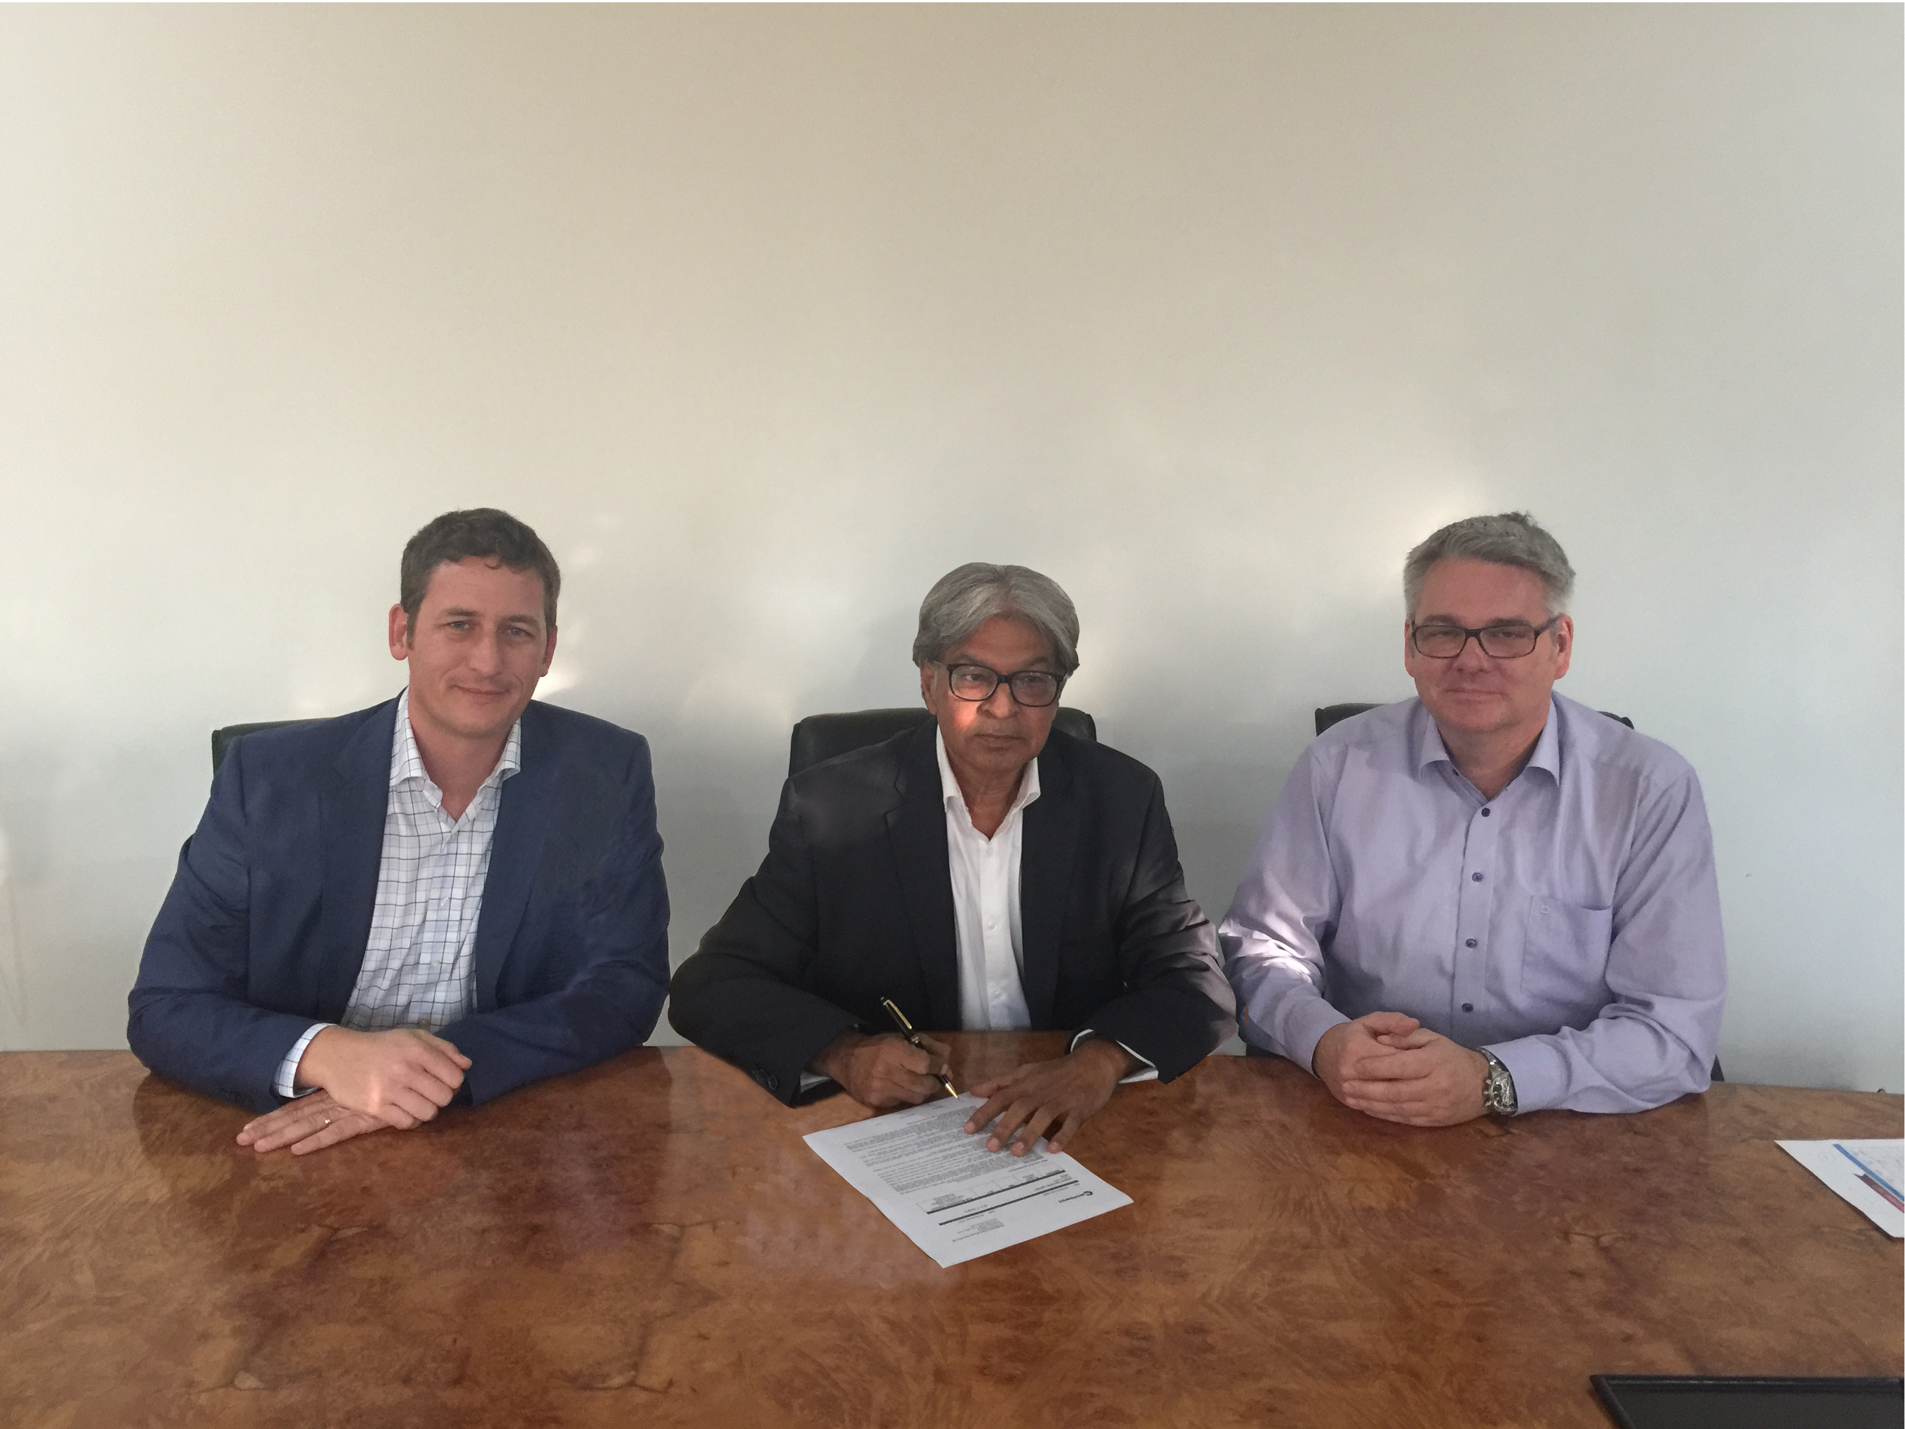

David Semple (Manitowoc), Chris Sanghvi (Sanghvi Movers) and Jens Ennen (Manitowoc), celebrate the purchase 18 Grove GMK6300L cranes.

-END-

CONTACT
Punitha Govindasamy Ben Shaw
Manitowoc SE10
T +65 6263 7863 T +65 6408 3861
punitha.govindasamy@manitowoc.com ben.shaw@se10.com

ABOUT THE MANITOWOC COMPANY, INC.
Founded in 1902, The Manitowoc Company, Inc. is a leading global manufacturer of cranes and lift solutions with manufacturing, distribution, and service facilities in 20 countries. Manitowoc is recognized as one of the premier innovators and providers of crawler cranes, tower cranes, and mobile cranes for the heavy construction industry, which are complemented by a slate of industry-leading aftermarket product support services. In 2016, Manitowoc’s revenues totaled $1.6 billion, with over half of these revenues generated outside the United States.

THE MANITOWOC COMPANY, INC.
2400 S. 44th Street - PO Box 66 - Manitowoc, WI 54221, USA
T +1 920 684 4410
www.manitowoc.com

