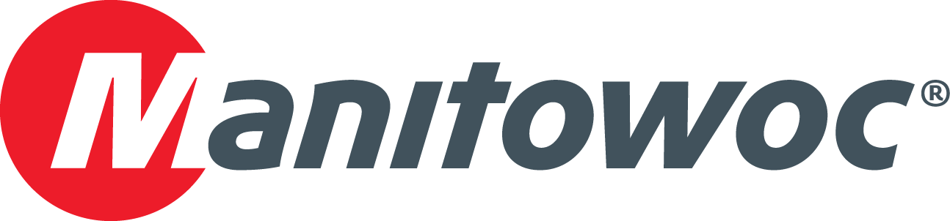
NEWS RELEASE
January 11, 2017

Grove cranes to help Thailand power up
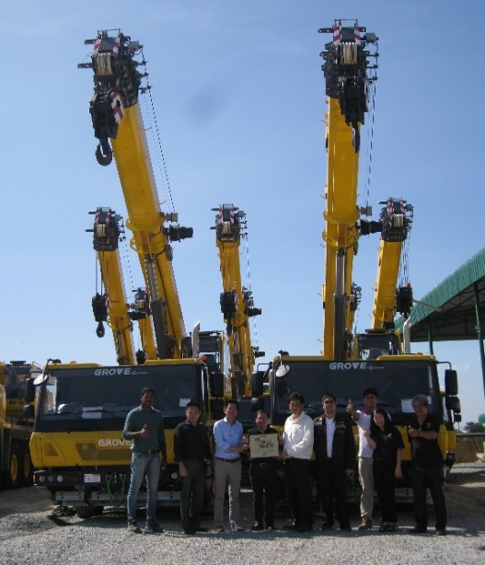
The Provincial Electricity Authority (PEA) in Thailand has ordered eight Grove GMK2035E all-terrain cranes. The cranes are new additions to the PEA fleet, which already includes six GMK2035 cranes. The GMK2035 is the predecessor to the GMK2035E and PEA purchased these back in 2000. The state-owned enterprise plans to use the cranes to erect electrical poles and install transformers at sites around Thailand.

It selected the GMK2035E because of the crane’s superior mobility, as well as its option to lift with both mid-span and full-span outrigger deployments. All the cranes were supplied by VDS Machinery, the official Grove dealer for Thailand.

Grove all-terrain cranes are known for their powerful lifting performance, superior off-road mobility and on-road traveling. The GMK2035E is Grove’s most compact all-terrain crane, and includes a 29 m main boom which can be extended to 46 m with jib extensions. Maximum capacity is 40 t and power comes from a 205 kW Mercedes engine.

Pictured are staff from Manitowoc, VDS Machinery and PEA at a ceremony in Bangkok to celebrate the handover of the first units. All deliveries will be complete by the end of Q1 2017.

-END-

CONTACT
Punitha Govindasamy Ben Shaw
Manitowoc SE10
T +65 6263 7863 T +65 6408 3861
punitha.govindasamy@manitowoc.com ben.shaw@se10.com

ABOUT THE MANITOWOC COMPANY, INC.
Founded in 1902, The Manitowoc Company, Inc. is a leading global manufacturer of cranes and lift solutions with manufacturing, distribution, and service facilities in 20 countries. Manitowoc is recognized as one of the premier innovators and providers of crawler cranes, tower cranes, and mobile cranes for the heavy construction industry, which are complemented by a slate of industry-leading aftermarket product support services. In 2015, Manitowoc’s revenues totaled $1.9 billion, with over half of these revenues generated outside of the United States.

MANITOWOC CRANES
2401 South 30th Street - PO Box 70 - Manitowoc, WI 54221-0070
T +1 920 684 6621
www.manitowoc.com

