PICTURE CAPTION RELEASE

February 03, 2016

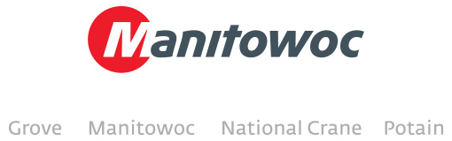

**Potain MDT 178 working at iconic castle**

A Potain MDT 178 is working outside the Château de Chambord in Loire Valley, France. The tower crane was chosen by the construction company Foucher Fournier to help build a new welcome center for tourists visiting the castle and the surrounding parkland. The MDT 178 is owned by the French crane dealer VALEM. The job will take three months to complete.

-END-

CONTACT

**Cristelle Lacourt** **Charlie Ebers**

Manitowoc SE10

T +33 472 182 018 T +44 207 923 5864

[cristelle.lacourt@manitowoc.com](mailto:cristelle.lacourt@manitowoc.com) [charlie.ebers@se10.com](mailto:charlie.ebers@se10.com)

ABOUT THE MANITOWOC COMPANY, INC.   
Founded in 1902, The Manitowoc Company, Inc. is a multi-industry, capital goods manufacturer with 92 manufacturing, distribution, and service facilities in 25 countries. The company is recognized globally as one of the premier innovators and providers of crawler cranes, tower cranes, and mobile cranes for the heavy construction industry. Manitowoc is also one of the world's leading innovators and manufacturers of commercial foodservice equipment, which includes 24 market-leading brands of hot- and cold-focused equipment. In addition, both segments are complemented by a slate of industry-leading product support services. In 2014, Manitowoc’s revenues totaled $3.9 billion, with approximately half of these revenues generated outside of the United States.

MANITOWOC CRANES

2401 South 30th Street - PO Box 70 - Manitowoc, WI 54221-0070

T +1 920 684 6621

[**www.manitowoccranes.com**](http://www.manitowoccranes.com)**­**