PICTURE CAPTION RELEASE

July 8, 2016

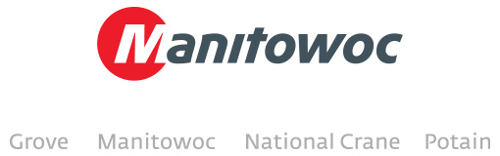

**SSK invests in new Grove RT890E to support Peru’s growth**

SSK, a Sigdo Koppers company, has just added an RT890E rough-terrain crane to its Grove fleet. The firm will immediately put the rough terrain crane to use in industrial construction and assembly of major projects in sectors such as mining and metallurgy, power generation, industrial plants, ports and pipelines. Peru is one of the fastest-growing economies in South America, and SSK’s Grove RT890E is its latest asset to help keep the country moving forward on solid footing. The 80 t (90USt) capacity RT890E is one of Grove’s most popular cranes in the region, ideal for countless applications. It features an electronically controlled 275 HP Cummins diesel engine and Manitowoc’s Full Vision cab which has ergonomic controls to minimize operator fatigue during long work hours. Created in 1998, SSK is headquartered in Lima.

***Caption:*** *Juan Willis, service manager at SSK, Cristian Galaz, Manitowoc’s vice president of sales in South America, Gianfranco Martinelli, sales manager at SSK, Gerardo Castillo, Manitowoc’s regional business manager in Peru and Argentina, and Wilson Martinez, Manitowoc’s Crane Care director.*

-END-

CONTACT

**Amy Marten** **Ricardo Rosa**

Manitowoc SE10

T +1 920 683 6345 T +1 312 548 8444

[amy.marten@manitowoc.com](mailto:amy.marten@manitowoc.com) ricardo.rosa@se10.com

ABOUT THE MANITOWOC COMPANY, INC.   
Founded in 1902, The Manitowoc Company, Inc. is a leading global manufacturer of cranes and lift solutions with 49 manufacturing, distribution, and service facilities in 20 countries. Manitowoc is recognized as one of the premier innovators and providers of crawler cranes, tower cranes, and mobile cranes for the heavy construction industry, which are complemented by a slate of industry-leading aftermarket product support services. In 2015, Manitowoc’s revenues totaled $1.9 billion, with over half of these revenues generated outside the United States.

MANITOWOC CRANES

2401 South 30th Street - PO Box 70 - Manitowoc, WI 54221-0070

T +1 920 684 6621

[**www.manitowoccranes.com**](http://www.manitowoccranes.com)**­**