PICTURE CAPTION RELEASE

July 21, 2016

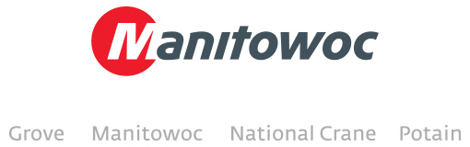

**Potain MR 605 B tightens schedule of Chicago tower project**

The maneuverable luffing jib of a Potain MR 605 B is keeping the construction of an apartment tower in the River North neighborhood of Chicago on schedule. With another construction project also using a tower crane just across the street, contractors are able to adjust the MR 605 B’s boom so the crane avoids nearby buildings and equipment.

Paul Urbanski, sales manager for Central Contractors Service, a division of the ALL Family of Companies, said the 35.2 USt capacity MR 605 B was chosen for its adaptability in congested urban settings. The crane is hoisting rebar, waste debris and concrete-filled aluminum buckets to heights of up to 380 ft, and it’s doing so while avoiding the swing radius of the crane on the neighboring job site, less than 150 ft away. The MR 605 B’s ability to work in close proximity with other cranes enables contractors to keep to a demanding schedule in downtown Chicago, a crowded work environment where development is booming. The new apartment tower will stand 39 stories tall and contain 450 residential units upon its scheduled completion in January of 2017.

-END-

CONTACT

**Amy Marten** **Damian Joseph**

Manitowoc SE10

T +1 920 683 6345 T +1 312 548 8441

[amy.marten@manitowoc.com](mailto:chris.bratthauar@manitowoc.com) [damian.joseph@manitowoc.com](mailto:chris.bratthauar@manitowoc.com)

ABOUT THE MANITOWOC COMPANY, INC.   
Founded in 1902, The Manitowoc Company, Inc. is a leading global manufacturer of cranes and lift solutions with 49 manufacturing, distribution, and service facilities in 20 countries. Manitowoc is recognized as one of the premier innovators and providers of crawler cranes, tower cranes, and mobile cranes for the heavy construction industry, which are complemented by a slate of industry-leading aftermarket product support services. In 2015, Manitowoc’s revenues totaled $1.9 billion, with over half of these revenues generated outside of the United States.

MANITOWOC CRANES

2401 South 30th Street - PO Box 70 - Manitowoc, WI 54221-0070

T +1 920 684 6621

[**www.manitowoccranes.com**](http://www.manitowoccranes.com)**­**