CAPTION RELEASE

December 7, 2016

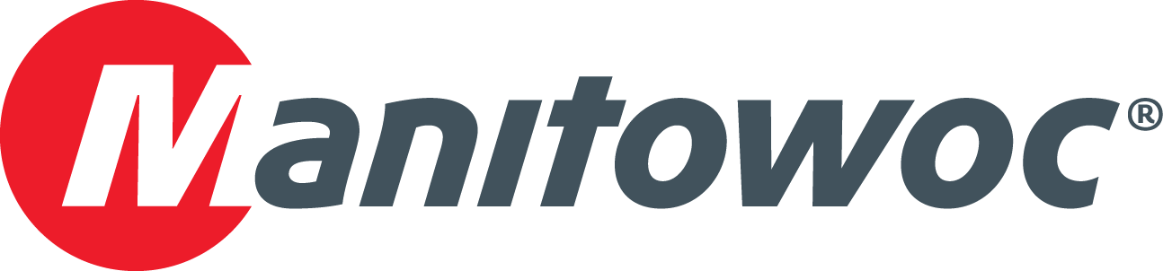

**Manitowoc 18000 makes impressive lifts on lock in upstate New York**

A massive project to transport power plant components through the Erie Canal is underway in Schenectady, New York, and a Manitowoc 18000 crawler crane is at the center of the action.

In September, a team of engineers and local union contractors erected the 660 USt crane—equipped with 120 ft of boom—near the end of a bulkhead on Erie Canal Lock 8. Since then, the crane has been lifting 260 USt generators, 197.5 USt turbines and 142.5 USt rotors onto barges for transport to Albany, New York, where the parts are then shipped to various power plants around the world.

Lomma Crane & Rigging rented the Manitowoc 18000 to the contracting team. A sales representative for the South Kearny, New Jersey-based equipment company said that the crawler crane was chosen for its capacity and compact footprint, which enabled contractors to make the lifts from a custom-built crane pad that was engineered by Lomma to fit on the limited real estate of the bulkhead.

The crane will continue to make similar lifts into 2017, helping contractors to move equipment through the Mohawk River section of the Erie Canal that would otherwise be immovable by truck or rail.

-END-

CONTACT

**Amy Marten** **Damian Joseph**

Manitowoc SE10

T +1 920 683 6345 T +1 312 548 8441

[amy.marten@manitowoc.com](mailto:amy.marten@manitowoc.com) [damian.joseph@se10.com](mailto:damian.joseph@se10.com)

ABOUT THE MANITOWOC COMPANY, INC.

Founded in 1902, The Manitowoc Company, Inc. is a leading global manufacturer of cranes and lift solutions with manufacturing, distribution, and service facilities in 20 countries.  Manitowoc is recognized as one of the premier innovators and providers of crawler cranes, tower cranes, and mobile cranes for the heavy construction industry, which are complemented by a slate of industry-leading aftermarket product support services.  In 2015, Manitowoc’s revenues totaled $1.9 billion, with over half of these revenues generated outside the United States.

MANITOWOC CRANES

2401 South 30th Street - PO Box 70 - Manitowoc, WI 54221-0070

T +1 920 684 6621

[**www.manitowoc.com**](http://www.manitowoccranes.com)**­**