PICTURE CAPTION RELEASE

August 25, 2016

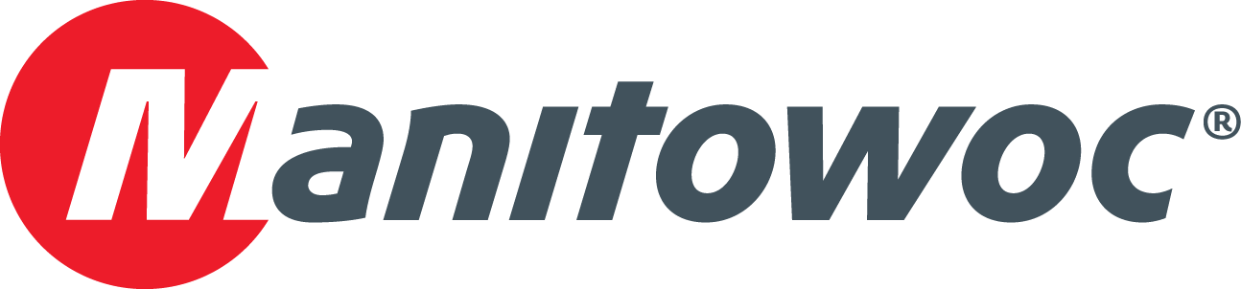

**National Crane NBT45 tackles flagpole lift at Pro Football Hall of Fame**

Canton Erectors, a rigging and heavy haul trucking company based in Canton, Ohio, used a National Crane NBT45 boom truck to erect a series of flagpoles at the Pro Football Hall of Fame, also located in Canton. Brian Selinsky, owner of Canton Erectors, said that the NBT45 was chosen for its ability to fit on a job site where there was not much room for outrigger placement. The 45 USt capacity boom truck lifted three 66 ft-tall flagpoles, which weigh between 0.3 USt and 0.35 USt, to a height of 50 ft for the job, and the crane’s ground level and in-cab outrigger controls enabled quick and easy set-up. Richfield, Ohio-based ALT Sales Corp, a member of the ALL Family of Companies, provided the crane for the project, which was completed in less than six hours in June of 2016.

-END-

CONTACT

**Amy Marten** **Damian Joseph**

Manitowoc SE10

T +1 920 683 6345 T +1 312 548 8441

[amy.marten@manitowoc.com](mailto:amy.marten@manitowoc.com) [damian.joseph@se10.com](mailto:damian.joseph@se10.com)

ABOUT THE MANITOWOC COMPANY, INC.

Founded in 1902, The Manitowoc Company, Inc. is a leading global manufacturer of cranes and lift solutions with manufacturing, distribution, and service facilities in 20 countries.  Manitowoc is recognized as one of the premier innovators and providers of crawler cranes, tower cranes, and mobile cranes for the heavy construction industry, which are complemented by a slate of industry-leading aftermarket product support services.  In 2015, Manitowoc’s revenues totaled $1.9 billion, with over half of these revenues generated outside the United States.

MANITOWOC CRANES

2401 South 30th Street - PO Box 70 - Manitowoc, WI 54221-0070

T +1 920 684 6621

[**www.manitowoccranes.com**](http://www.manitowoccranes.com)**­**