PICTURE CAPTION RELEASE

August 18, 2016

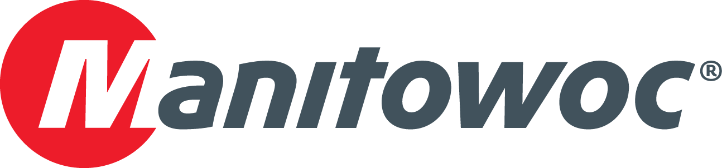

**Manitowoc crawler fleet lifts new Dolphin stadium**

Maxim Crane Works is employing a fleet of Manitowoc crawler cranes for its work on the construction of the new Miami Dolphins football stadium. The job began with four 660 USt Manitowoc 18000s, each equipped with a MAX-ER that brought their capacities to 826 USt. Then the Newport, Kentucky-based company added a 772 USt Manitowoc MLC650 to the job site. Often the cranes lifted together in tandem, with the heaviest load weighing 800 USt.

“This is a challenging project and the cranes are often working around the clock, 24/7 shifts,” explained Frank Bardonaro, president of Maxim Crane Works. “Our ability to have the latest and greatest lift technology from Manitowoc enabled us to efficiently perform multiple, tandem crane picks that exceeded one million pounds. Having multiple cranes of these sizes with synchronized working speeds and qualified operating engineers were they key reasons we were able to secure the project.”

-END-

CONTACT

**Amy Marten** **Damian Joseph**

Manitowoc SE10

T +1 920 683 6345 T +1 312 548 8441

[amy.marten@manitowoc.com](mailto:amy.marten@manitowoc.com) [damian.joseph@se10.com](mailto:damian.joseph@se10.com)

ABOUT THE MANITOWOC COMPANY, INC.   
Founded in 1902, The Manitowoc Company, Inc. is a leading global manufacturer of cranes and lift solutions with manufacturing, distribution, and service facilities in 20 countries. Manitowoc is recognized as one of the premier innovators and providers of crawler cranes, tower cranes, and mobile cranes for the heavy construction industry, which are complemented by a slate of industry-leading aftermarket product support services. In 2015, Manitowoc’s revenues totaled $1.9 billion, with over half of these revenues generated outside of the United States.

MANITOWOC CRANES

2401 South 30th Street - PO Box 70 - Manitowoc, WI 54221-0070

T +1 920 684 6621

[**www.manitowoccranes.com**](http://www.manitowoccranes.com)**­**