PHOTO CAPTION RELEASE

August 29, 2016

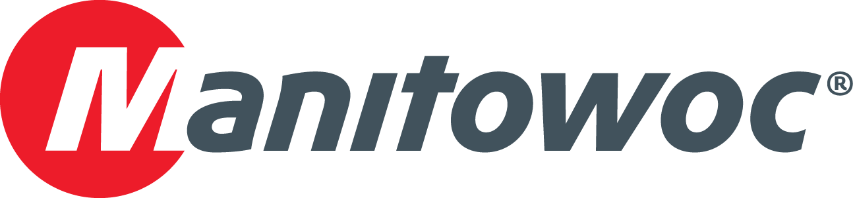

**Grove GHC75 gets to work building brewery in Mexico**

A Grove GHC75 telescoping crawler crane is helping to construct a new $146.8 million Grupo Modelo beer-brewing plant near Merida, Yucatan, Mexico. GIASA, a contractor based in Saltillo, Coahuila, chose the 70 t (75 USt) crane for the project because it combines the maneuverability of a crawler crane with the versatility of a telescoping boom. The GHC75’s ability to pick-and-carry at 100 percent of its load chart and to swing loads a full 360 degrees are facilitating the movement and placement of steel beams at the contruction site. Mexico City’s SITSA, a Grove dealer, supplied the crane.

-END-

CONTACT

**Amy Marten** **Ricardo Rosa**

Manitowoc SE10

T +1 920 683 6345 T +1 312 548 8444

[amy.marten@manitowoc.com](mailto:amy.marten@manitowoc.com) [ricardo.rosa@se10.com](mailto:ricardo.rosa@se10.com)

ABOUT THE MANITOWOC COMPANY, INC.   
Founded in 1902, The Manitowoc Company, Inc. is a leading global manufacturer of cranes and lift solutions with manufacturing, distribution, and service facilities in 20 countries. Manitowoc is recognized as one of the premier innovators and providers of crawler cranes, tower cranes, and mobile cranes for the heavy construction industry, which are complemented by a slate of industry-leading aftermarket product support services. In 2015, Manitowoc’s revenues totaled $1.9 billion, with over half of these revenues generated outside the United States.

MANITOWOC CRANES

2401 South 30th Street - PO Box 70 - Manitowoc, WI 54221-0070

T +1 920 684 6621

[**www.manitowoccranes.com**](http://www.manitowoccranes.com)**­**