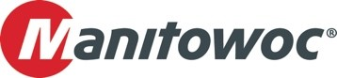
PRESS RELEASE
November 27, 2025

Dutch company Pfeifer Rentals BV selects Grove for long-term ‘bare rental’ projects

- The crane rental company recently took delivery of a package of 6 Grove all-terrain cranes including GMK5150XL, GMK5250XL-1, and GMK6300L-1.
- Due to their impressive lifting capacity (150, 250 and 300 t) and user-friendly operations these Grove models are ideal for expanding the Pfeifer Group's unmanned rental activities.
- The company selected a wide range of productivity-enhancing options for the cranes to provide more rental options and increase convenience for the operator.

Pfeifer Group has received the first three units from its latest order of Grove GMK all-terrain cranes, marking another step forward in the company’s strategic expansion of its bare rental operations. The newly delivered models— GMK5150XL, GMK5250XL-1, and GMK6300L-1 — were selected for their high lifting capacity, operator friendly systems and exceptional capabilities. All the three cranes are already in operation, including a long-term rental in the Netherlands and another currently operating for a customer in Germany.

Each crane was configured with a bi-fold swingaway jib featuring hydraulic offset and ‘luffing under load’ functionality for superior performance and optional auxiliary hoist to enhance operational flexibility. The GMK6300L-1 extends its 80 m main boom with a 37 m jib to an impressive 120 m tip height, enabling access to a broader range of job sites. Similarly, the GMK5250XL-1’s eight-section, 78.5 m boom reaches 109 m with the jib, offering 10 degrees more articulation than comparable models. The GMK5150XL also excels with the longest main boom in its class, 68.7 m, and is equipped with a 16 m hydraulically luffable jib, which can also be extended with extensions on the boom and jib. All the cranes are equipped with multiple hook blocks and the comfort package which includes options like air conditioning, comfort seats and heating systems etc.

“This fleet expansion clearly reflects our growth and adaptability in the bare rental segment,” said Gerrit Pfeifer, CEO of Pfeifer Group. “Our customers often have their own qualified personnel and technical resources, allowing them to rent equipment without requiring one of our operators. The new Grove cranes allows us to efficiently address project requirements by providing high-performance equipment that is immediately available for deployment from our facility.”

From its headquarters in Groenlo, the Netherlands, Pfeifer Rentals BV offers a wide range of services to national and international construction industry. With many years of experience in the short- and long-term rentals of construction and material handling machinery, the company also provides storage and handling, transport and haulage services, and operator training. Pfeifer supplies all the necessary equipment and services as part of its solution to help sites operate at optimal efficiency and can even provide advanced surveillance and security.

“These powerful Grove all-terrain cranes reflect the importance of efficiency and versatility in today’s rental solutions,” said Erik Baas, Sales Manager Mobile Cranes at Manitowoc Crane Group Netherlands BV. “For bare rental, delivering an intuitive and easy-to-use crane is vital for the operator, as some potential users might have limited experience of using mobile cranes. This is where features such as MAXbase™, and the boom configurator as part of our intuitive Crane Control System (CCS) stand out, as they simplify planning, setup, and lifting to deliver productivity benefits.”

To learn more about Grove all-terrain cranes, click here.

-END-

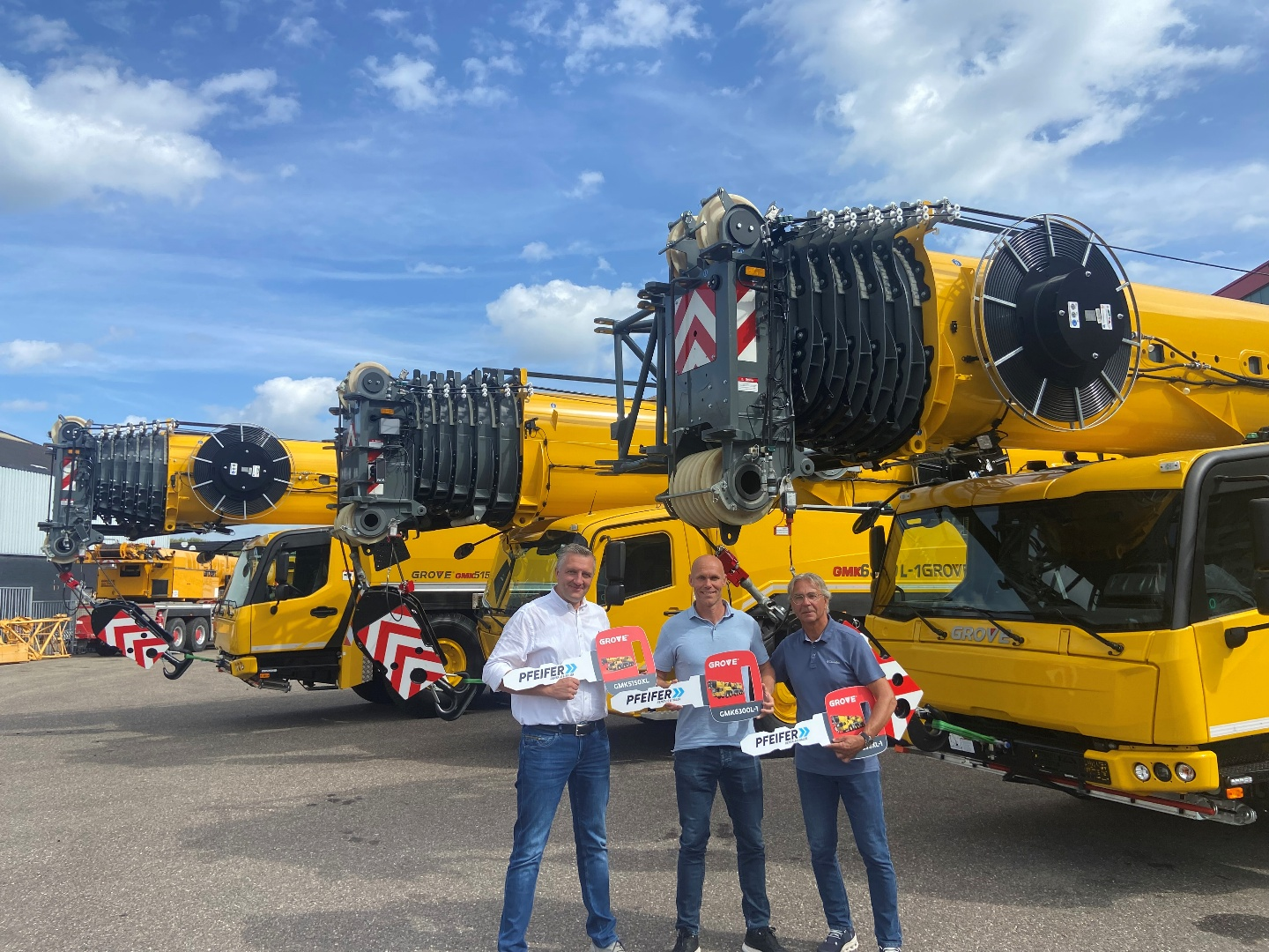
L-R: Rolf Klooster, Manitowoc; Gerrit Pfeifer, Pfeifer Group; Erik Baas, Manitowoc.

CONTACT
Anna Theilen
Marketing Communication Specialist
Manitowoc
T +49 4421 294 4632
Anna.Theilen@manitowoc.com

ABOUT THE MANITOWOC COMPANY, INC.
The Manitowoc Company was founded in 1902 and has over a 120-year tradition of providing high-quality, customer-focused products and aftermarket support services to its markets. Manitowoc is one of the world's leading providers of engineered lifting solutions. Manitowoc, through its wholly owned subsidiaries, designs, manufactures, markets, distributes, and supports comprehensive product lines of mobile hydraulic cranes, lattice-boom crawler cranes, boom trucks, and tower cranes under the Grove, Manitowoc, MGX Equipment Services, National Crane, Potain, Shuttlelift, and Upfits by Aspen Equipment brand names.

THE MANITOWOC COMPANY, INC.
One Park Plaza – 11270 West Park Place – Suite 1000 – Milwaukee, WI 53224, USA
T +1 414 760 4600
www.manitowoc.com

