
PRESS RELEASE
October 22, 2025

Grove delivers new GMK3050-3 to Mann Crane Hire at Vertikal Days 2025
- Grove delivers GMK3050-3 to Mann Crane Hire at Vertikal Days 2025 – The compact 50 t all-terrain crane with a 40 m main boom is designed for tight jobsites and urban projects, offering outstanding maneuverability and efficiency.
- Strengthening a trusted partnership – Mann Crane Hire chose the GMK3050-3 after excellent experience with the GMK3060L-1, expanding its fleet of 40–100 t cranes.

At Vertikal Days 2025, a new Grove GMK3050-3 all-terrain crane was handed over to Mann Crane Hire, a leading Isle of Man crane rental company. The event, held at Newark Showground on September 10–11, marked another milestone in the strong partnership between Grove and Mann Crane Hire.
The Grove GMK3050-3 is a compact three-axle crane with a maximum capacity of 50 t and a 40 m main boom, making it an ideal solution for projects in urban environments and on tight jobsites. With a carrier length of only 8.94 m, and a compact outrigger base of 6.8 × 6.2 m, the crane offers exceptional maneuverability without compromising lifting performance. Its single 7.5 t counterweight configuration simplifies logistics, while the 12 t axle load allows for higher travel speeds on UK roads— ideal for rapid deployment across urban jobsites.
The GMK3050-3 also comes equipped with Grove CONNECT™, the advanced telematics system that provides real-time performance data, utilization analytics, and predictive maintenance tools. This technology helps fleet owners maximize uptime and reduce operating costs, ensuring the crane delivers value throughout its lifecycle.
“Our positive experience with the GMK3060L-1 made this an easy decision. The GMK3050-3 enhances our flexibility in urban environments and fills an important gap between 40 and 60 t,” said Chris Barnes, owner and managing director of Mann Crane Hire. The new crane fits seamlessly into Mann Crane Hire’s existing fleet of 40 – 100 t cranes, further enhancing its ability to serve a wide range of customer needs.
“The GMK3050-3 is purpose-built for the realities of UK jobsites: tight spaces, frequent relocations, and the need for strong performance in taxi configuration. We’re delighted to continue our successful partnership with Mann Crane Hire by adding this compact 50-tonner to their fleet,” said James A. Leishman, Sales Manager UK at Manitowoc Cranes.
Mann Crane Hire is a trusted name in the UK crane rental industry, serving construction, industrial, and infrastructure projects with a modern fleet and a highly skilled team. The addition of the GMK3050-3 underscores the company’s commitment to providing customers with the most efficient and versatile lifting solutions available.
You can find more information about Grove all-terrain cranes here.

-END-
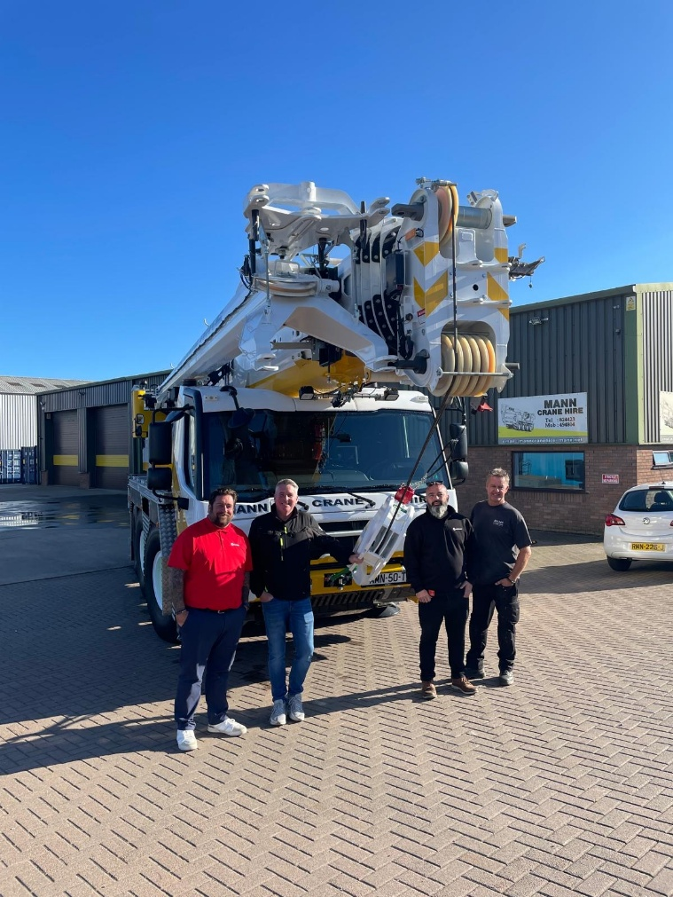

Left to right: Jim Leishman, Manitowoc; Chris Barnes, Mann Crane Hire;
Dave Grayson, Manitowoc; Steve Clark, Mann Crane Hire.
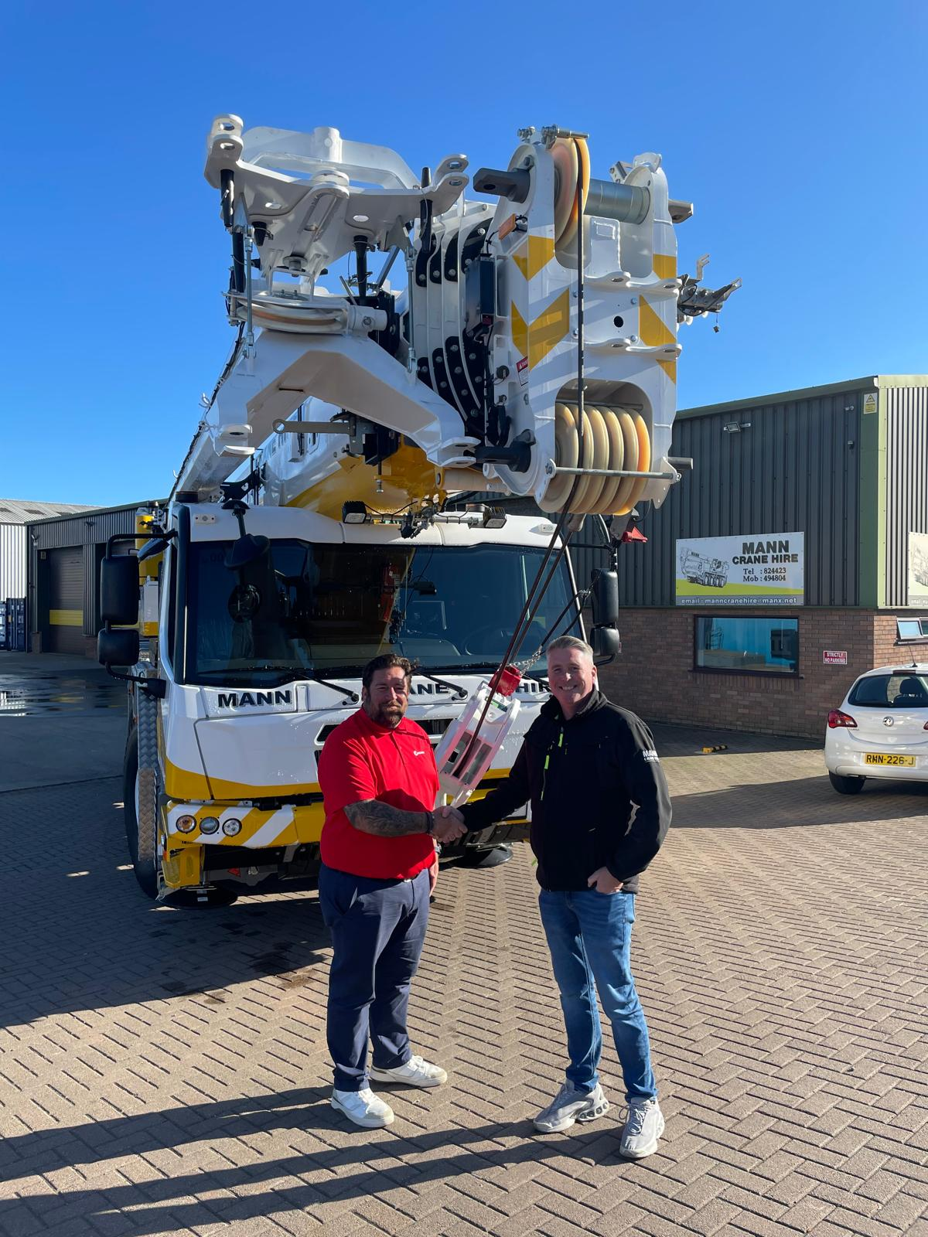

Jim Leishman, sales manager UK at Manitowoc with Chris Barnes,
owner and managing director at Mann Crane Hire.

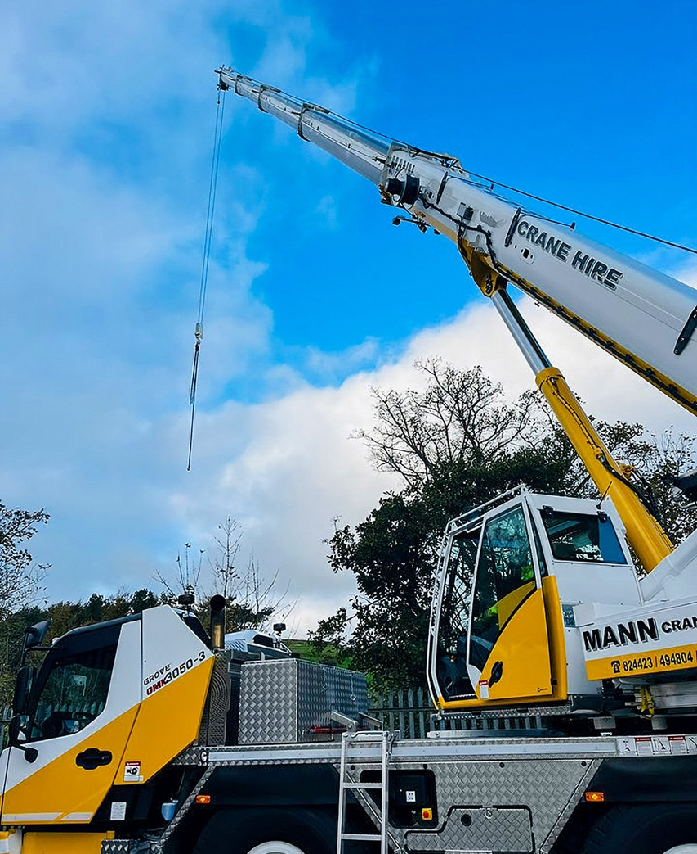

The new Grove GMK3050-3 on site in the Isle of Man.

CONTACT
Anna Theilen
Marketing Communication Specialist
Manitowoc
T +49 4421 294 4632
Anna.Theilen@manitowoc.com

ABOUT THE MANITOWOC COMPANY, INC.
The Manitowoc Company was founded in 1902 and has over a 120-year tradition of providing high-quality, customer-focused products and aftermarket support services to its markets. Manitowoc is one of the world's leading providers of engineered lifting solutions. Manitowoc, through its wholly owned subsidiaries, designs, manufactures, markets, distributes, and supports comprehensive product lines of mobile hydraulic cranes, lattice-boom crawler cranes, boom trucks, and tower cranes under the Aspen Equipment, Grove, Manitowoc, MGX Equipment Services, National Crane, Potain, and Shuttlelift brand names.

THE MANITOWOC COMPANY, INC.
One Park Plaza – 11270 West Park Place – Suite 1000 – Milwaukee, WI 53224, USA
T +1 414 760 4600
www.manitowoc.com

