
PRESS RELEASE

October 20, 2025

DS Lausnir adds two Grove All-Terrain cranes equipped for Icelandic winter challenges
- The company took delivery of a Grove GMK5250XL-1 just months after receiving a GMK5150L-1.
- The cranes are equipped for special sub-zero conditions with several customized features that add winter durability, enhance operator comfort, and increase visibility in low-light conditions.

Reykjavík winters are notoriously tough. From November to March, average temperatures hover around 0 °C and can drop to −10 °C on the coldest days. Strong winds make it feel even colder than the thermometer suggests, and there are only 4–7 hours of daylight to work with.

To meet these demanding conditions, DS Lausnir has invested in two Grove all-terrain cranes. In recent months, the Icelandic lifting company took delivery of a Grove GMK5250XL-1 and a Grove GMK5150L-1, both customized with features that enhance winter durability and provide operators with a more comfortable working environment.

“Iceland doesn’t give you easy weather or easy logistics. We wanted cranes that just get on with the job,” said Daníel Sigurðarson, owner of DS Lausnir. “Our new Grove GMK5150L-1 and GMK5250XL-1 give us the reach, roadability, and all-weather readiness we need for year-round work in Reykjavík and across the country.”

The GMK5250XL-1 offers an impressive 250 t lifting capacity and a 78.5 m main boom. It comes equipped with Grove’s snow cover package, which includes carrier cab bottom protection, hose reel cover, cable reel cover, and valve block cover. Additional features include winter tires, auxiliary heaters for both the upper and lower cabs, and LED front and work lights to ensure optimal visibility in low-light conditions.

The GMK5150L-1 delivers a 150 t capacity and a 60 m main boom. Its custom configuration features the same snow cover package and winter tires, along with an engine-independent diesel cab heater that doubles as an engine preheater and includes a 24-hour timer. The crane is also fitted with a 270° birds eye view camera system and an advanced LED work light package. This package consists of two retractable carrier-mounted work lights, two superstructure-mounted lights for field illumination, and two LED lights on the superstructure cab, replacing the standard halogen lights.

“Seeing the Grove GMK5250XL-1 follow the Grove GMK5150L-1 so quickly speaks to DS Lausnir’s confidence in the product and Manitowoc’s regional support,” Daníel Sigurðarson said.

Both cranes are now operating out of Reykjavík and are already busy on job sites. As winter approaches, DS Lausnir knows it has all-terrain cranes ready to handle the most challenging conditions the season may bring.

Shortly after delivery, the Grove GMK5250XL-1 was deployed on demanding projects. For example, the crane assisted in laying precast concrete floors weighing up to 11 t at a radius of up to 40 m. This project took place at the Þorraholt site in Garðabær and is part of a residential development by ÞG-Verk ehf.

To learn more about the Grove GMK5250XL-1 click here, or to learn more about the GMK5150L-1 click here.

-END-

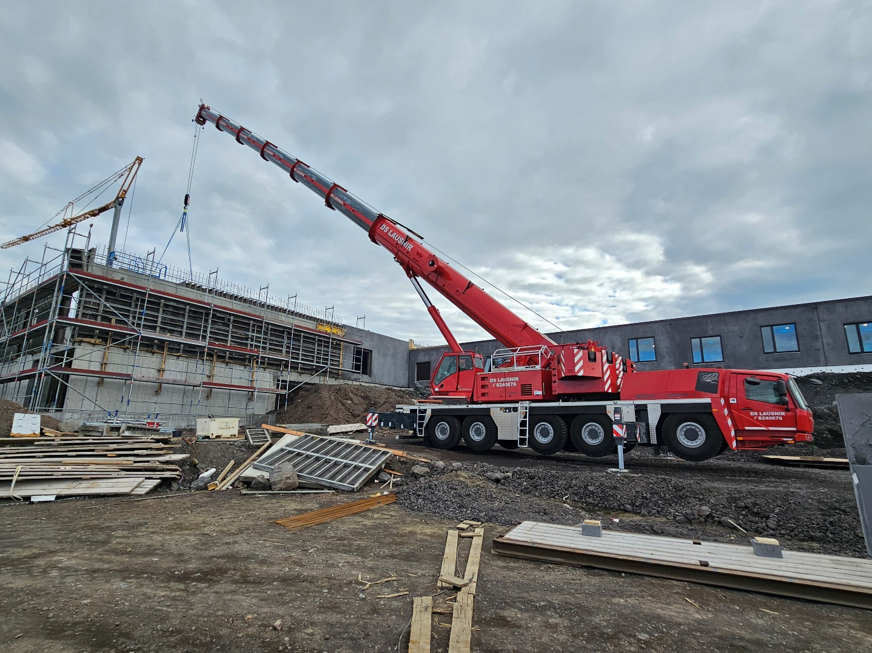

The new Grove GMK5250XL-1 for DS Lausnir.
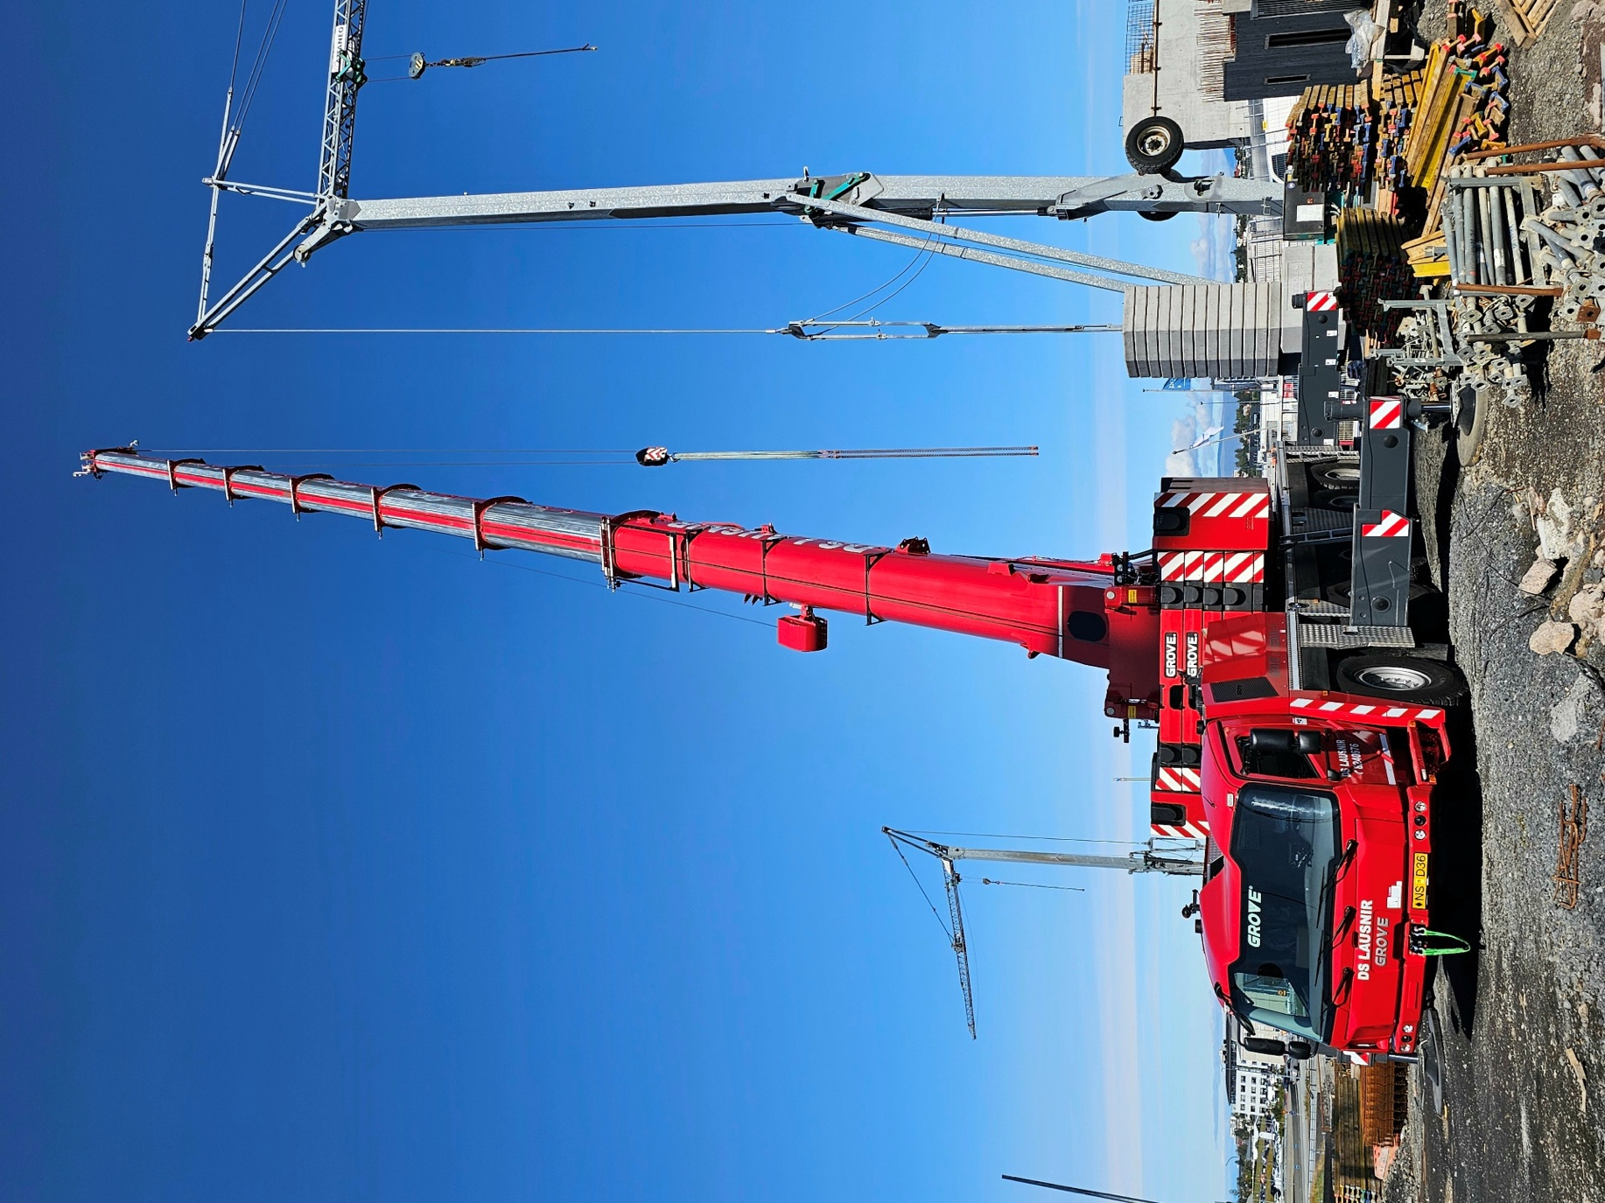
Both of the new cranes are operating on jobsites around Reykjavík.
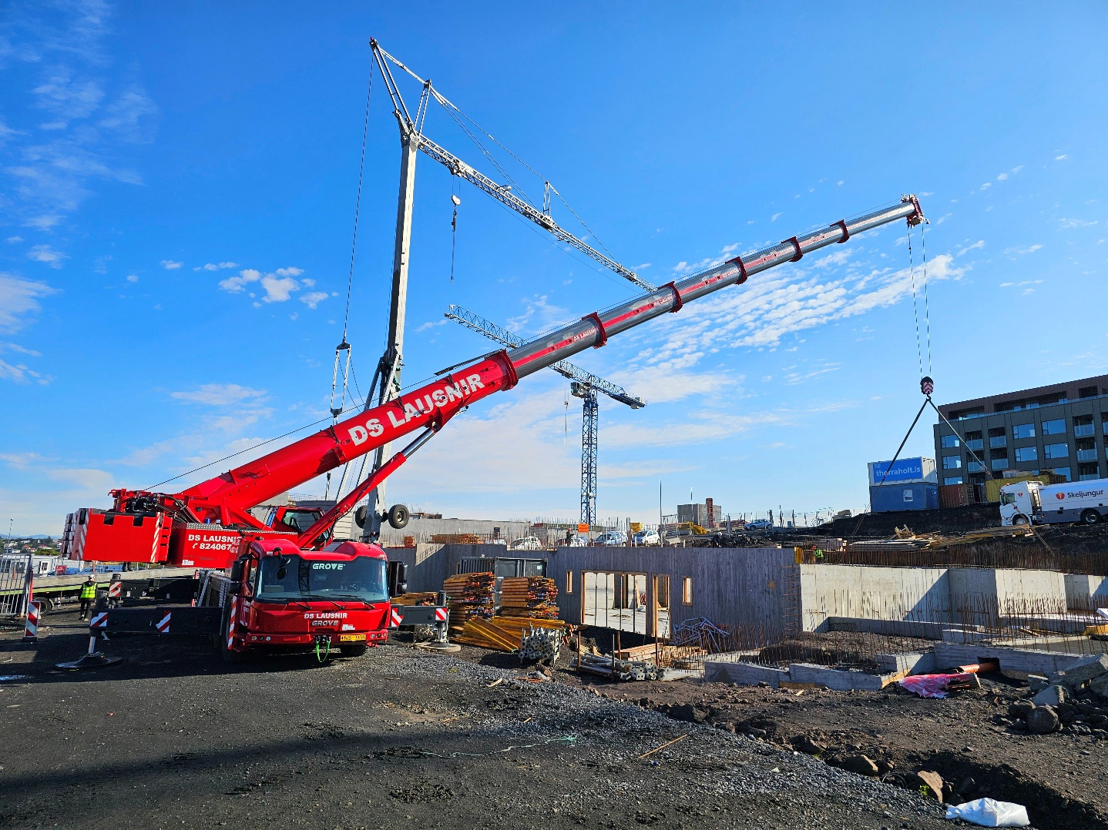

The cranes are customized with several additional features to enhance their cold weather durability.

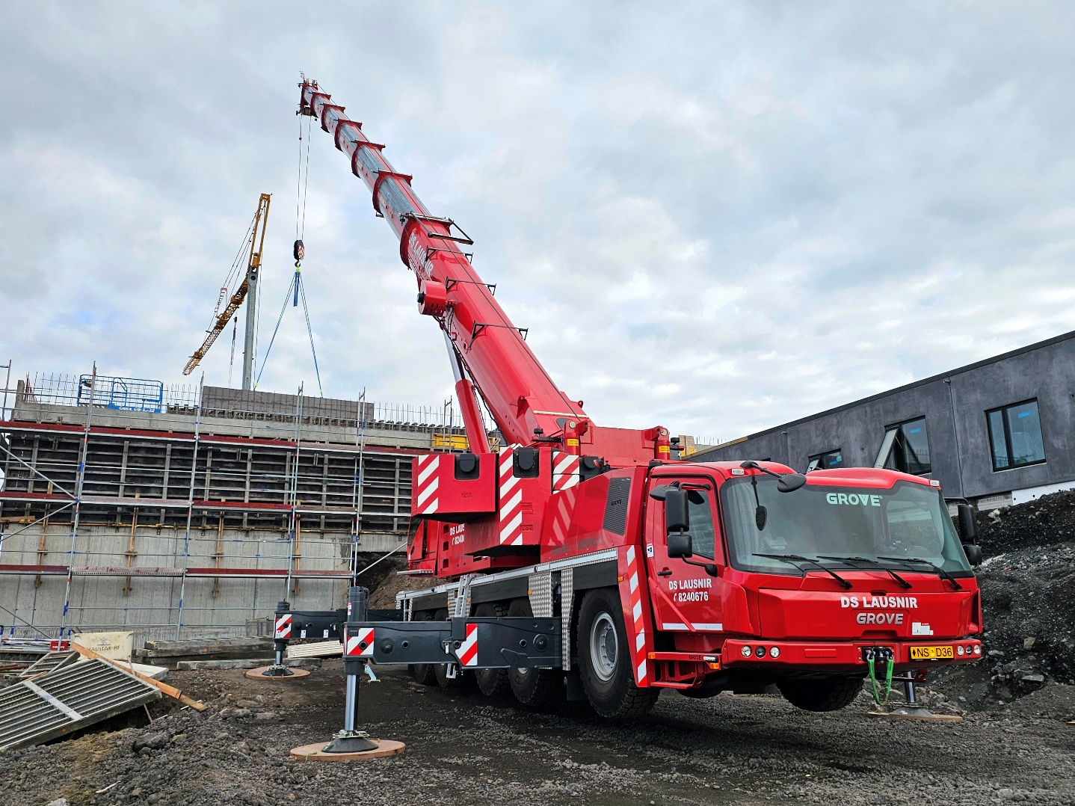

Additional features on the cranes include winter tires, auxiliary heaters for both the upper and lower cabs, and LED front and work lights to ensure optimal visibility in low-light conditions.

CONTACT
Anna Theilen
Marketing Communication Specialist
Manitowoc
Tel. +49 4421 294 4632
anna.theilen@manitowoc.com

ABOUT THE MANITOWOC COMPANY, INC.
The Manitowoc Company was founded in 1902 and has over a 120-year tradition of providing high-quality, customer-focused products and aftermarket support services to its markets. Manitowoc is one of the world's leading providers of engineered lifting solutions. Manitowoc, through its wholly owned subsidiaries, designs, manufactures, markets, distributes, and supports comprehensive product lines of mobile hydraulic cranes, lattice-boom crawler cranes, boom trucks, and tower cranes under the Aspen Equipment, Grove, Manitowoc, MGX Equipment Services, National Crane, Potain, and Shuttlelift brand names.

THE MANITOWOC COMPANY, INC.
One Park Plaza – 11270 West Park Place – Suite 1000 – Milwaukee, WI 53224, USA
T +1 414 760 4600
www.manitowoc.com

