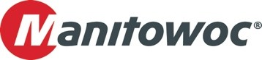
PRESS RELEASE
October 16 2025

Bott Group welcomes its 30th Grove Mobile Crane: A GMK5250XL-1 joins the fleet
- Bott Group took delivery of its 30th Grove all-terrain crane at Manitowoc’s Wilhelmshaven factory – a Grove GMK5250XL-1.
- Bott Group’s large all-terrain fleet consists primarily of Grove GMK models.
Marking a significant milestone for the Bott Group, the 30th Grove mobile crane—a new GMK5250XL-1—was officially handed over at the Wilhelmshaven plant and is now based at the company's headquarters in Bad Kreuznach, Germany.
This investment was made possible through the successful resale of an older crane via KranAgentur Werner. Thanks to this smooth transaction, the Bott Group was able to invest in cutting-edge technology without delay, expanding its fleet with a powerful crane with a lifting capacity of 250 t.
Optimal equipment for the highest demands
The new GMK5250XL-1 is equipped with an extensive range of features, including:
- Hydraulic bi-fold swing-away jib for maximum jobsite flexibility
- Preparation for the auxiliary hoist that is already a part of Bott Group's existing fleet
- Proven VIAB turbo retarder clutch for smooth, wear-free starts
- BirdView 270° camera system and boom head camera for optimal visibility
- Numerous additional features designed to make the operator’s work easier
Bott Group: From Workshop to Heavy-Lift Specialist
Founded in 1972 as a small automotive workshop, the company entered the towing and recovery business just three years later. In 1999, Bott expanded into heavy transport, followed by the addition of its first crane in 2001. Today, the Bott Group employs around 120 people across three locations and handles projects up to the 450-ton class – flexible, reliable, and well-equipped.
You can find more information about the Grove all-terrain cranes here.
-END-

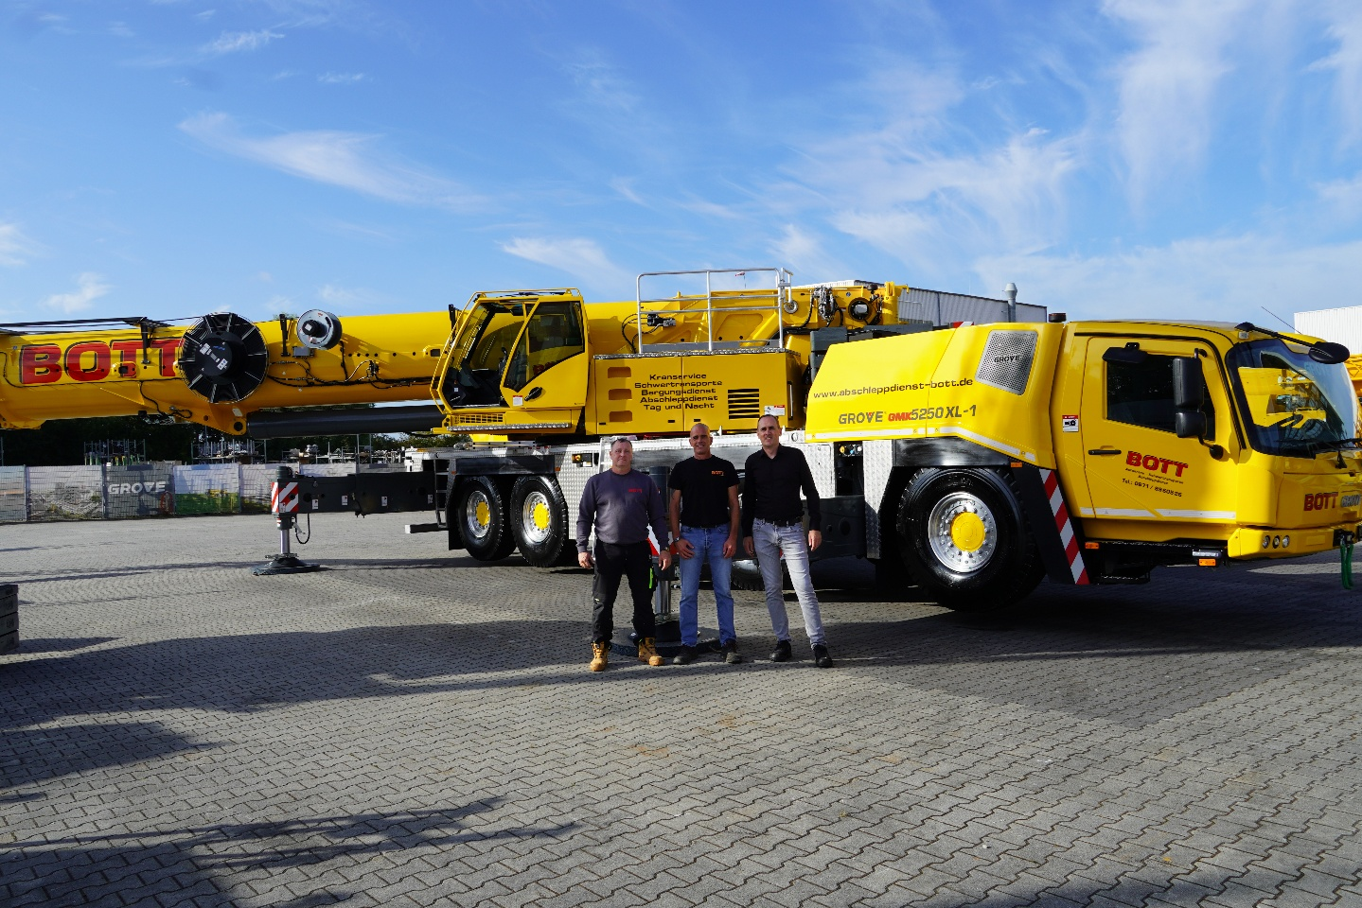

From left to right: Wolfgang Hansen, Bott Group; Daniel Matheis, Bott Group; and Lukas Brämer, KranAgentur Werner.

CONTACT
Anna Theilen
Marketing Communication Specialist
Manitowoc
T +49 4421 294 4632
Anna.Theilen@manitowoc.com

ABOUT THE MANITOWOC COMPANY, INC.
The Manitowoc Company was founded in 1902 and has over a 120-year tradition of providing high-quality, customer-focused products and aftermarket support services to its markets. Manitowoc is one of the world's leading providers of engineered lifting solutions. Manitowoc, through its wholly owned subsidiaries, designs, manufactures, markets, distributes, and supports comprehensive product lines of mobile hydraulic cranes, lattice-boom crawler cranes, boom trucks, and tower cranes under the Aspen Equipment, Grove, Manitowoc, MGX Equipment Services, National Crane, Potain, and Shuttlelift brand names.

THE MANITOWOC COMPANY, INC.
One Park Plaza – 11270 West Park Place – Suite 1000 – Milwaukee, WI 53224, USA
T +1 414 760 4600
www.manitowoc.com

