
PRESS RELEASE
November 17, 2025

Foselev takes delivery of a new Grove GMK4080L – Compact, Powerful and Ready for Action
- Foselev is replacing an older GMK4080-1 with a new Grove GMK4080L, which has a long boom length and outstanding taxi configurations – the new addition was handed over at the JDL Expo in Beaune.
- Immediately after the handover, the crane travelled from Nancy to Martigues, where it is supporting a large-scale maintenance operation on a chemical site.
French crane and industrial services specialist Foselev recently took delivery of a new Grove GMK4080L – a mobile crane that impresses with its combination of compact design, long main boom and flexible taxi configurations. The handover took place at the JDL Expo in Beaune and marks the completion of a multiple crane purchase.
With a main boom length of 60 m, the GMK4080L is one of the most powerful cranes in its class. Particularly noteworthy is the ability to move the crane with 13.3 t of counterweight at 12 t axle load – a significant advantage for Foselev, as no additional transport vehicle is required for the counterweight for many applications. This not only saves time and money but also increases flexibility in use.
Another feature that convinced Foselev is the compact outrigger base of the GMK4080L, measuring only 6.2 x 6.8 m. This allows the crane to be used as an alternative for a three-axle crane when required – a real advantage for operations with limited space.
The new GMK4080L replaces an older GMK4080-1 in Foselev's fleet and represents a targeted modernization of the fleet. The decision to choose this model was made to increase performance and versatility in day-to-day operations.
“We chose the Grove GMK4080L because of its 60 m main boom and its excellent taxi crane characteristics, which make it particularly efficient and flexible in use. In addition, the compact support base allows us to use it as a replacement for smaller cranes when necessary,” said Brice Bonnefoy, Equipment Director at Foselev.
Immediately after delivery, the crane left its home base in Nancy and travelled to Martigues in southern France to support large-scale maintenance work on a chemical site. The driver particularly appreciated the MEGATRAK® independent suspension, which proved to be extremely comfortable and reliable during the long cross-country journey.
Further information on the Grove GMK4080L can be found here.

-END-

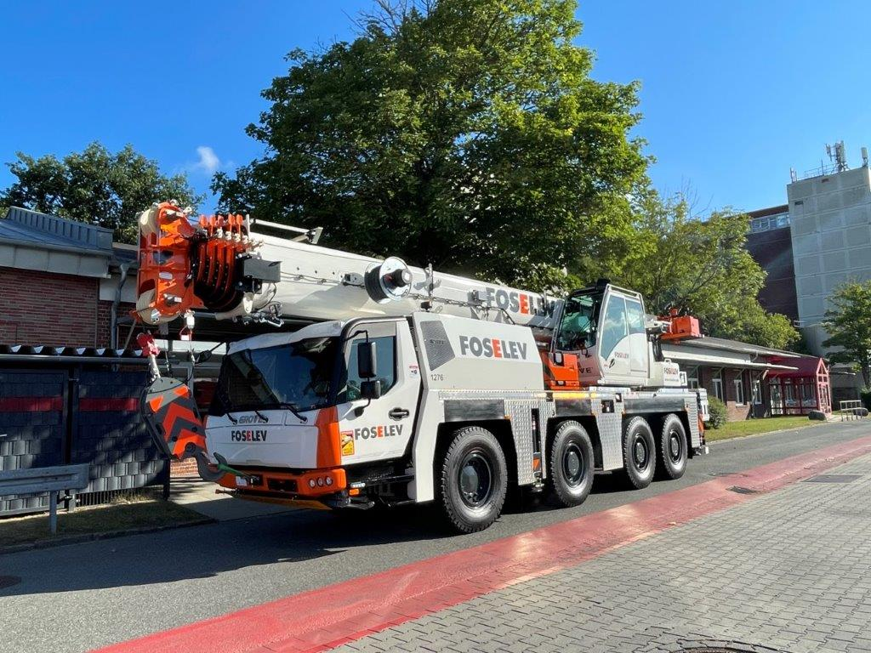

The new GMK4080L for Foselev.

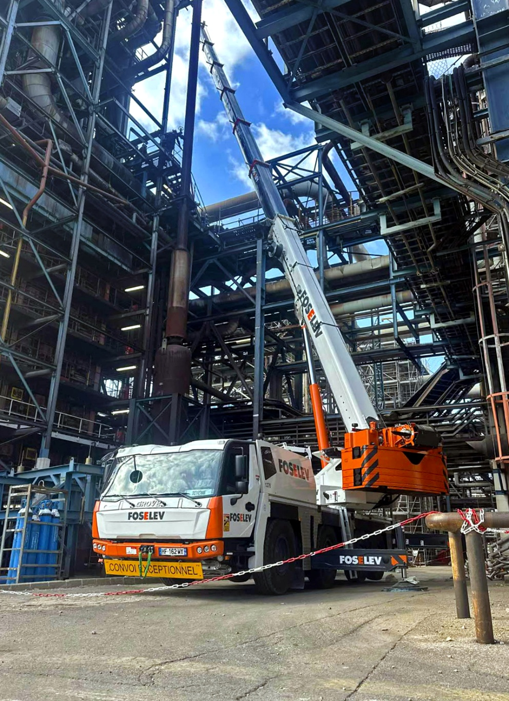

The new crane gets to work on an industrial jobsite.

CONTACT
Anna Theilen
Marketing Communication Specialist
Manitowoc
T +49 4421 294 4632
Anna.Theilen@manitowoc.com

ABOUT THE MANITOWOC COMPANY, INC.
The Manitowoc Company was founded in 1902 and has over a 120-year tradition of providing high-quality, customer-focused products and aftermarket support services to its markets. Manitowoc is one of the world's leading providers of engineered lifting solutions. Manitowoc, through its wholly owned subsidiaries, designs, manufactures, markets, distributes, and supports comprehensive product lines of mobile hydraulic cranes, lattice-boom crawler cranes, boom trucks, and tower cranes under the Grove, Manitowoc, MGX Equipment Services, National Crane, Potain, Shuttlelift, and Upfits by Aspen Equipment brand names.

THE MANITOWOC COMPANY, INC.
One Park Plaza – 11270 West Park Place – Suite 1000 – Milwaukee, WI 53224, USA
T +1 414 760 4600
www.manitowoc.com

