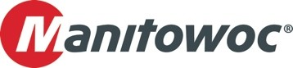
PRESS RELEASE
August 5, 2025

Wilhelm Bruns Kranvermietung adds two new Grove all-terrain cranes

- The company expanded its fleet with a 100 t capacity Grove GMK4100L-2 and 250 t capacity Grove GMK5250XL-1
- The two cranes are already delivering productive results for their new owner.

German crane rental company Wilhelm Bruns Kranvermietung has expanded its offering with the addition of Grove GMK4100L-2 and GMK5250XL-1all-terrain cranes from the Manitowoc factory in Wilhelmshaven. The company is one of the longest-established crane providers in its region, with offices in Lüneburg and Hamburg, and customers across the construction, energy, industrial, and infrastructure sectors.

The Grove GMK4100L-2 features a 100 t lift capacity and a wide range of capabilities, including a fully equipped operator’s cab with reversing and Bird’s Eye View cameras. Other details include a remote control and a 16 m bi-fold jib, which provides even greater reach for the impressive 60 m main boom. The engine is specified to the latest EUROMOT 5/Tier 4 Final requirements, offering reduced fuel consumption and enabling operation with 100% HVO diesel.

“The two new cranes combine compact dimensions and excellent lifting capacities – we are extremely impressed,” said Adrian Keck, managing director of Wilhelm Bruns Kranvermietung. “They have done a first-class job on their first projects. We equipped them with the MAXbase™ system for variable outrigger positions, and they are extremely user-friendly thanks to the intuitive boom configurator. Their features and benefits, combined with category-leading lift and reach capacities, enable us to use them on a wide range of applications. "

The Grove GMK5250XL-1 has a maximum capacity of 250 t. It is based on Grove’s single-engine concept, which reduces diesel consumption by 30% compared to previous models, resulting in lower emissions and operating costs for owners. The crane features a 78.5 m long main boom and up to 109 m of reach when using the jib, giving it some of the best capabilities in this category of five-axle cranes.

The Wilhelm Bruns group of companies celebrated its 100th anniversary last year and serves a broad customer base across the northern German industrial and construction sectors. The company’s relationship with Manitowoc dates back to the 1960s. Manitowoc provides comprehensive service support to the company from its Langenfeld customer center.

To learn more about the Grove range of all-terrain cranes, click here.

-END-

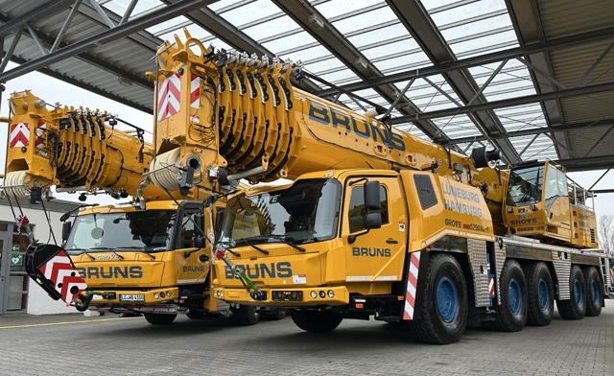

Wilhelm Bruns Kranvermietung GmbH added two new Grove all-terrain cranes to its fleet.

CONTACT
Anna Theilen
Marketing Communication Specialist
Manitowoc
T +49 4421 294 4632
anna.theilen@manitowoc.com

ABOUT THE MANITOWOC COMPANY, INC.
The Manitowoc Company was founded in 1902 and has over a 120-year tradition of providing high-quality, customer-focused products and aftermarket support services to its markets. Manitowoc is one of the world's leading providers of engineered lifting solutions. Manitowoc, through its wholly owned subsidiaries, designs, manufactures, markets, distributes, and supports comprehensive product lines of mobile hydraulic cranes, lattice-boom crawler cranes, boom trucks, and tower cranes under the Aspen Equipment, Grove, Manitowoc, MGX Equipment Services, National Crane, Potain, and Shuttlelift brand names.

THE MANITOWOC COMPANY, INC.
One Park Plaza – 11270 West Park Place – Suite 1000 – Milwaukee, WI 53224, USA
T +1 414 760 4600
www.manitowoc.com

