PRESS RELEASE

February 7, 2025

**Spanish students discover the future of crane technology at Manitowoc**

* *A group of university students from Spain toured Manitowoc’s local facility, gaining insights from industry experts and exploring the Company’s advanced technology.*
* *They also got a sneak peek at Grove’s latest models, including some exciting new additions.*

A group of Spanish university students from the IES Humanejos in Madrid had the chance to enter the world of cranes with a visit to the local Manitowoc facility. What began as a routine educational visit turned into an unforgettable learning experience, offering the students not just a look at cutting-edge technology but a glimpse into the future of the crane industry.

The group was guided on its visit by Vicente Sánchez, head of aftersales at Manitowoc Spain, and accompanied by Francisco de Borja González and Ángel Sánchez from the Company’s commercial department. The students learned how Manitowoc provides round-the-clock support to customers across the Iberian Peninsula, offering original spare parts and expert service support. They also toured the workshop, observing crane repairs and learning about Manitowoc’s meticulous quality control process.

“The visit was 10 out of 10,” said one of the students. “Manitowoc’s team was extremely welcoming, and they guided us through everything. It really helped me understand what my options are for my future.”

The group also got an exclusive opportunity to see some of the latest Grove crane models.

“We got to see some new machines, which was super exciting. Manitowoc explained how they worked – the controls and functions – and it gave me a better idea of what kind of companies I want to work for,” said another.

**Exciting crane demos**

A memorable moment for the students was meeting Pier Domenico Ravera, Manitowoc’s VP of mobile crane sales for West Europe and general manager in the UK. He spoke to them about the future of the industry and the opportunities for young professionals. He emphasized the Company’s efforts to enhance customer support and encouraged the students to consider careers at Manitowoc.

“It was a unique moment to meet a vice president and be able to ask questions about potential future careers,” a student said. “It’s clear that Manitowoc values young talent, and the whole visit was a valuable opportunity to learn and grow.”

Students also observed a live demonstration of a Grove crane. This hands-on experience gave them a closer look into the daily work of operators, allowing them to sit at the controls and appreciate the intricacies of crane operation.

“It was incredible to see the crane move with such precision. The crane monitoring system is essential for its operations, and it really impressed me,” another student said.

At the end of the visit, the students left with renewed excitement about possible career paths. Many agreed that it gave them a clearer understanding of Manitowoc’s commitment to innovation and quality – and a better sense of what they want to achieve in their careers.

To learn more about a career with Manitowoc, click [here](https://www.manitowoc.com/careers).

-END-

IMAGES:

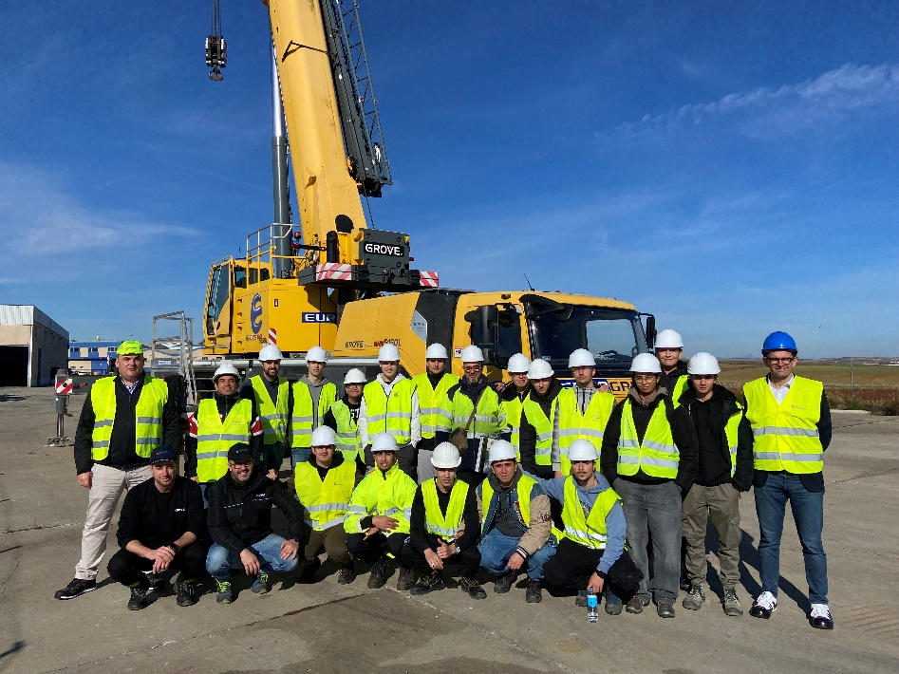

"Students from IES Humanejos gather for a group photo during their visit to Manitowoc in Spain."

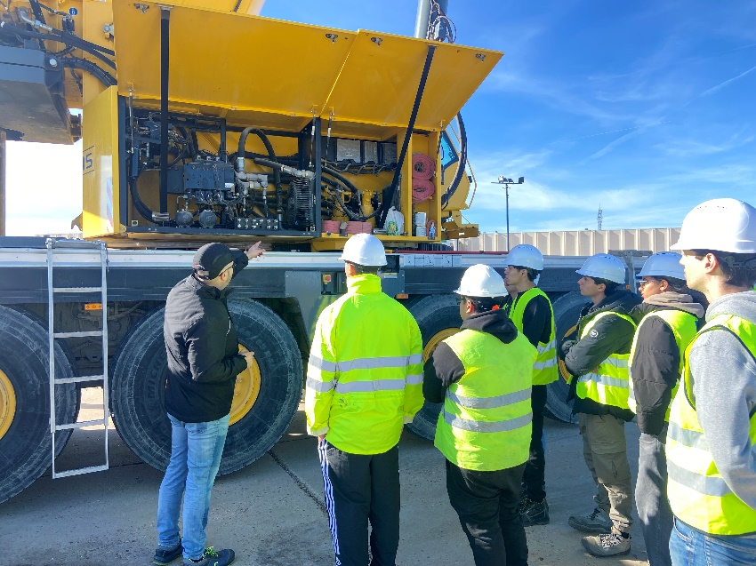

"A Manitowoc team member showcases one of the latest Grove cranes to students."

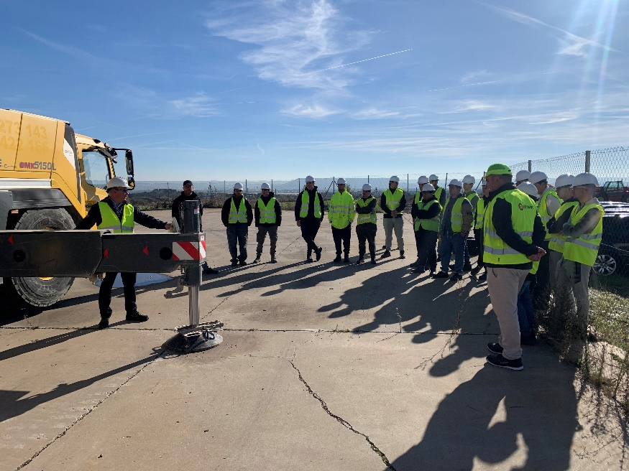

"Students listen as a Manitowoc expert explains crane operations."

CONTACT

**Anna Theilen**

**Marketing Communication Specialist**

**Manitowoc**

**T +49 4421 294 4632**

[**anna.theilen@manitowoc.com**](mailto:anna.theilen@manitowoc.com)

ABOUT THE MANITOWOC COMPANY, INC.

The Manitowoc Company was founded in 1902 and has over a 120-year tradition of providing high-quality, customer-focused products and aftermarket support services to its markets. Manitowoc is one of the world's leading providers of engineered lifting solutions. Manitowoc, through its wholly owned subsidiaries, designs, manufactures, markets, distributes, and supports comprehensive product lines of mobile hydraulic cranes, lattice-boom crawler cranes, boom trucks, and tower cranes under the Aspen Equipment, Grove, Manitowoc, MGX Equipment Services, National Crane, Potain, and Shuttlelift brand names.

THE MANITOWOC COMPANY, INC.

One Park Plaza – 11270 West Park Place – Suite 1000 – Milwaukee, WI 53224, USA

T +1 414 760 4600

www.manitowoc.com