PRESS RELEASE

March 31 2025

**UK crane rental company Lawson Haulage and Crane Hire switches to Grove for new flagship model**

* *Lawson Haulage and Crane Hire has added a Grove GMK5250XL-1 all-terrain crane to its fleet: its largest mobile crane and first Grove.*
* *The 250 t capacity crane has a 78.5 m long and strong boom, giving the company access to new contracts across northern England and southern Scotland.*
* *Lawson invested after seeing the Grove GMK5250XL-1’s advanced technical features and the superb Manitowoc customer support set-up, including the* [*new Barnsley facility*](https://www.manitowoc.com/company/news/manitowoc-opens-additional-uk-service-facility-expand-crane-sales-and-aftermarket) *that opened last year.*

[Lawson Haulage and Crane Hire](https://www.lawsonshaulage.co.uk/) has chosen Grove mobile cranes for the first time, and it’s a choice that is already paying dividends. The company’s new 250 t [GMK5250XL-1](https://www.manitowoc.com/grove/all-terrain-cranes/gmk5250xl-1) enjoyed a successful first job changing out two turning wheels during a shutdown of the [Egger UK](https://www.egger.com/en/?country=GB&country=GB) wood plant in Hexham, Northumberland. Handling loads of 25 t, the GMK5250XL-1 was configured with 80 t of counterweight and a main boom of 41.6 m for work at a 25 m radius.

“The GMK5250XL-1 handled the first job with ease, and the operation went extremely smoothly, allowing the plant to get back online quickly, which the customer really appreciated. We expect to see equally impressive results and customer satisfaction when the crane begins its other projects in wind turbine erection and maintenance, boat lifts, large dismantling works, and even on projects at the nearby Blackpool Pleasure Beach theme park,” said Gary Audley, crane manager at Lawsons Haulage and Crane Hire Services.

Lawson Haulage and Crane Hire Services is based in Cockermouth, close to the Lake District, and serves clients across northern England and southern Scotland. Manitowoc will support the company from its [new service location in Barnsley](https://www.manitowoc.com/company/news/manitowoc-opens-additional-uk-service-facility-expand-crane-sales-and-aftermarket), which opened last year, and from the UK head office in Buckingham.

“The new Grove GMK5250XL-1 has allowed us to handle heavier loads and to do jobs faster because, with the long boom, we can handle more work without needing a jib. We’re a long-established haulage and crane rental business with a great reputation, facing many new opportunities, and we believe our GMK5250XL-1 will allow us to access more tier-one work while supporting our substantial existing customer base,” said Grant Kennedy, assistant crane manager at Lawsons Haulage and Crane Hire Services.

The crane offers an exceptional main boom of 78.5 m, plus flexible counterweight configurations and a spacious, ergonomic driver’s cab. Lawson took the decision to invest after being impressed with the crane on a visit to the Manitowoc factory in Wilhelmshaven, Germany with UK sales manager Derek Kidd:

“The guys at Lawson really loved the capabilities of the GMK5250XL-1 and they even added the [MAXbase](https://www.manitowoc.com/grove/all-terrain-cranes/gmk5250xl-1#gallery-8)™ variable outrigger positioning system and a boom head camera. But they were equally impressed with our customer support and the impressive Wilhelmshaven factory. We’re delighted Lawson has added its first Grove crane and look forward to a long working relationship together,” said Kidd.

To learn more about the Grove GMK5250XL-1 click [here](https://www.manitowoc.com/grove/all-terrain-cranes/gmk5250xl-1).

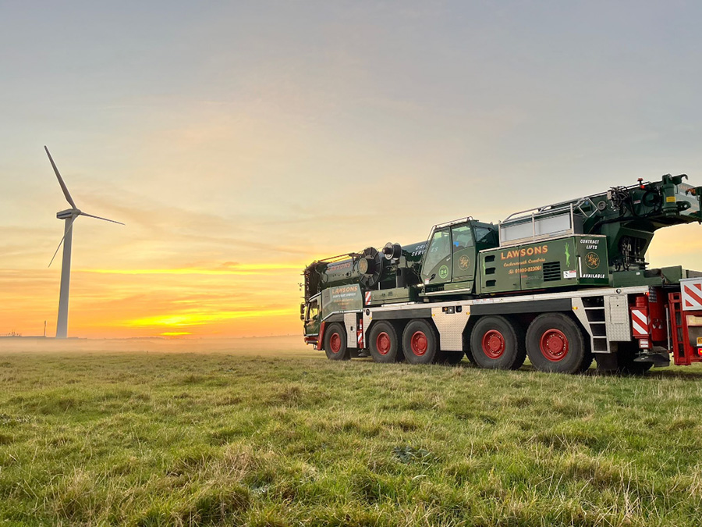

The new Grove GMK5250XL-1 for Lawson Haulage & Crane Hire in the UK.

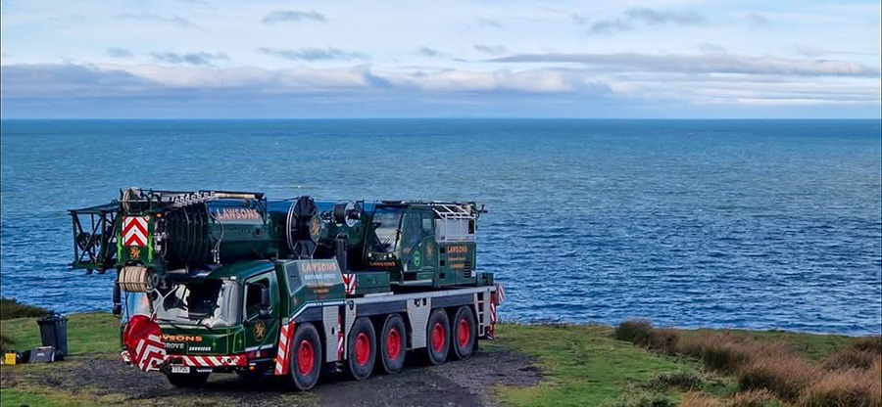

The new crane will work across northern England and southern Scotland.

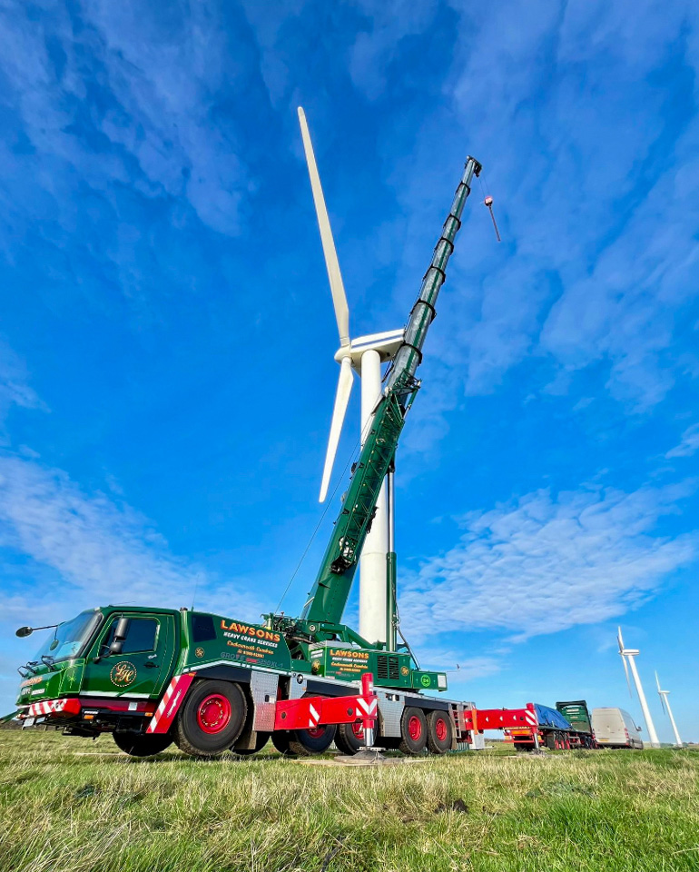

The new Grove GMK5250XL-1 will be used to erect and maintain wind turbines.

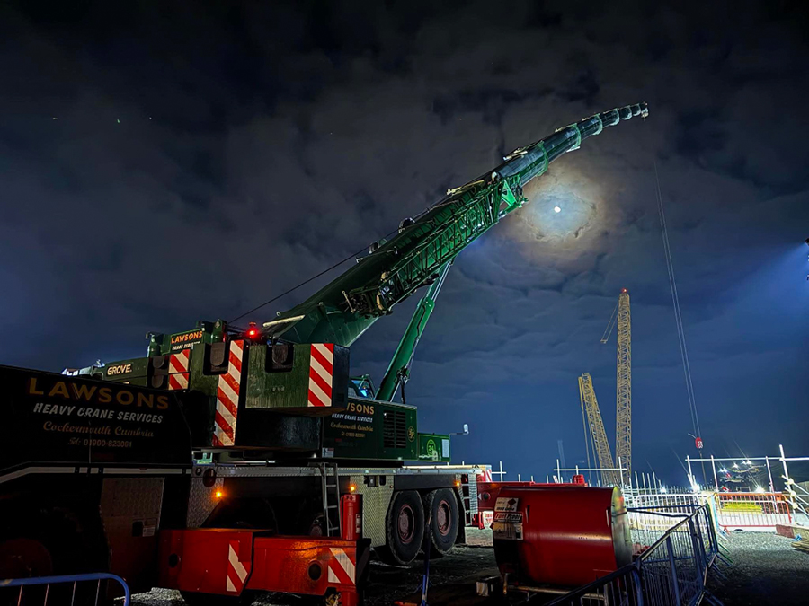

The crane was ordered with the optional MAXbase™ variable outrigger positioning system for optimum flexibility in set-up – perfect for working on congested jobsites.

-END-

CONTACT

**Anna Theilen**

Marketing Communication Specialist

Manitowoc

T +49 4421 294 4632

[anna.theilen@manitowoc.com](mailto:anna.theilen@manitowoc.com)

ABOUT THE MANITOWOC COMPANY, INC.

The Manitowoc Company was founded in 1902 and has over a 120-year tradition of providing high-quality, customer-focused products and aftermarket support services to its markets. Manitowoc is one of the world's leading providers of engineered lifting solutions. Manitowoc, through its wholly owned subsidiaries, designs, manufactures, markets, distributes, and supports comprehensive product lines of mobile hydraulic cranes, lattice-boom crawler cranes, boom trucks, and tower cranes under the Aspen Equipment, Grove, Manitowoc, MGX Equipment Services, National Crane, Potain, and Shuttlelift brand names.

THE MANITOWOC COMPANY, INC.

One Park Plaza – 11270 West Park Place – Suite 1000 – Milwaukee, WI 53224, USA

T +1 414 760 4600

www.manitowoc.com