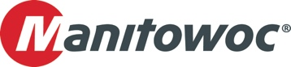
PRESS RELEASE

July 22, 2025

Lights. Camera. Lift! Grove GMK5250XL-1 creates movie magic with Lee Lifting

- UK rental company Lee Lifting purchased the Grove GMK5250XL-1 all-terrain crane — the highest capacity crane on five axles — for its work in the movie industry.
- The customizable specs of the crane match the company’s ever-changing needs on film and TV sets and is a great addition to a fleet that already includes a GMK3060L and a GMK5150L.
A high proportion of Lee Lifting’s turnover comes from the film and TV industry. The company has worked on many blockbuster movies and TV shows in over 40 years of business and has also recently moved to a new, larger location in Camberley Surrey, UK.

The company received the new Grove GMK5250XL-1 in March and promptly put the crane to work in the UK’s increasingly busy film industry. It needed to be well spec’d for holding lights, rigging equipment, and other production tasks, all while managing lifts on dynamic sets with ever decreasing amounts of space.
“Originally, we were going for a smaller capacity crane, but we switched to the Grove GMK5250XL-1 after evaluating upcoming projects and realizing we needed more flexibility and specs that met our evolving needs,” said Jody Whitmore of Lee Lifting. “It’s the highest capacity crane on five axles, which offers more lifting power without jumping up to a six-axle crane that would be harder to manage and fit on jobsites.”

The 250 t GMK5250XL-1 has a main boom of 78.5 m, and optional configurations include an 11.2 m/17.8 m swingaway jib that can be luffed hydraulically allowing for a high level of flexibility. Lee Lifting also specified its crane with a dual winch, which is vital for many of the lifts that film sets demand, eg., using one winch to hold the lighting while the other holds the cable loom.

The new GMK5250XL-1 joins a GMK5150L and GMK3060L in the Lee Lifting fleet. The company has steadily added new Grove models to its fleet, selecting each for its class-leading capabilities and unique features, while Manitowoc ensures performance and uptime remain at the highest levels through its comprehensive, local customer support.

“With the 150 t Grove we got a really long boom, with the 60 t Grove we got a hydraulic luffing jib, and now with the 250-tonner we’ve got the strongest crane on five axles. Each Grove gives us something unique — that’s why we keep choosing them,” said Whitmore.

In combination with its Grove GMK5150L and GMK3060L, Lee Lifting offers the versatility to support a wide range of production applications, including aerial lighting, aerial stunts (such as controlled falling and flying), prop movements in shots, live action, set building, and more.

“We tend to spec our machines with additional features that give us the most flexibility,” Whitmore said. “For example, we always add a separate pedal to telescope the boom — it gives us another layer of control. A film set is a dynamic environment that requires constant repositioning, which is why we always opt for a hydraulic luffing jib on our Grove cranes. That extra functionality makes a big difference. We also like the MAXbase™ capability, which enables us to set up with asymmetrical outrigger positioning and still optimize lifting capacity.”

Lee Lifting’s relationship with Grove goes back more than eight years. In 2017, the company purchased a Grove GMK5150L, which at the time was the five-axle crane with the longest boom in this segment. Lee Lifting later provided feedback to Grove product management, much of which was incorporated into an updated version of the model.

“It’s great to see input being taken on board — we ultimately replaced our original order with the updated version in 2020,” Whitmore said.

To learn more about the Grove GMK5250XL-1, click here.

-END-

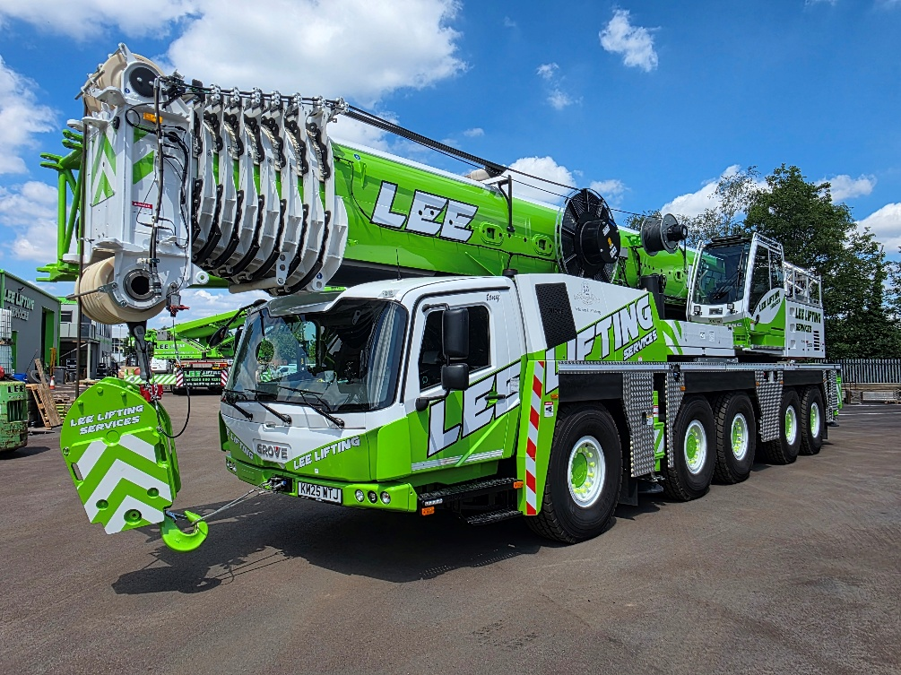

The UK’s Lee Lifting, which specializes in supplying cranes to the film industry, has
added a new Grove GMK5250XL-1 to its fleet.

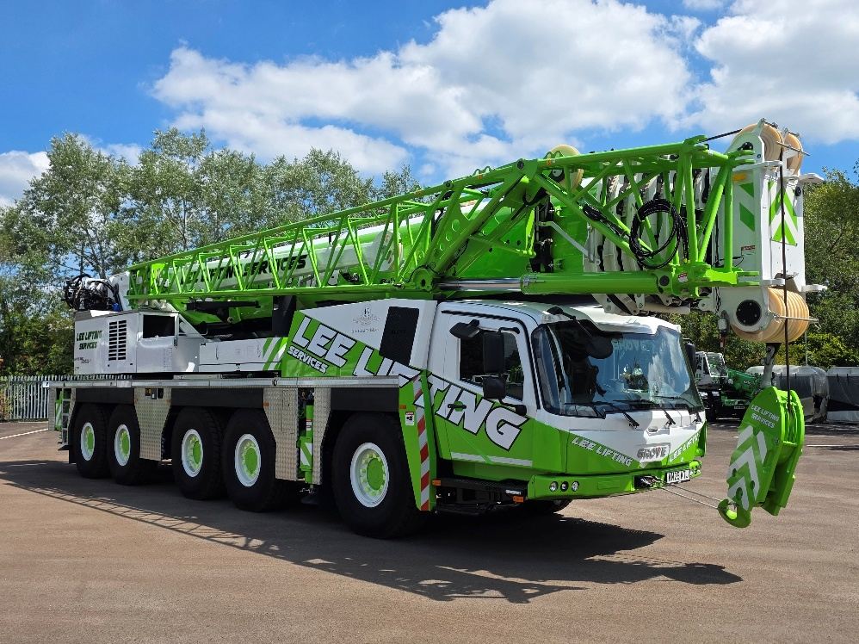

Lee Lifting purchased the Grove GMK5250XL-1 because it’s the strongest crane on
five-axles, allowing it to cover the complex and varied work on film and TV sets.

CONTACT
Anna Theilen
Marketing Communication Specialist
Manitowoc
T +49 4421 294 4632
Anna.theilen@manitowoc.com

ABOUT THE MANITOWOC COMPANY, INC.
The Manitowoc Company was founded in 1902 and has over a 120-year tradition of providing high-quality, customer-focused products and aftermarket support services to its markets. Manitowoc is one of the world's leading providers of engineered lifting solutions. Manitowoc, through its wholly owned subsidiaries, designs, manufactures, markets, distributes, and supports comprehensive product lines of mobile hydraulic cranes, lattice-boom crawler cranes, boom trucks, and tower cranes under the Aspen Equipment, Grove, Manitowoc, MGX Equipment Services, National Crane, Potain, and Shuttlelift brand names.

THE MANITOWOC COMPANY, INC.
One Park Plaza – 11270 West Park Place – Suite 1000 – Milwaukee, WI 53224, USA
T +1 414 760 4600
www.manitowoc.com

