NEWS RELEASE

August 7, 2024

**Grúas del Vallés receives new Grove GMK3060L-1 cranes**

* *The Spanish crane rental company added two new GMK3060L-1 all-terrain cranes after great experiences with its first GMK3060L-1, purchased in 2022.*
* *Grúas del Vallés will use* *the versatile cranes across multiple applications.*

Catalonia-based crane rental company Grúas del Vallés has acquired two new 60 t capacity Grove GMK3060L-1 all-terrain cranes. The company invested in the models after being thoroughly impressed with its first GMK3060L-1, delivered in 2022. This crane offers a long main boom of 48 m combined with exceptional agility inside a compact package.

Grúas del Vallés is a steadfast customer of cranes from Manitowoc, purchasing its first Grove nearly six years ago. Its fleet now has seven Grove all-terrains, engaged in various tasks on residential projects, road-building jobs, industrial sites, and more. They handle duties such as assembling and disassembling tower cranes, mounting air conditioning units, providing general lifting work in tight spaces or at industrial yards, and assembling pre-cast concrete sections.

“We really like Grove’s GMK3060L-1. Its compact dimensions, long boom, 8.7-15 m bi-fold swingaway jib, and MEGATRAK® suspension are outstanding features that enhance our operations. The cranes are ideal for the jobs we focus on, and we get great support from our local dealer Rexma which always provides swift and responsive service,” said Marc Gelabert, manager at Grúas del Vallés.

Grove’s three-axle GMK3060L-1 all-terrain crane features a comfortable cab on a compact 8.67 m carrier. Strong lift capacities are paired with long reach from the 48 m seven-section MEGAFORM TM boom. The GMK3060L-1 can be operated indoors and outdoors thanks to load charts that start at a 0° boom angle. The 60 t vehicle can drive with up to 7.5 t counterweight and still meet 12 t per axle weight limits, offering class-leading transportation capabilities.

Spanish crane rental company [Grúas del Vallés](https://www.gruasdelvalles.com/) was founded in 1968 by Mr. Jordi Gelabert in Granollers, 30 km to the northeast of Barcelona. It employs 45 people and runs a fleet of 35 cranes.

To learn more about Grove’s GMK3060L-1, click [here](https://www.manitowoc.com/grove/all-terrain-cranes/gmk3060l-1).

IMAGES:

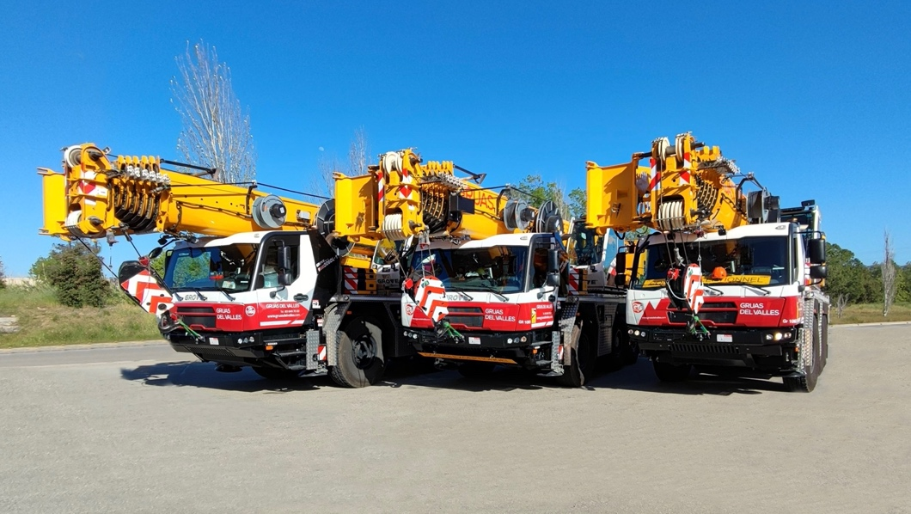

“Grúas del Vallés’ two new Grove GMK3060L-1 cranes alongside the original unit it purchased in 2022.”

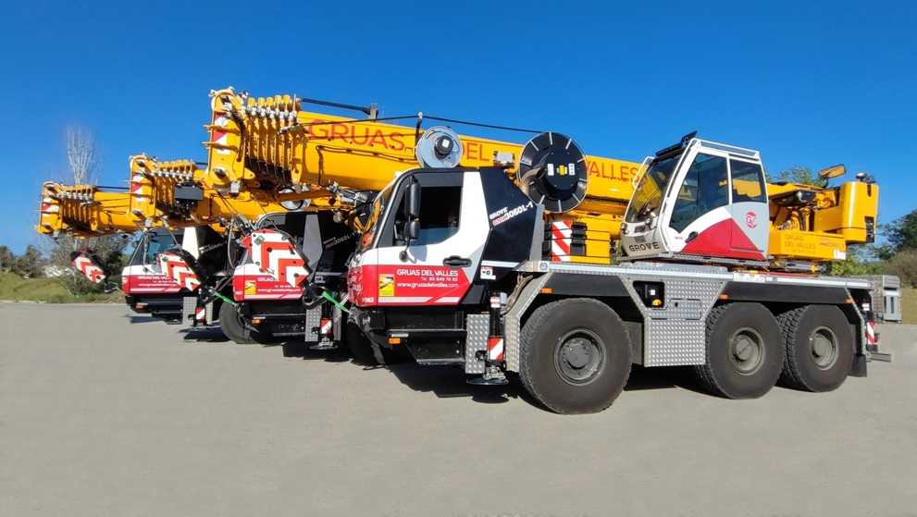

“The company appreciates the GMK3060L-1's compact dimensions, long main boom, and MEGATRAK® suspension system.”

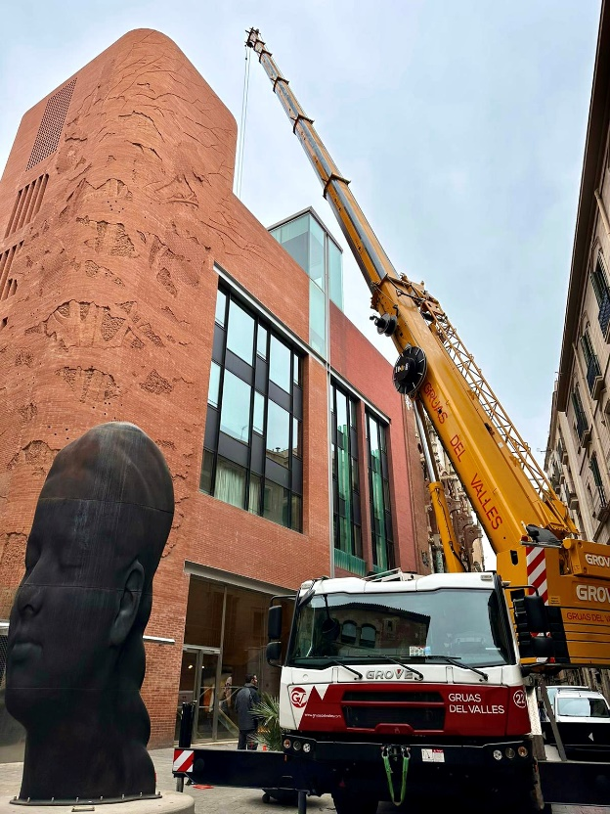

“The company’s first GMK3060L-1 using its compact dimensions to handle maintenance work at the Palau de la Música in Barcelona.”

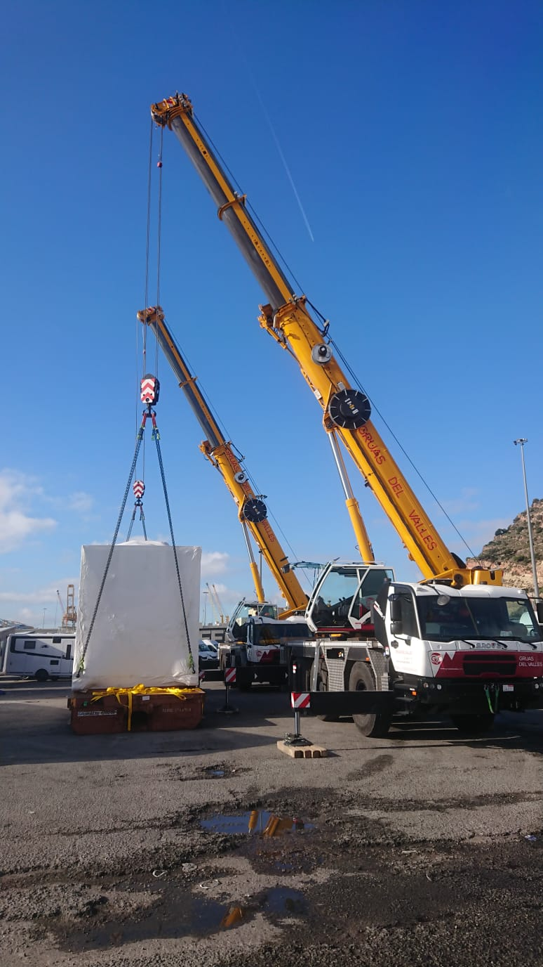

“Grúas del Vallés’ GMK3060L-1 models performing a 35 t tandem lift at Barcelona Port.”

-END-

CONTACT

**Anna Theilen**

Marketing Communication Specialist

Manitowoc

T +49 4421 294 4632

a[nna.theilen@manitowoc.com](mailto:Anna.Theilen@manitowoc.com)

ABOUT THE MANITOWOC COMPANY, INC.

The Manitowoc Company was founded in 1902 and has over a 120-year tradition of providing high-quality, customer-focused products and aftermarket support services to its markets. Manitowoc is one of the world's leading providers of engineered lifting solutions. Manitowoc, through its wholly owned subsidiaries, designs, manufactures, markets, distributes, and supports comprehensive product lines of mobile hydraulic cranes, lattice-boom crawler cranes, boom trucks, and tower cranes under the Aspen Equipment, Grove, Manitowoc, MGX Equipment Services, National Crane, Potain, and Shuttlelift brand names.

THE MANITOWOC COMPANY, INC.

One Park Plaza – 11270 West Park Place – Suite 1000 – Milwaukee, WI 53224, USA

T +1 414 760 4600

[**www.manitowoc.com**](http://www.manitowoccranes.com/)