
PRESS RELEASE

May 20, 2022

Grove and National Crane, two iconic Franklin County brands, celebrate 75th anniversaries

Two iconic brands in the lifting industry, with their home base in Franklin County, are marking significant milestones in 2022. For 75 years Grove and National Crane have consistently delivered lifting innovation that has powered some of the best-selling mobile cranes and boom trucks of all time and provided rewarding careers for generations of employees.

Over 2,600 employees, retirees, and their families celebrated at the Manitowoc Cranes campus in Shady Grove, Pennsylvania, on Saturday, May 14. The event adopted a festival feel, with a showcase of new cranes, live music, kids’ games, historic displays, and factory tours.

“It is a time for celebration of our Grove and National Crane brands, and that strength comes from our people. We’re taking an opportunity to come together and show our appreciation to our employees, and the work we do to deliver the greatest cranes in the world to our customers,” said Dave Hull, general manager, North America mobile cranes.

Grove was launched in 1947 in a garage in Shady Grove. The Grove brothers — John and Dwight, and Wayne Nicarry — were building farm wagons when they realized they needed a more efficient way to move raw materials. John designed a rudimentary rubber-tired crane, giving birth to the first Grove mobile crane. In time he would manufacture the first mobile, hydraulic industrial cranes, and Grove would transition from a farm machine company to a crane company. Today, Grove is one of the world’s most recognized crane brands, with operations around the world.

National Crane was founded in 1947. The company’s first product was agricultural weed sprayers, but in 1963 it changed its name to National Crane Corp., to reflect its expansion into boom trucks. Grove Manufacturing acquired the company in 1978. For decades the National Crane brand has been synonymous with boom trucks, and it remains the market leader.

Both brands became part of The Manitowoc Company, Inc., in 2002. Manitowoc is perennially ranked as one of the top manufacturing employers in the region. The Shady Grove factory produces Grove and National Crane rough-terrain, truck cranes, industrial cranes, and boom trucks. The full line of Manitowoc crawler cranes is also built at the site. In addition to the U.S., Grove crane production facilities are located in Wilhelmshaven, Germany, and Niella Tanaro, Italy.

View the highlights reel from the Employee Open House.

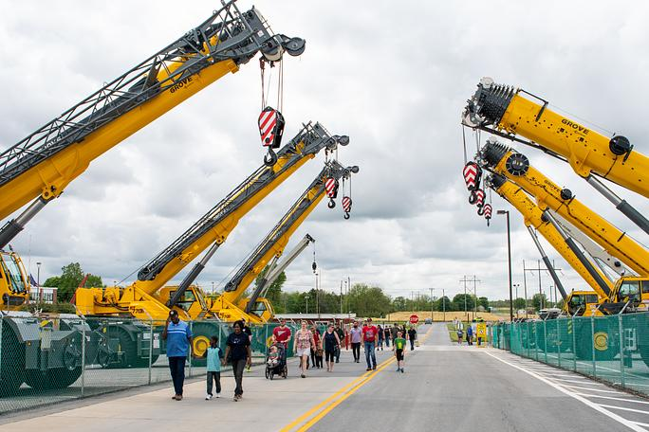

Photo caption 01:
Over 2,600 Manitowoc Cranes employees, retirees, and their families attended the open house on May 14 in Shady Grove, Pennsylvania.
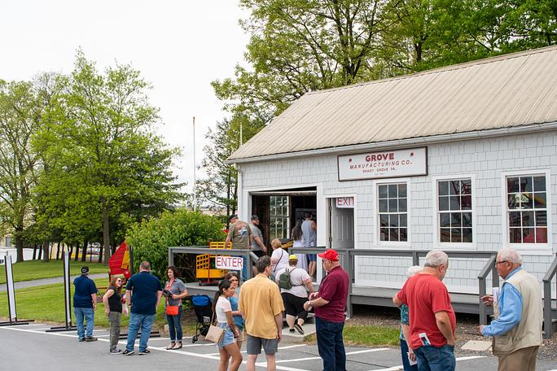
Photo 02:
The Grove Museum is the original garage where brothers Dwight and John L. Grove, along with partner Wayne Nicarry, began Grove Manufacturing in 1947. It has been relocated to the Manitowoc Cranes campus in Shady Grove.

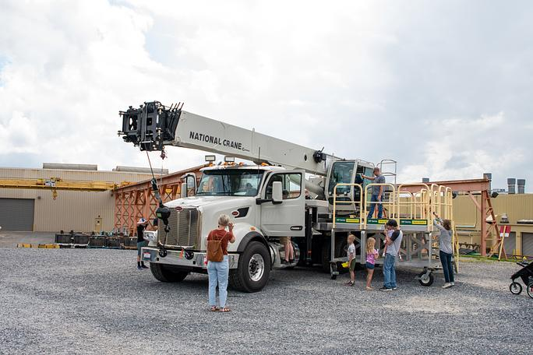

Photo 03:
Cranes produced at the factory, such as this National Crane boom truck, were on display.


Photo 04:
The open house had activities for all ages.

-END-

CONTACT
Amy Crouse
Manitowoc
T +1 717 593 5960
amy.crouse@manitowoc.com

ABOUT THE MANITOWOC COMPANY, INC.
The Manitowoc Company, Inc. was founded in 1902 and has over a 119-year tradition of providing high-quality, customer-focused products and support services to its markets. Manitowoc is one of the world's leading providers of engineered lifting solutions. Manitowoc, through its wholly-owned subsidiaries, designs, manufactures, markets, and supports comprehensive product lines of mobile hydraulic cranes, lattice-boom crawler cranes, boom trucks, and tower cranes, under the Aspen Equipment, Grove, Manitowoc, MGX Equipment Services, National Crane, Potain, and Shuttlelift brand names.

THE MANITOWOC COMPANY, INC.
One Park Plaza – 11270 West Park Place – Suite 1000 – Milwaukee, WI 53224, USA
T +1 414 760 4600
www.manitowoc.com

