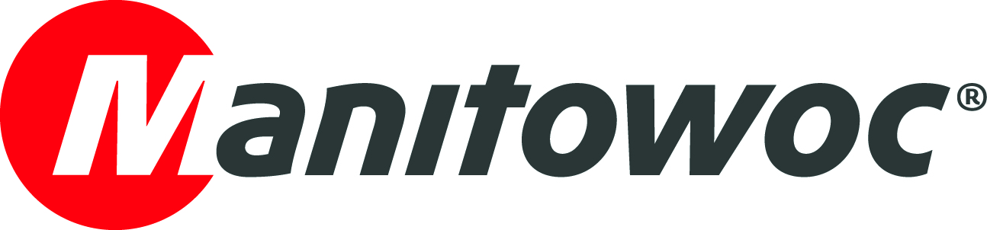
NEWS RELEASE

October 24, 2022

Potain unveils first in new generation of luffing jib tower cranes at bauma 2022

- Manitowoc launched the MR 229 at bauma 2022, the first of a new generation of Potain luffing jib tower cranes.
- The Potain MR 229 is the first luffing jib crane to feature Manitowoc’s CCS (Crane Control System) and the new Potain CONNECTTM telematics offering.
- The design of the 14 t capacity crane facilitates easy installation on confined jobsites and delivers productive performance.

Visitors to bauma 2022 saw the design and technology upgrades that will roll out to the Potain range of luffing jib tower cranes as Manitowoc introduced the first in a new generation, the MR 229. The new MR 229 is the first Potain luffing jib crane to feature Manitowoc’s Crane Control System (CCS), the popular control command system that already features on all Potain hammerhead cranes.

Compliant with the latest and upcoming standards, CCS maximizes lifting performance, increases flexibility on the jobsite, improves ergonomics for the crane operator, and decreases commissioning times. Its features include the ability to activate Potain Plus quickly and easily from the cab via joystick control. Potain Plus is the Company’s technology that maximizes load curves for cranes while optimizing lift speeds, delivering unbeatable productivity.

In addition, the Potain MR 229 is the first luffing jib crane from the company to come equipped with the new Potain CONNECTTM telematics system. This user-friendly, intuitive solution gives owners greater control and insight into their cranes, offering seamless integration of remote diagnostics, advanced analytics, and fleet management to boost uptime and machine utilization.

Easiest installation to date

Assembling the crane on-site has been streamlined, with the MR 229 offering reduced windvane spans for easier installation on constrained jobsites. The out-of-service radius is between 10 and 12 m, approximately 5 to 10 m less than equivalent cranes in this category. There’s also a new design for the luffing mechanism for improved assembly while an integrated basket is built-in to the jib end, for more secure installation, inspection, and maintenance. Once assembled, maximum capacity for the new crane is 14 t and it can be fitted with up to 55 m of jib. The crane offers excellent strength along the load chart and at its 55 m jib end has a capacity of 2.7 t. Lifting power comes from a choice of hoists, including the 110 HPL 35 from the High-Performance Lifting range, capable of reaching speeds of up to 207 m/minute.

Operator productivity is a key focus, with the proven and popular Ultra View cab offering panoramic visibility and exceptional comfort. Its ergonomic design reduces operator fatigue, allowing optimal productivity on the jobsite. From the seat, all controls are accessible directly from the joysticks for minimum effort, with the jog dial allowing easy navigation and menu selection from the CCS screen.

For operations requiring closer control, the speed limiter gives increased precision by recalibrating controls so bigger joystick movements deliver restricted responses from the mechanisms. The speed limiter can be adjusted in increments of 25% and is a great feature for operations where high accuracy is required. Operators can also customize the controls to their own liking, setting pre-defined speeds and dynamism of movements to suit their preferences.

“We are excited to bring this first model in the new generation of Potain luffing jib cranes to market, offering customers the benefits of greater performance, efficiency, and flexibility. It is a preview of many more great things to come from our Potain line of luffing jib cranes,” said Thibaut Le Besnerais, vice president for brand and product management, tower cranes, at Manitowoc.

Visit the Manitowoc website to learn more about the Potain MR 229 luffing jib crane.

-END-

CONTACT
Dominique Leullier
Marketing Director Europe
Manitowoc
+ 33 4 72 18 21 60
dominique.leullier@manitowoc.com

ABOUT THE MANITOWOC COMPANY, INC.
The Manitowoc Company, Inc. was founded in 1902 and has over a 120-year tradition of providing high-quality, customer-focused products and support services to its markets. Manitowoc is one of the world's leading providers of engineered lifting solutions. Manitowoc, through its wholly-owned subsidiaries, designs, manufactures, markets, and supports comprehensive product lines of mobile hydraulic cranes, lattice-boom crawler cranes, boom trucks, and tower cranes under the Aspen Equipment, Grove, Manitowoc, MGX Equipment Services, National Crane, Potain, and Shuttlelift brand names.

THE MANITOWOC COMPANY, INC.
One Park Plaza — 11270 West Park Place — Suite 1000 — Milwaukee, WI 53224, USA
T +1 414 760 4600
www.manitowoc.com

