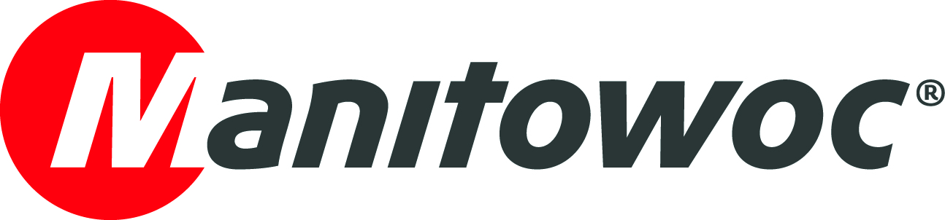
NEWS RELEASE

March 16, 2022

Three Grove GMK3060L-1 and one GMK5150L-1 all-terrain crane for French transport specialist Groupe Cayon

- Longstanding Manitowoc customer Groupe Cayon from Chalon-sur-Saône in France received three new Grove GMK3060L-1 all-terrain cranes and one GMK5150L-1 for its growing fleet of cranes in 2021 and 2022.
- Groupe Cayon chose the compact 60 t Grove all-terrain cranes for their long boom and strong taxi load charts, and the 150 t Grove taxi crane for erecting tower cranes.
- The company’s previous experience with the Grove brand, including its innovative technology, reliable designs and responsive service support, gave Groupe Cayon the trust and confidence to place an order for the new all-terrain cranes.

French transport specialist Groupe Cayon took delivery of three new 60 t capacity Grove GMK3060L-1 all-terrain cranes in 2021 and one GMK5150L-1 in February 2022.

“The compact size, long boom and strong load charts on the GMK3060L-1 are perfect for our fleet and will help us improve our productivity,” said Julien Cayon, director of Groupe Cayon.

“When choosing a new model for our fleet, it was also important to select a mobile crane that complies with road regulations and travels well between jobsites. We were very impressed by the new carrier cab design on the GMK3060L-1, which will make travel more comfortable for the operators,” he continued.

The three-axle GMK3060L-1 features the newly designed Grove carrier cab on its compact 8.67 m long carrier, while offering strong lifting capacities and long reach from its 48 m seven-section MEGAFORM boom. Because its load charts start at a 0° boom angle, the GMK3060L-1 can be operated on many different jobsites, including indoors. It can drive with up to 7.5 t counterweight within 12 t per axle, making the 60 tonner the best three-axle taxi crane on the market.

Groupe Cayon also received a new Grove GMK5150L-1 at the beginning of 2022. The five-axle GMK5150L-1 can lift up to 11.8 t on the 60 m main boom and offers ample space for the operator in the new Grove carrier cab. The 150 t capacity crane has a maximum counterweight of 44.5 t and can travel with 10.2 t of counterweight within a 12 t per axle configuration. As a result, the GMK5150L-1 can be optimally utilized as a taxi crane and, with its compact dimensions, can access even tight jobsites.

“The new Grove GMK5150L-1 is perfect for erecting tower cranes and will help us to expand our business in this respect,” Julien Cayon said.

All four new Grove cranes will be used in jobs in and around Lyon in France.

A decade of trust

Groupe Cayon has been a Grove customer for over 10 years, which gave the company the trust and confidence to place an order for the new all-terrain cranes.

Jean-Paul Cayon, chairman of Groupe Cayon, said: “Grove has a good reputation in terms of compactness and carrier design – and the new GMK3060L-1 cranes are easier and more comfortable to use than ever before. Everything has been improved.”

“Over the years, we have also had a great experience with the technological innovations, the reliability of the machines and the quality of the Grove aftersales service,” he continued.

Grove takes pride in the quality of its aftermarket support with quick and reliable service available all over France. The European parts depot is also based near Lyon, not far from Groupe Cayon’s headquarters in Chalon-sur-Saône.

Groupe Cayon was founded in 1925 and offers a wide variety of industrial transport, handling and lift services. The company employs 700 people and operates a fleet of almost 1,400 vehicles, including 25 cranes.

To learn more about the Grove GMK3060L-1 and GMK5150L-1 all-terrain cranes, please visit the Manitowoc website.

-END-

CONTACT
Insa Heim
Marketing Communication Manager | Mobile Cranes Europe & Africa
Manitowoc
T +49 4421 294 4170
insa.heim@manitowoc.com

ABOUT THE MANITOWOC COMPANY, INC.
The Manitowoc Company, Inc. was founded in 1902 and has over a 118-year tradition of providing high-quality, customer-focused products and support services to its markets. Manitowoc is one of the world's leading providers of engineered lifting solutions. Manitowoc, through its wholly-owned subsidiaries, designs, manufactures, markets, and supports comprehensive product lines of mobile hydraulic cranes, lattice-boom crawler cranes, boom trucks, and tower cranes under the Aspen Equipment, Grove, Manitowoc, MGX Equipment Services, National Crane, Potain, and Shuttlelift brand names.

THE MANITOWOC COMPANY, INC.
One Park Plaza — 11270 West Park Place — Suite 1000 — Milwaukee, WI 53224, USA
T +1 414 760 4600
www.manitowoc.com

