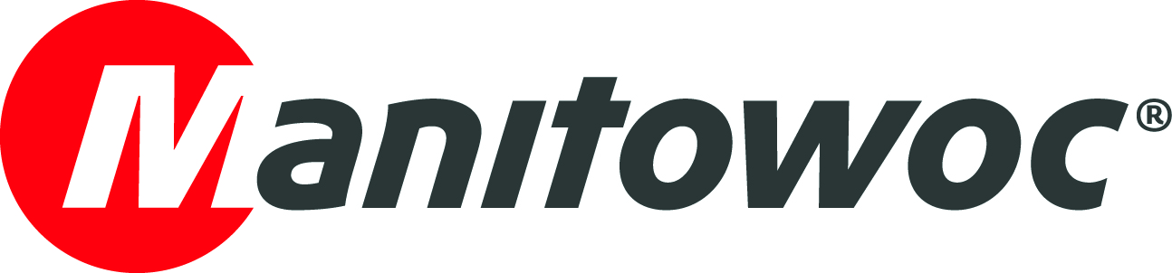
NEWS RELEASE

February 28, 2022

French rental company Mediaco places 10 mobile crane order with Grove

- Marseille-headquartered Mediaco is renewing its fleet with seven GMK3060L-1 all-terrain cranes, two GMK5150L-1 all-terrain cranes and one RT550E rough-terrain crane from Grove. All were chosen for their compact size, long booms and strong load charts.
- The leading French crane rental company purchased its first Grove crane in 1972 and has remained a loyal customer ever since, praising the reliability and innovative technology of Grove cranes, as well as the excellent service support.
- Mediaco was impressed with the improved comfort, ease of use and smooth operation of the new cranes.

Mediaco has signed a deal with Manitowoc for 10 Grove mobile cranes to renew its fleet. Since most of the French crane specialist’s rental activities are for three- and four-axle models, the company led the order with seven GMK3060L-1 60 t capacity three-axle all-terrain cranes.

With a maximum chassis length of 8.67 m, the GMK3060L-1 is extremely compact, but it also offers strong load charts. This means it can often complete the work of a larger crane using its 48 m seven-section MEGAFORM boom. It can drive with up to 7.5 t counterweight within 12 t per axle and offers a spacious and comfortable ride from the new Grove carrier cab.

Mediaco also ordered two GMK5150L-1 all-terrain cranes, which also feature the new Grove carrier cab. The GMK5150L-1 is a 150 t capacity five-axle crane that can lift up to 11.8 t at 20 m on the 60 m main boom. It has a maximum counterweight of 44.5 t and can travel with 10.2 t of counterweight within a 12 t per axle configuration.

Finally, Mediaco purchased a new RT550E rough-terrain crane, which offers the greatest strength and the longest boom (48.8 m) in the 50 t class. Its compact size makes it easy to transport and ideal for congested jobsites where long reach is needed.

“We chose these models for their compact size, long booms and best-in-class taxi and maxi load charts. They are also comfortable and easy to use, which makes life easier for our operators, who arrive on the job feeling relaxed and are able to work efficiently and productively,” said Alexandre Vernazza, CEO at Mediaco Group.

50 years of partnership

Mediaco was founded by Christian Jacques Vernazza in Marseille in 1972. That same year, the company purchased its first ever Grove crane, a TM800, which was the world’s most powerful telescopic boom crane at the time. Today, the company operates a fleet of 800 cranes, ranging from 35 to 1,200 t, which it provides through a network of 80 agencies across France. With 2,000 employees, Mediaco is the largest crane rental company in France and the third largest in Europe.

Throughout its history, Mediaco has been a loyal customer of Manitowoc and Grove, counting on the manufacturer’s reliable design, innovative technology and industry-leading aftermarket support.

“The positive experiences we have had with Grove over many years gave us the trust and confidence to place this latest order. The cranes are always well designed and built and have modern technology to increase reliability and productivity on the jobsite. Also, we have always been pleased with the high-quality aftermarket support we get from Grove. Any potential issues with the cranes are quickly resolved,” Mr Vernazza explained.

Grove takes pride in the quality of its aftermarket support and offers responsive service from highly trained technicians all over France, as well as the European parts depot near Lyon.

“We appreciate that Grove strives for ever greater quality and performance from its cranes and were impressed by the latest improvements, such as the longer booms, stronger load charts, easier operation and more comfortable cabs. We are excited to add the new machines to our fleet,” he concluded.

To find out more about the Grove GMK3060L-1 all-terrain crane, GMK5150L-1 all-terrain crane or RT550E rough-terrain crane, please visit the Manitowoc website.

-END-

CONTACT
Insa Heim
Marketing Communication Manager | Mobile Cranes Europe & Africa
Manitowoc
T +49 4421 294 4170
insa.heim@manitowoc.com

ABOUT THE MANITOWOC COMPANY, INC.
The Manitowoc Company, Inc. was founded in 1902 and has over a 118-year tradition of providing high-quality, customer-focused products and support services to its markets. Manitowoc is one of the world's leading providers of engineered lifting solutions. Manitowoc, through its wholly-owned subsidiaries, designs, manufactures, markets, and supports comprehensive product lines of mobile hydraulic cranes, lattice-boom crawler cranes, boom trucks, and tower cranes under the Aspen Equipment, Grove, Manitowoc, MGX Equipment Services, National Crane, Potain, and Shuttlelift brand names.

THE MANITOWOC COMPANY, INC.
One Park Plaza — 11270 West Park Place — Suite 1000 — Milwaukee, WI 53224, USA
T +1 414 760 4600
www.manitowoc.com

