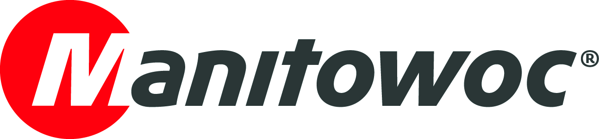
NEWS RELEASE

May XX, 2021

Heavy Equipment Colleges of America chooses Manitowoc cranes to educate the next generation of crane operators

- Amid a nationwide shortage of blue-collar workers, and crane operators in particular, Heavy Equipment College is training new students for a future in the lifting industry.
- The college has chosen several Manitowoc and Grove models to train students on because of their cutting-edge CCS Crane Control Systems and the support of local dealer, H&E Equipment Services.
- In 2021 it is taking delivery of two new Manitowoc MLC100-1 crawler cranes to join its fleet of approximately 15 Manitowoc and Grove cranes.

The U.S. has seen an acute shortage of skilled trades workers over the last 20 years. As boomers retire, there are not enough people from younger generations filling their roles. In 2017 a survey by the Associated General Contractors of America found that 75% of construction companies reported difficulties in filling skilled positions.

Heavy Equipment Colleges of America (HEC) is the only Department of Education accredited school for crane operation and it is reaching out to prospective students to show them that crane operator jobs are high-tech and often quite different than their perception of what the position might entail.

As part of these efforts, HEC purchased two Manitowoc MLC100-1 crawler cranes from H&E Equipment Services for its Stonecrest, Georgia, and Oklahoma City locations. It’s part of the school’s strategy to have its students train on modern cranes that feature the most cutting-edge technology. It’s a timely move — with the introduction of a new infrastructure bill, Georgetown University estimates that 1,624,000 jobs could be created in construction alone. New operators can be trained at HEC in six weeks and 83% of them are successfully placed in jobs.

“The total focus of our business is addressing the skills gap in blue-collar training and placing people in jobs,” said Bob Albano, president and CEO of HEC. “That means having new equipment to train on that will help students gain the best experience. The MLC100-1 units are sophisticated and natural for learning on. We have an instructor with 20 years of experience that says these units are much easier to teach on because they can customize and fine tune the operations to enable students to get used to operating them.”

The MLC100-1 is a 110 USt lattice-boom crawler crane and has 200 ft of main boom. It features self-assembly capabilities and button-style wire rope terminations for quick and easy assembly. A new wide body cab and improved accessibility have increased comfort and ease of maintenance over previous generation crawler cranes.

Cabs like cockpits

Some 60% of HEC’s students are veterans and a majority of the remaining students are millennials and younger. Albano says that operating Manitowoc’s CCS Crane Control System can be similar to operating the military equipment or playing the video games many of them grew up with. Many workers shy away from blue-collar jobs because they think they are dirty or dangerous, which is not an accurate portrait of this industry in 2021.

“The inside of a Manitowoc MLC100-1 cab is like being in a cockpit. It isn’t pulling levers and pulleys like when I started out,” Albano said. “The CCS utilizes computers screens and joysticks. All of our students are in a transitional phase of their lives, and we know that many of them are at home. They are highly connected people and it’s very likely that they are engaged with technology.”

With CCS, all commands are launched from joysticks, and a jog dial provides easy on-screen navigation. The speed limiter function improves control and accuracy by adjusting the speed of all crane movements in 25 percent increments. Operators have the option to customize the speed and dynamic settings of the crane’s movements if they choose. A redundant sensor design continuously monitors and controls all crane movements and structural stresses in real time. This precise information exchange and analysis empowers the operator to maximize lifting capacities and safely increase the pace of work.

H&E Equipment Services, a longtime Manitowoc dealer, suggested the MLC100-1s to HEC to complement its strategic focus on education and new technologies. The two companies have enjoyed a long business relationship and H&E has helped HEC secure some 15 Manitowoc and Grove cranes for its training fleet across six U.S. locations. H&E sent a supervisor to oversee the erection of the first MLC100-1 to ensure there were no issues, and it’s already being used for training.

“We have a great partnership with H&E and we are completely satisfied with the MLC100-1s that they suggested for us,” Albano said. “By investing in these cranes, we are investing in the best technology to train our students on, and that will help us improve the lifting industry for years to come.”

For more information on HEC, click here.
For more information on the MLC-100, click here.

-END-

CONTACT
Chris Bratthauar
Manitowoc
T +1 717 593 5348
chris.bratthauar@manitowoc.com

ABOUT THE MANITOWOC COMPANY, INC.
The Manitowoc Company, Inc. was founded in 1902 and has over a 118-year tradition of providing high-quality, customer-focused products and support services to its markets. Manitowoc is one of the world's leading providers of engineered lifting solutions. Manitowoc, through its wholly-owned subsidiaries, designs, manufactures, markets, and supports comprehensive product lines of mobile telescopic cranes, lattice-boom crawler cranes, boom trucks, tower cranes, and industrial cranes under the Grove, Manitowoc, National Crane, Potain and Shuttlelift brand names.

THE MANITOWOC COMPANY, INC.
One Park Plaza – 11270 West Park Place – Suite 1000 – Milwaukee, WI 53224, USA
T +1 414 760 4600
www.manitowoc.com

