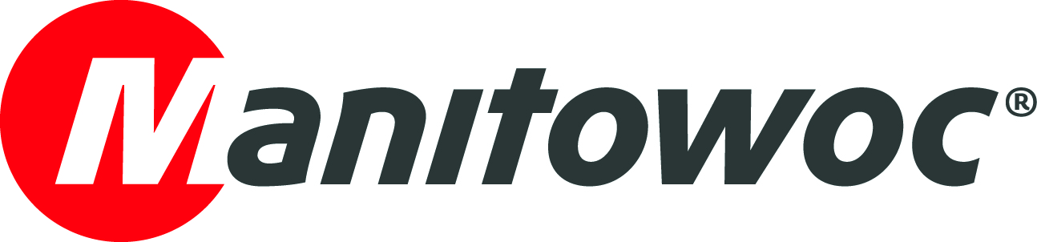
PRESS RELEASE

May 25, 2021

Utah-based Wagstaff Crane acquires Potain self-erecting tower crane dealership Bronson Crane

- Through the Bronson Crane acquisition, Wagstaff Crane will expand its product portfolio with Potain self-erecting cranes and offer NCCCO training and certification.
- Bronson Crane will continue to operate under its name, but the company will now be based out of the Wagstaff facilities in Murray, Utah.

With the acquisition of Utah-native Potain self-erecting tower crane dealer Bronson Crane, lifting specialist Wagstaff Crane is poised to offer an expanded range of services to customers in Utah. The purchase of the self-erecting tower crane specialist sees Wagstaff take over all its assets and business functions, although Bronson Crane will continue to trade under its existing name, and operate from the Wagstaff building in Murray, Utah.

Bronson Crane, which became a Potain dealer in 2008, has been the top self-erecting crane dealer in the U.S. since 2011. Having built up strong relationships with many key contractors over that time, the company now dominates the wood-framing commercial construction and masonry market in the territory. To further serve the area’s lifting needs, the Bronson/Wagstaff team now offers NCCCO training and certification at its premises.

Earl Bronson, the company’s founder, has built Bronson Crane from the ground up over the last two decades, and has been largely responsible for introducing self-erecting cranes to Utah and the surrounding region. He will continue to support the team at Bronson Crane.

“We’re excited to join Wagstaff and look forward to continue to support our customers in their projects,” he said. “We’ve worked hard to build this company over the years and develop this important market. We’re confident we’ll continue to grow with Wagstaff and expand self-erecting crane construction.”

Bronson Crane will be a welcome addition to Wagstaff Crane, its new parent company, where it will slot in perfectly alongside its Manitowoc mobile crane offering.

“For almost 60 years, we've offered the most complete line of hydraulic cranes in the Intermountain West,” said Jim Wagstaff, co-owner of Wagstaff Crane and now Bronson Crane. “In that time, we’ve operated virtually every type of Manitowoc mobile crane there is. Now it’s time to expand our services even further by taking the logical next step and providing Potain’s tower crane offering, too.”

To visit Bronson Crane’s website, click here.

-END-

Photo caption:
From left to right: Ronnie Wagstaff, Jacob Neilson, Kevin Wagstaff, Judd Wagstaff, Whitney Tucker, Jan Bronson, and Earl Bronson. Not pictured: Jim Wagstaff, Ron Wagstaff and James Wagstaff.
CONTACT
Chris Bratthauar
Manitowoc
T +1 717 593 5348
chris.bratthauar@manitowoc.com

ABOUT THE MANITOWOC COMPANY, INC.
The Manitowoc Company, Inc. was founded in 1902 and has over a 118-year tradition of providing high-quality, customer-focused products and support services to its markets. Manitowoc is one of the world's leading providers of engineered lifting solutions. Manitowoc, through its wholly-owned subsidiaries, designs, manufactures, markets, and supports comprehensive product lines of mobile telescopic cranes, lattice-boom crawler cranes, boom trucks, tower cranes, and industrial cranes under the Grove, Manitowoc, National Crane, Potain and Shuttlelift brand names.

THE MANITOWOC COMPANY, INC.
One Park Plaza — 11270 West Park Place — Suite 1000 — Milwaukee, WI 53224, USA
T +1 414 760 4600
www.manitowoc.com

