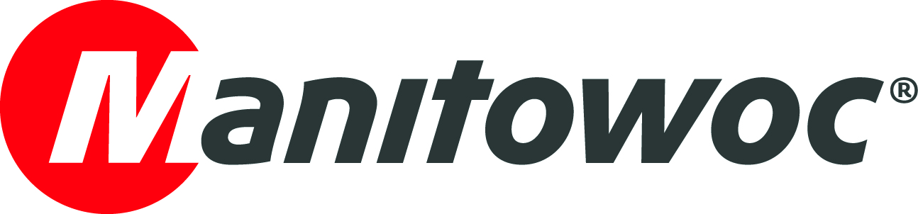
NEWS RELEASE

September 07, 2021

Manitowoc looks forward to meeting customers face to face at Vertikal Days 2021 in the UK

- Manitowoc is excited for the opportunity to discuss customers’ challenges with them in person at the forthcoming Vertikal Days exhibition, held September 22-23 at the East of England Showground in Peterborough, UK.
- At booth no. 106-107, Manitowoc will showcase the new Grove GMK5150L-1 all-terrain crane and the market leading Potain Hup 40-30 self-erecting crane, along with a host of value-adding aftermarket and financing solutions.

Besides the quality, performance and reliability of its cranes, Manitowoc understands the importance of delivering excellent service with a personal touch to earn customers’ trust and confidence. The company is thrilled to be able to meet customers again and have relaxed discussions with them at Vertikal Days 2021.

Taking place September 22-23 at the East of England Showground in Peterborough, the event is the UK and Ireland’s only crane, access and telehandler exhibition – and an important occasion to network with the who’s who of the industry.

“Of course, customers see our sales guys regularly, but they don’t necessarily get the chance that often to have a catch-up with me or our spare parts manager, for example,” said Mr. Kim Dandridge, managing director of Manitowoc UK. “Vertikal Days is a valuable opportunity to discuss with customers the bigger picture of their challenges, strengthen our relationships and demonstrate the ‘yes, we can’ attitude of the whole Manitowoc UK team.”

At the Manitowoc booth (no. 106-107), both sales and service staff will be on hand to offer visitors a warm welcome and talk them through the latest machines and solutions. From the Grove brand, Manitowoc will showcase a new 150 t capacity GMK5150L-1 all-terrain crane with 60 m main boom, kindly loaned by Steve Foster Cranes.

“The Grove GMK5150L-1 is a particularly impressive crane because of the large amount of counterweight it can carry on the road. The machine has a roadable counterweight of 30.9 t, which enables some strong lifts while keeping within the 16.5 t per axle limit,” Dandridge explained. “In addition, customers will have the chance to explore the 150 t Grove all-terrain crane’s new modern carrier cab, which offers increased space as well as added comfort for operators.”

From the Potain brand, Manitowoc will exhibit a Hup 40-30 self-erecting crane, courtesy of City Lifting. This crane offers a 4 t maximum load, 1 t load at a 40 m radius and nine flexible jib configurations with several height modes.

“The Potain Hup 40-30 takes up very little space on the ground, is clean, quiet and has low power requirements. This makes it a convenient alternative on jobsites to telescopic forklifts, which can churn up the ground and have stability issues, punctures and fuel leakages. It also offers great capacity up and over buildings and has the added bonus of being remote controlled,” he said.

More than just machines

In addition to these models, Manitowoc is keen to highlight its aftermarket solutions and financing offer in partnership with DLL (De Lage Landen Leasing) for Grove mobile cranes and BNP Paribas Leasing Solutions for Potain tower cranes.

“Our aftermarket services can help customers get the most value from their cranes, while our finance offer can make the whole process of purchasing equipment much smoother as our financing partners understand our customers’ needs and the value of the equipment down the line. We are looking forward to discussing all this and more when we meet with customers at Vertikal Days,” he concluded.

Visit the Manitowoc website to discover more about the Grove and Potain brands.

-END-

Captions
Image 1 & 2: Grove GMK5150L-1 all-terrain crane.
Image 3: Potain Hup 40-30 self-erecting crane.

CONTACT
Insa Heim
Marketing Communication Manager | Mobile Cranes Europe & Africa
Manitowoc
T +49 4421 294 4170
insa.heim@manitowoc.com

ABOUT THE MANITOWOC COMPANY, INC.
The Manitowoc Company, Inc. was founded in 1902 and has over a 118-year tradition of providing high-quality, customer-focused products and support services to its markets. Manitowoc is one of the world's leading providers of engineered lifting solutions. Manitowoc, through its wholly-owned subsidiaries, designs, manufactures, markets, and supports comprehensive product lines of mobile telescopic cranes, lattice-boom crawler cranes, boom trucks, tower cranes, and industrial cranes under the Grove, Manitowoc, National Crane, Potain and Shuttlelift brand names.

THE MANITOWOC COMPANY, INC.
One Park Plaza — 11270 West Park Place — Suite 1000 — Milwaukee, WI 53224, USA
T +1 414 760 4600
www.manitowoc.com

