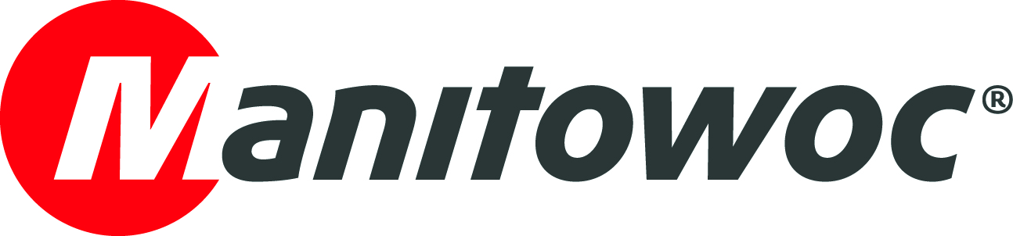
NEWS RELEASE

May 27, 2021

French customers of Vernazza Autogru book new Grove GMK5250XL-1 before it even leaves Manitowoc factory

- Several Vernazza Autogru customers already requested and booked the rental company’s new Grove GMK5250XL-1 all-terrain crane before its official handover at the Manitowoc plant in Niella Tanaro, Italy.
- The highly anticipated five-axle, 250 t capacity crane joined Vernazza Autogru’s French fleet, where its compact design, easy maneuverability and long 78.5 m boom – the longest of all five-axle cranes on the market – will enable it to efficiently complete a broad range of jobs.
- Vernazza Autogru has counted on Manitowoc’s reliable technical support since the company purchased its first Grove crane in 2001, praising the responsiveness and professionalism of the Manitowoc teams in Wilhelmshaven, Germany, and Niella Tanaro, Italy.

Representatives from crane rental company Vernazza Autogru recently attended a handover ceremony at the Manitowoc Niella Tanaro plant in Italy to receive a new Grove GMK5250XL-1 – one of the first units sold in Italy.

Vernazza Autogru is a longstanding Manitowoc customer, having purchased its first Grove crane – a 40 t GMK2035 model – in 2001. With the new GMK5250XL-1, the company’s fleet now counts a total of eight all-terrain and three rough-terrain cranes from Grove with capacities ranging between 35 t and 450 t.

Its latest addition, the GMK5250XL-1, is a five-axle all-terrain crane with a 78.5 m main boom and 250 t capacity. It was purchased to support the company’s French operations, which are managed by Paolo Delfino, director general of Vernazza SAS (France).

Vernazza Autogru’s general manager, Diego Vernazza, first became interested in the GMK5250XL-1 during its launch at Bauma Munich in 2019. The impressive length of the extended seven section TWIN-LOCK boom, the independent MEGATRAK suspension with steer by wire system, compact dimensions, easy transport and extreme versatility made a strong and lasting impression on him.

“We were immediately attracted by the GMK5250XL-1,” Diego Vernazza said. “And I guess we were not the only ones because many of our specialized customers, as soon as they learned about our purchase decision, already requested and booked this crane for their projects – even before the all-terrain crane's delivery.”

“Such a telescopic mobile crane in this category with a 78.5 m boom presents an extraordinary resource for us,” he continued. “We can count on the compactness of a five-axle carrier paired with the boom length which is typical for a six-axle crane.”

Increased jobsite possibilities
Vernazza Autogru deploys mobile cranes in France across various sectors and the new Grove GMK5250XL-1 will broaden the range of jobs the company is equipped to complete.

“The additional 10.5 m of boom compared to the 220 t Grove model we already have in our fleet will increase our working possibilities, for example, in port area operations and in the maintenance or outfitting of ships, as well as in the nuclear energy field, construction and industry,” explained Paolo Delfino.

“The set-up possibilities have also increased compared to the past and in many cases, we do not need to use the jib because of the length and strength of the main boom. In addition, it is important to consider that often a second winch is required and in these cases the bi-fold swingaway, with 3.8 m integrated two sheave heavy duty jib, is an ideal solution for two hook operation!” Delfino added.

In all Vernazza Autogru’s years working with Grove cranes, Manitowoc’s Italian operations in Niella Tanaro have proved a center of excellence for service, maintenance and technical support.

“We can communicate perfectly with the team and appreciate the way they take care of any issues in real time, reacting immediately and at any time. The availability, reliability and professionalism are excellent,” said Massimo Mastrorilli, technical director and purchasing manager at Vernazza Autogru.

Commitment to customer care
Despite challenges caused by the pandemic situation, Manitowoc’s reliable service support has enabled the manufacturer to maintain strong relationships with customers and an enviable market position.

“At such a challenging time for the manufacturing sector, Manitowoc is looking after its customers and delivering excellent results,” said Giorgio Angelino, senior vice president for mobile cranes in Europe and managing director of Manitowoc in Italy. “We are growing very well in the Italian market, and in particular, we have focused on customer care over the years. For us, this is key to technical and commercial growth and it is paying off. The loyalty of influential players such as Vernazza Autogru is substantial. Here in Niella Tanaro, our people, technical expertise and good customer relationships are what make the difference. All in all, I want to thank the whole Vernazza Autogru team for their trust in Grove and our continued business over the last 20 years in Italy, France and beyond,” he concluded.

Visit the Manitowoc website to discover more about the Grove GMK5250XL-1 all-terrain crane.

-END-

Captions

Image 1: Roberto Zucchi, sales area manager for mobile cranes at Manitowoc; Giorgio Angelino, senior vice president mobile cranes Europe at Manitowoc; Massimo Mastrorilli, technical director and purchasing manager at Vernazza Autogru; Diego Vernazza, general manager of Vernazza Autogru; Paolo Delfino; director general of Vernazza SAS (France); Matteo Camilla, technical service manager at Manitowoc; and Matteo Bagnasco, engineer at Vernazza Autogru.

Image 2: Vernazza Autogru’s new Grove GMK5250XL-1 all-terrain crane.

Image 3: Vernazza Autogru’s new Grove GMK5250XL-1 installing an air conditioning system at the IKEA store in Genova.

Image 4: Vernazza Autogru’s new Grove GMK5250XL-1 installing a sewerage pipe in Omegna.

Image 5: Vernazza Autogru’s new Grove GMK5250XL-1 lifting a 32 t bridge in Varese Ligure.

CONTACT
Insa Heim
Marketing Communication Manager | Mobile Cranes Europe & Africa
Manitowoc
T +49 4421 294 4170
insa.heim@manitowoc.com

ABOUT THE MANITOWOC COMPANY, INC.
The Manitowoc Company, Inc. was founded in 1902 and has over a 118-year tradition of providing high-quality, customer-focused products and support services to its markets. Manitowoc is one of the world's leading providers of engineered lifting solutions. Manitowoc, through its wholly-owned subsidiaries, designs, manufactures, markets, and supports comprehensive product lines of mobile telescopic cranes, lattice-boom crawler cranes, boom trucks, tower cranes, and industrial cranes under the Grove, Manitowoc, National Crane, Potain and Shuttlelift brand names.

THE MANITOWOC COMPANY, INC.
One Park Plaza — 11270 West Park Place — Suite 1000 — Milwaukee, WI 53224, USA
T +1 414 760 4600
www.manitowoc.com

