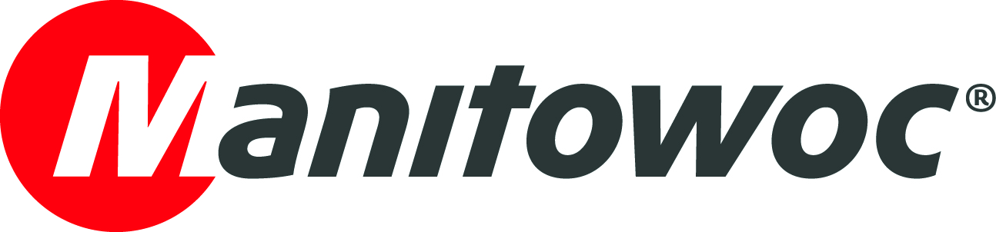
NEWS RELEASE

June 29, 2021

Germany’s first Grove GMK3060L-1 with new carrier cab goes to Arbeitsbühnen Gagarin

- Arbeitsbühnen Gagarin has taken delivery of the first GMK3060L-1 in Germany with the new generation of Grove carrier cabs.
- The ergonomic layout of the controls makes the carrier cab a pleasant work environment that Arbeitsbühnen Gagarin’s crane operators will not want to go without.
- Reasons for deciding to purchase the GMK3060L-1 include, above all, the 48 m long main boom, the company’s long association with the Grove brand and its extraordinary experience with Grove service and support.

In mid-May 2021, Arbeitsbühnen Gagarin strengthened its fleet with Germany’s first Grove GMK3060L-1 with the new carrier cab. The company already has a Grove GMK3055 and GMK4100L-1, with the new 60-tonner from Grove now completing the trio.

The latest generation of Grove carrier cabs was officially launched for three-axle Grove all-terrain cranes at the end of last year. The modern design makes the carrier cab a real eye-catcher. Inside, it provides an ergonomic, comfortable and user-friendly work environment. The Arbeitsbühnen Gagarin team was already thoroughly thrilled by the new carrier cab during the handover at the Manitowoc factory in Wilhelmshaven.

“The new carrier cab makes the 60-tonner from Grove look like a big crane and when you sit inside you get a real feeling of space,” said Alex Gagarin, managing director and owner of Arbeitsbühnen Gagarin. “I noticed straight away that the cab of the GMK3060L-1 is extremely quiet compared to other cranes. So my crane operators will definitely arrive at the jobsite relaxed.”

As well as providing high levels of comfort, the new carrier cab also meets the latest European crash test regulations according to ECE R29-3. The exterior is characterized by dynamic lines and its modern design makes a lasting impression. With a width of 2.55 m, the carrier cab perfectly fits the overall compact dimensions of the GMK3060L-1.

“The controls inside the new Grove carrier cab are clearly arranged and easy to reach,” said Stefan Hufgart, crane operator at Arbeitsbühnen Gagarin, of the new GMK3060L-1. “In our job, we spend a lot of time in the carrier cab – especially in a crane such as our new 60-tonner, which we will use as a taxi crane for working on multiple jobsites a day and driving from one task to the next. With the new GMK3060L-1, I can get to the next jobsite in comfort.”

The GMK3060L-1 combines compact dimensions with strong lifting capacities and long reach, thanks to the 48 m long, seven-section MEGAFORM boom. Arbeitsbühnen Gagarin’s new GMK3060L-1 was equipped with several options to increase operator comfort and productivity. With its additional 8 m long swingaway jib the Grove all-terrain crane can reach over obstacles easily. In addition, the BirdView system improves the operator’s all-round visibility when driving and a boom head camera is especially helpful when lifting loads indoors and in halls. The GMK3060L-1’s load charts that start at 0 degree boom angle are also extremely useful in these applications. The large storage space with three storage boxes on the crane itself and the large storage compartment in the vehicle frame, which allows all sorts of crane accessories to be brought along without issue, have also received particularly positive feedback.

“We are delighted that Arbeitsbühnen Gagarin has chosen another Grove mobile crane and we are grateful for their trust and good cooperation,” said Dieter Popp, sales manager at Manitowoc.

Arbeitsbühnen Gagarin specializes in the rental of mobile cranes, work platforms, forklift trucks and excavators and operates throughout Germany in the System Lift network. With more than 15 years of experience in the industry, the Gagarin team is at the customer’s right hand. Besides the headquarters in Waldaschaff, Lower Franconia, the company has a further facility in Hammersbach. Arbeitsbühnen Gagarin has been a Grove customer ever since the company was founded.

The new carrier cab is available on all three-axle all-terrain cranes from Manitowoc (GMK3050-3, GMK3060-2 and GMK3060L-1). For more information on Grove models, please visit the Manitowoc website.

-END-

Captions
Image 1: Handover of the new Grove GMK3060L-1 to Alex Gagarin, director and owner of Arbeitsbühnen Gagarin (2nd from right) by Dieter Popp, sales manager at Manitowoc (3rd from right). In the photo: (L to R) Uwe Kirchoff, crane handover quality analyst at Manitowoc; Stefan Hufgart, crane operator at Arbeitsbühnen Gagarin; Sven Hoffmann, project leader for the GMK3060L-1 at Manitowoc; Dieter Popp, sales manager at Manitowoc; Alex Gagarin, director and owner of Arbeitsbühnen Gagarin; and Felix Geis, crane operator at Arbeitsbühnen Gagarin.

Image 2: Arbeitsbühnen Gagarin’s new Grove GMK3060L-1 all-terrain crane during the handover at the Manitowoc factory in Wilhelmshaven.

Image 3: Arbeitsbühnen Gagarin’s livery on the new Grove carrier cab.

CONTACT
Insa Heim
Marketing Communication Manager | Mobile Cranes Europe & Africa
Manitowoc
T +49 4421 294 4170
insa.heim@manitowoc.com

ABOUT THE MANITOWOC COMPANY, INC.
The Manitowoc Company, Inc. was founded in 1902 and has over a 118-year tradition of providing high-quality, customer-focused products and support services to its markets. Manitowoc is one of the world's leading providers of engineered lifting solutions. Manitowoc, through its wholly-owned subsidiaries, designs, manufactures, markets, and supports comprehensive product lines of mobile telescopic cranes, lattice-boom crawler cranes, boom trucks, tower cranes, and industrial cranes under the Grove, Manitowoc, National Crane, Potain and Shuttlelift brand names.

THE MANITOWOC COMPANY, INC.
One Park Plaza — 11270 West Park Place — Suite 1000 — Milwaukee, WI 53224, USA
T +1 414 760 4600
www.manitowoc.com

