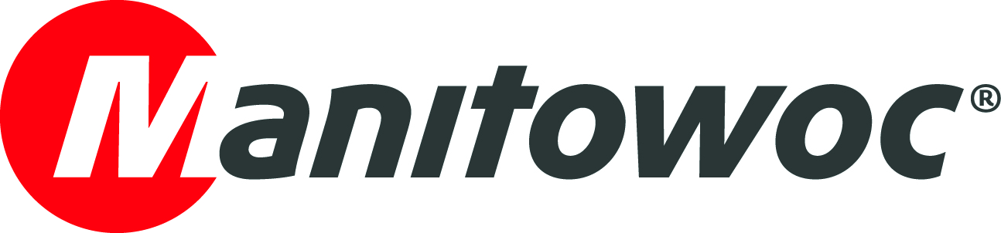
NEWS RELEASE

June 23, 2021

Belgian Potain dealer BLE sells 500th self-erecting crane

- BLE (Belgium Lifting Equipment), which has supplied and serviced Potain self-erecting cranes in Belgium since 2008, has reached a major milestone.
- The Puurs, Flanders-based dealer has sold its 500th self-erecting crane, a Potain Hup 40-30, to AS Bau to be used in structural work and roofing, as well as the installation of facades, exterior carpentry, and other exterior fittings.
- BLE attributes its growth to a focus on outstanding aftersales support and smart partnerships across Belgium, which differentiate it from the competition.

Belgian Potain dealer BLE has sold its 500th self-erecting crane, a Hup 40-30, to AS Bau, based in Rocherath, Wallonia. Owners Andreas and Isabelle Schmitz-Heinrichs founded AS Bau in 2016 and have been customers of Mondia (a company wholly-owned by BLE) almost ever since. They already have two Potain Igo 32 self-erecting cranes in their fleet and will use the new Hup 40-30 for structural work and roofing, as well as the installation of facades, exterior carpentry and other exterior fittings.

BLE marked the milestone with two banners saying ‘I am number 500’ alongside the BLE, Potain, Mondia and AS Bau logos. BLE and AS Bau staff also enjoyed a cake decorated with the number 500 and the company logos.

“Potain self-erecting cranes offer many advantages over other brands – exclusive remote control as standard, a battery charger integrated in the cabinet, automatic lubrication, lubrication points on each pivot, excellent galvanization, cables inside the mast, electrical cabinet heating, engines protected from the elements. The list goes on!” says Bert Pauwels, sales and marketing manager at BLE.

Industry-leading service and footprint

BLE, based in Puurs, Flanders, employs 27 people and has its own facility, technicians, spare parts stock, aftersales team and workshop. The dealer also works with partners across Belgium to offer a rental fleet of around 100 cranes.

Since the company started representing Potain self-erecting cranes in 2008, it has focused on offering quality aftersales service and a large stock of spare parts. BLE has also been flexible towards its customers regarding financing, rental options and trade-ins of old Potain cranes.

“To ensure quick support for our customers, we work with five partners throughout Belgium who transport the machines and provide aftersales service. These partners also move cranes from other brands and when the time comes to replace a crane, they recommend Potain. This way of working has been very successful for us and we have grown together with our partners,” Bert Pauwels explained.

“Unlike in some markets, Belgian contractors like to buy their equipment instead of renting it. Because of this, there is a lot of competition, but importers often stay in their region. By working with partners all over the country, we have a better footprint and a competitive advantage,” he added.

New dealer headquarters

Based on this success, BLE has constructed new headquarters, three times the size of its previous facilities. The new workshop is equipped with four 16 t cranes and two grease pits.

“We needed a lot more space to store, service and repair our cranes so we had to enlarge the workshop a lot. The new facilities also provide a much more comfortable environment for our staff to work in,” Bert Pauwels said.

BLE’s order book continues to be strong and the dealer forecasts yet more growth in 2021.

“There has been a lot of sales activity already this year and the utilization rate of our rental cranes is great. Here’s to further growth and selling our 1,000th crane!” he concluded.

Visit the Manitowoc website to learn more about Potain tower cranes or the BLE website to learn more about the dealer’s operations.

-END-

Captions

Image 1: The 500th Potain self-erecting crane to be sold by BLE, a Hup 40-30, went to AS Bau.
Image 2: The Hup 40-30 arrives at the AS Bau site.
Image 3: The cake enjoyed by the customer and dealer celebrating this milestone.
Image 4: BLE’s future new headquarters.

CONTACT
Dominique Leullier
Marketing Director Europe
Manitowoc
+ 33 4 72 18 21 60
dominique.leullier@manitowoc.com

ABOUT THE MANITOWOC COMPANY, INC.
The Manitowoc Company, Inc. was founded in 1902 and has over a 118-year tradition of providing high-quality, customer-focused products and support services to its markets. Manitowoc is one of the world's leading providers of engineered lifting solutions. Manitowoc, through its wholly-owned subsidiaries, designs, manufactures, markets, and supports comprehensive product lines of mobile telescopic cranes, lattice-boom crawler cranes, boom trucks, tower cranes, and industrial cranes under the Grove, Manitowoc, National Crane, Potain and Shuttlelift brand names.

THE MANITOWOC COMPANY, INC.
One Park Plaza — 11270 West Park Place — Suite 1000 — Milwaukee, WI 53224, USA
T +1 414 760 4600
www.manitowoc.com

