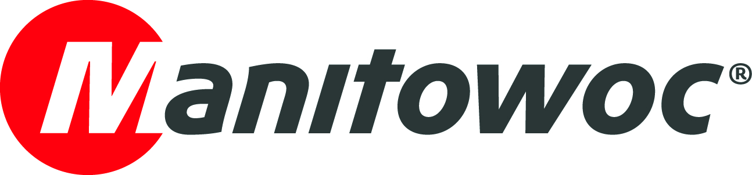
NEWS RELEASE

January 4, 2021

Three Potain cranes keep Warsaw apartment block project on schedule

- Contractor Totalbud S.A is using two Potain MDT 109 top-slewing cranes and one Igo T 70 A self-erecting crane to construct the Oszmiańska 20 apartment complex in Warsaw, Poland, on a tight schedule.
- Totalbud chose the cranes for their reliability, helping to complete the project as quickly as possible and maximize profits.

In August 2020, two Potain MDT 109 top-slewing cranes and one Igo T 70 A self-erecting crane were commissioned to construct the Oszmiańska 20 apartment complex, close to the Targówek Mieszkaniowy metro station in Warsaw, Poland. The complex will consist of two 11-story buildings that house a total of 170 apartments from 35 m² to 107 m² in size, along with six commercial units and an underground parking garage.

The top-slewing cranes were tailored to the needs of the buildings, erected to a height of 47.5 m with a 35 m jib to lift the steel and concrete components. Their impressive technical specifications and slim tower sections make the MDT 109 cranes ideal for confined inner-city construction projects such as this. The Igo T 70 A, meanwhile, offers the high capacity and flexibility required to safely transport materials around the jobsite.

“Potain is a quality brand that we can rely on to help us keep on schedule while completing the work safely and profitably,” said Mariusz Palka, CEO of Totalbud S.A., which purchased the cranes directly from Manitowoc.

The cranes will remain on site until January 2021 when they will be dismantled.

Founded in 2003, Warsaw-based Totalbud specializes in the construction of high-quality residential, office and industrial projects as the general contractor or subcontractor.

Visit the Manitowoc website to learn more about the Potain MDT 109 and Igo T 70.

-END-

CONTACT

Cristelle Lacourt
Marketing Communication Manager | Tower Cranes Europe & Africa
Manitowoc
T +33 472 182 018
cristelle.lacourt@manitowoc.com

ABOUT THE MANITOWOC COMPANY, INC.
The Manitowoc Company, Inc. (“Manitowoc”) was founded in 1902 and has over a 117-year tradition of providing high-quality products and support services that are tailored to customers’ needs. Its 2019 net sales were approximately $1.83 billion. Manitowoc is one of the world's leading providers of engineered lifting solutions. Through its wholly-owned subsidiaries, Manitowoc designs, manufactures, markets and supports comprehensive product lines of mobile telescopic cranes, tower cranes, lattice-boom crawler cranes, boom trucks and industrial cranes under the Grove, Potain, Manitowoc, National Crane, Shuttlelift and Manitowoc Crane Care brand names.

THE MANITOWOC COMPANY, INC.
One Park Plaza — 11270 West Park Place — Suite 1000 — Milwaukee, WI 53224, USA
T +1 414 760 4600
www.manitowoc.com

