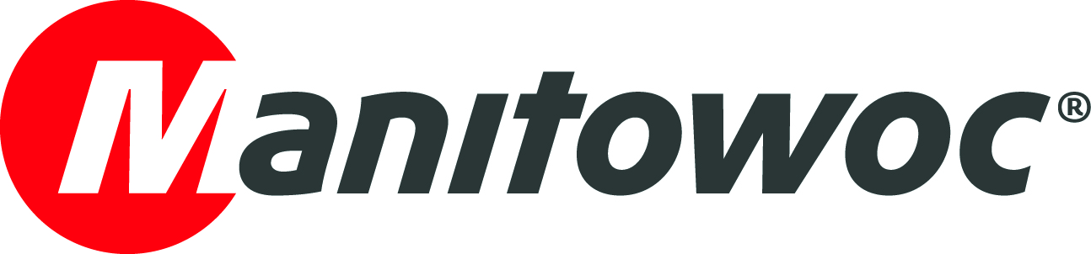
NEWS RELEASE

August XX, 2021

Potain cranes fuel success for Indian real estate developer

- Aparna Constructions and Estates trusts Potain cranes for their reliable performance and excellent return on investment
- The company’s positive results with the hammerhead MCi 85 A gave it the confidence to invest in several units of the successor model, the topless MCT 85.

Real estate developer Aparna Constructions and Estates has been building its fleet of Potain cranes for over a decade, trusting them to lead construction work on a range of residential and commercial projects across Hyderabad, India. Today, Aparna’s fleet consists of 16 topless MCT 85 cranes and four of the MCi 85 A tower cranes. All are from Potain’s top-slewing line that is built locally in Manitowoc’s manufacturing plant in Pune.

Vinay Kumar, executive vice president at Aparna, said the company’s fleet of Potain tower cranes has been central to the company’s ongoing success.

“We are constantly looking to grow our business and our investment in Potain cranes has been a big part in helping us do that,” he said. “They are the backbone of our projects, giving us confidence and providing the performance and reliability we need to keep our projects on track.”

Among the company’s recent projects to feature Potain tower cranes is the high-profile Aparna One development taking shape in one of Hyderabad’s most prestigious locations. Standing at 36 stories, the 145 m building sits at the heart of the fast-developing Shaikpet suburb and has been designed with environmental care at its heart, earning a platinum certification from the Indian Green Building Council (IGBC) thanks to its sustainable architecture.

In recent years Aparna has invested heavily in the Potain MCT 85, a hugely popular model in the India market. With a maximum boom length of 52 m and height under hook of 47.6 m it offers up to 5 t in maximum capacity. It’s a perfect choice for the high-pressure environment of India’s construction industry with easier and faster assembly and disassembly plus a topless design that allows more overlapping of cranes for faster progress. For better control, users also have the option of full variable frequency control on the hoisting, slewing and trolleying mechanisms for smooth and accurate operation.

“We invested in the MCT 85 because the MCi 85 A has always been such a strong performer for us,” said Kumar. “We had confidence in the newer model and when the first units arrived we weren’t disappointed. The cranes’ fast set up, coupled with a long working radius and compact footprint has helped us deliver more urban projects and save costs.”

Aparna Constructions and Estates, part of the Aparna Group, is a real estate owner and developer operating primarily in Hyderabad. The company is particularly strong in the residential construction sector and is regarded as one of the pioneers of gated communities in India.

“We are very proud to have Aparna as our long-time customer and are grateful for our long-standing partnership with such a fantastic company,” said Prashant Suryawanshi, managing director of Manitowoc Cranes India. “Aparna is doing some amazing work in Hyderabad, and we are glad to be playing a part in their growth.”

-END-

CONTACT
Crystal Chi
Manitowoc
T +86 21 6457 0066 *103
crystal.chi@manitowoc.com

ABOUT THE MANITOWOC COMPANY, INC.
The Manitowoc Company, Inc. was founded in 1902 and has over a 118-year tradition of providing high-quality, customer-focused products and support services to its markets. Manitowoc is one of the world's leading providers of engineered lifting solutions. Manitowoc, through its wholly-owned subsidiaries, designs, manufactures, markets, and supports comprehensive product lines of mobile telescopic cranes, lattice-boom crawler cranes, boom trucks, tower cranes, and industrial cranes under the Grove, Manitowoc, National Crane, Potain and Shuttlelift brand names.

THE MANITOWOC COMPANY, INC.
One Park Plaza – 11270 West Park Place – Suite 1000 – Milwaukee, WI 53224, USA
T +1 414 760 4600
www.manitowoc.com

