NEWS RELEASE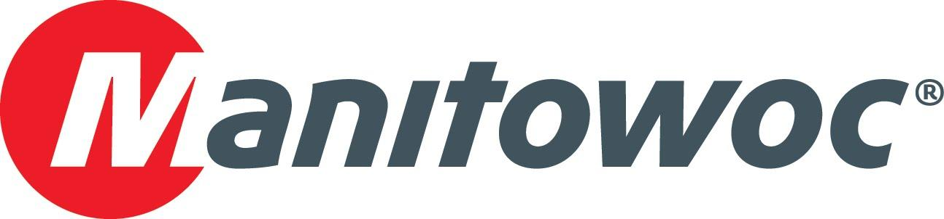

March 10, 2020

**Manitowoc announces new Potain MDT 569 at CONEXPO 2020**

* *The new high-capacity topless crane features industry-leading load charts of up to 35.3 USt (32 t) capacity, easy transport and quick operation.*
* *While the crane isn’t physically displayed at the event, its compact size and speedy assembly are set to impress the lifting world.*

Manitowoc has introduced the new Potain MDT 569, the latest model to join its MDT topless crane range. Designed to be one of Potain’s most high-capacity and versatile cranes, the MDT 569 crane’s modular design features optimized component sizes and weights, facilitating easy transport and assembly. The crane’s impressive load charts, along with its premium technology package, make it an attractive new option for North American customers.

Thibaut Le Besnerais, vice president of global products for tower cranes at Manitowoc, said the MDT 569 combines smart design with above-the-competition performance.

“We have seen strong demand for larger topless cranes in recent years,” he said. “The new MDT 569 topless slewing crane will help meet our customers’ needs for greater capacities, while also preserving the already well-known easy transport, fast assembly and industry-leading performances that our other topless cranes deliver.”

The MDT 569 can lift large loads of material at a time: Options for its maximum hoisting capacities are 22 USt (20 t), 27.6 USt (25 t) and 35.3 USt (32 t), while its maximum jib length is 262 ft (80 m). Tip capacity is up to 4.6 USt (4.2 t) when using the 27.6 USt (25 t) capacity model and working with 262 ft (80 m) jib. Maximum line speed is 640 ft/min (195 m/min) when the crane is equipped with the 150 HPL hoist. The crane can be equipped with a new 26 ft (8 m) cross-shaped base that is simple to assemble and more cost effective compared to previous bases.

The MDT 569 is also more compact for transport than previous cranes, needing only nine standard containers to transport the crane’s upper assembly. The topless design adds flexibility to sites where multiple cranes overfly the construction zone at the same time. Operators will find comfort and efficiency when using Manitowoc’s Crane Control System (CCS), as well as the crane’s ergonomic controls and Ultra View cab. Plans are for the first crane to be shipped in July 2020.

“Our focus is to bring to the market a robust crane in a compact design, offering multiple transportation options without compromising performance,” Le Besnerais said. “In addition, the MDT 569 can be fully assembled and erected in only two days, with time-saving features such as fast jib and counter-jib connections, and an automatic tensioning and slackening system for the trolley rope.”

The new MDT 569 announcement is in addition to the unveiling of the Potain MRH 175 tower crane, a new topless hydraulic luffing jib crane that makes its debut at CONEXPO 2020. The other Potain crane on show is the Hup M 28-22 that was introduced in 2019 and is making its first appearance in North America, complete with a new transport axle for the regional market. Both the Hup M 28-22 and the MRH 175 cranes can be found on the Manitowoc booth, #F6144, in the festival lot, near the corner of Las Vegas Boulevard and Sahara Avenue.

-END-

CONTACT

**Amy Marten**

Manitowoc

T +1 920 683 6345

[amy.marten@manitowoc.com](mailto:amy.marten@manitowoc.com)

ABOUT THE MANITOWOC COMPANY, INC.

The Manitowoc Company, Inc. (“Manitowoc”) was founded in 1902 and has over a 117-year tradition of providing high-quality, customer-focused products and support services to its markets and its 2019 net sales were approximately $1.83 billion. Manitowoc is one of the world's leading providers of engineered lifting solutions. Manitowoc, through its wholly-owned subsidiaries, designs, manufactures, markets, and supports comprehensive product lines of mobile telescopic cranes, tower cranes, lattice-boom crawler cranes, and boom trucks under the Grove, Manitowoc, National Crane, Potain, Shuttlelift and Manitowoc Crane Care brand names.

THE MANITOWOC COMPANY, INC.

One Park Plaza – 11270 West Park Place – Suite 1000 – Milwaukee, WI 53224, USA

T +1 414 760 4600

[**www.manitowoc.com**](http://www.manitowoccranes.com/)