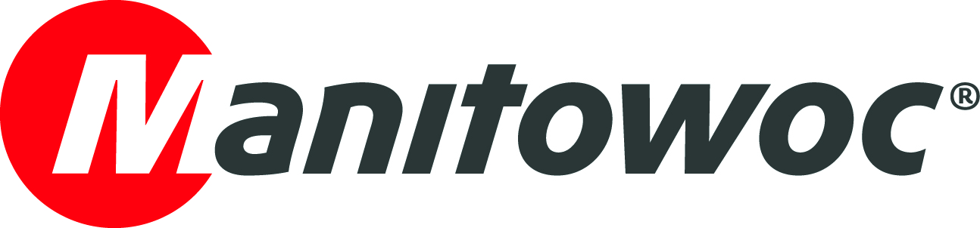
NEWS RELEASE

June 17, 2020

Steenhoff to erect Potain tower cranes with new Grove GMK5250L-1

- German construction equipment rental company Steenhoff GmbH & Co. KG collected its new Grove GMK5250L-1 crane from the Manitowoc factory in Wilhelmshaven, Germany, at the end of May.
- The compact 250 t all-terrain crane won the Steenhoff team over with its high capacity, as well as its sheer versatility in terms of cost-effectiveness, user-friendliness and operator comfort.

At the end of May, Steenhoff GmbH & Co. KG from Rhauderfehn in Ostfriesland, Northern Germany, took ownership of a GMK5250L-1, a strong and versatile five-axle crane from Grove, featuring an impressive 250 t capacity and 70 m long main boom.

The equipment rental company purchased the GMK5250L-1 with a view to replacing its existing Grove GMK5130-2 model.

“Tower cranes have been getting bigger and heavier over the last few years. We’ll be able to get much more use out of our new GMK5250L-1 as we will also be able to use it to erect our large tower cranes. Our largest tower crane at the moment is a Potain MD 569 with an 80 m jib,” explained Martin Steenhoff, managing director of Steenhoff.

“Tower crane components often need to be lifted high up and a long way out. With the high capacity and long reach of our new 250-tonner, this will be a piece of cake.”

The Grove GMK5250L-1 is a lean, mean lifting machine, capable of maneuvering 14.5 t loads within a 22 m radius using its long 70 m main boom. It’s also extremely compact and can comfortably be used on confined job sites thanks to its narrow 7.8 m maximum outrigger width.

“With the new GMK5250L-1 from Grove, we will be more cost-efficient, and up to date with the latest environmental technology,” Martin Steenhoff added.

The GMK5250L-1 is powered by a 530 hp Mercedes engine that meets the latest Euromot 5 emissions standard and consumes up to 30% less fuel than previous generations. The crane is also equipped with a VIAB Turbo Retarder clutch, which offers outstanding maneuverability and operator comfort, as well as enabling wear-free acceleration and braking.

For managing director Christa Steenhoff, the handover of the GMK5250L-1 in Wilhelmshaven was “truly something special” or ‘Heel wat Besünners’ as they say in Ostfriesland.

“It’s not every day you buy such a big machine,” she enthused.

Following the handover, the Steenhoff crane operators received a technical briefing on the mobile crane. They were particularly impressed by the CCS crane control system, which is operated by an intuitive jog-dial button, as well as the boom configurator mode for optimal boom configuration. These features made it easier for them to work it the first time, which was just as well because the GMK5250L-1 went straight to Bremen from the Manitowoc factory for its first job, where it erected a Potain MDT 222 tower crane with 50 m jib — an easy task for the Grove all-terrain crane.

“We are proud that Steenhoff relies on our crane technology from Wilhelmshaven and that the GMK5250L-1 will make their fleet even stronger in the future. We are grateful for the trust they place in us and hope they continue to be busy,” said Holger Haber, area sales manager for Grove mobile cranes in Northern Germany and Scandinavia.

Long-term partnership
Based in Rhauderfehn, Ostfriesland, Germany, Steenhoff was founded in 1973 and focuses primarily on equipment rental and sales. The company offers a range of tower cranes, construction machines and equipment, as well as containers and formwork systems. Steenhoff GmbH & Co. KG employs approximately 110 people, with around half of them involved in the tower crane side of the business. A Potain dealer since 1992, Steenhoff has a close relationship with Manitowoc Cranes and runs some 270 self-erecting and 90 top-slewing cranes from the Potain brand in its rental fleet. The company maintains a further 350 pieces of equipment from other brands.

Visit the Manitowoc website for more information about the Grove GMK5250L-1 all-terrain crane.

-END-

Image captions

Image 1: Martin and Christa Steenhoff from Steenhoff GmbH & Co. KG, along with Holger Haber, area sales manager for Grove mobile cranes in Northern Germany and Scandinavia.

Image 2: The compact and versatile Grove GMK5250L-1 all-terrain crane can lift 14.5 t loads within a 22 m radius using its long 70 m main boom.

Image 3: The Grove GMK5250L-1 prepares to leave the Manitowoc factory in Wilhelmshaven, Germany for its first job erecting a Potain MDT 222 tower crane with 50 m jib in Bremen.

CONTACT
Insa Heim
Marketing Communication Manager | Mobile Cranes Europe & Africa
Manitowoc
T +49 4421 294 4170
insa.heim@manitowoc.com

ABOUT THE MANITOWOC COMPANY, INC.
The Manitowoc Company, Inc. (“Manitowoc”) was founded in 1902 and has over a 117-year tradition of providing high-quality products and support services that are tailored to customers’ needs. Its 2019 net sales were approximately $1.83 billion. Manitowoc is one of the world's leading providers of engineered lifting solutions. Through its wholly-owned subsidiaries, Manitowoc designs, manufactures, markets and supports comprehensive product lines of mobile telescopic cranes, tower cranes, lattice-boom crawler cranes, boom trucks and industrial cranes under the Grove, Potain, Manitowoc, National Crane, Shuttlelift and Manitowoc Crane Care brand names.

THE MANITOWOC COMPANY, INC.
One Park Plaza — 11270 West Park Place — Suite 1000 — Milwaukee, WI 53224, USA
T +1 414 760 4600
www.manitowoc.com

