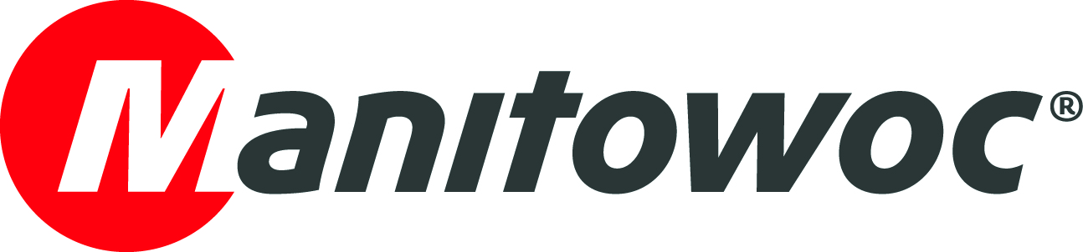
NEWS RELEASE

October 8, 2019

Manitowoc appoints new sales director for Brazil

- Luciano Dias is now directing both sales leadership and customer support on all product lines available in Brazil, as well as the company’s training center in Sao Paulo.
- He has worked for Manitowoc for 12 years and is committed to helping enhance the company’s customer-focused strategy in the Brazilian market.

Manitowoc Cranes has appointed Luciano Dias as the new sales director for Brazil. In this role, Dias is charged with furthering The Manitowoc Way in Brazil, bringing increased velocity and innovation to its operations in the country. He leads both sales and customer support on all of Manitowoc’s product lines available in the country. He is also responsible for Manitowoc’s training center located in Sao Paulo, which serves technicians across Latin America.

The new sales director is no stranger to the Manitowoc team in the South American country – before a recent venture outside of Manitowoc, Dias had worked for the company for 12 years. With 24 years of extensive experience in sales and marketing, Dias will help the company enhance its customer-focused strategy in the Brazilian market, strengthen aftersales service and support efforts and continue to cultivate relationships with dealers and customers.

“It’s great to be back to this innovative company that respects and values the relationship with its customers,” Dias said. “While the Brazilian economy is still recovering, I’m excited about the opportunity to work closely with our customers and demonstrate that our modern, cutting-edge products and services deliver more with less, which is exactly what they are looking for right now.”

Dias will report directly to Vice President South America, Cristian Galaz.

Said Galaz: “We’re excited to welcome Luciano Dias back to Manitowoc Brazil. He is a seasoned, results-oriented professional who has always been committed to helping customers grow their own businesses with support from Manitowoc Cranes.”

-END-

CONTACT
Leandro Moura
Manitowoc
T +55 11 98473-5851
leandro.moura@manitowoc.com

ABOUT THE MANITOWOC COMPANY, INC.
The Manitowoc Company, Inc. (“Manitowoc”) was founded in 1902 and has over a 116-year tradition of providing high-quality, customer-focused products and support services to its markets and its 2018 net sales were approximately $1.8 billion. Manitowoc is one of the world's leading providers of engineered lifting solutions. Manitowoc, through its wholly-owned subsidiaries, designs, manufactures, markets, and supports comprehensive product lines of mobile telescopic cranes, tower cranes, lattice-boom crawler cranes, and boom trucks under the Grove, Manitowoc, National Crane, Potain, Shuttlelift and Manitowoc Crane Care brand names.

THE MANITOWOC COMPANY, INC.
One Park Plaza – 11270 West Park Place – Suite 1000 – Milwaukee, WI 53224, USA
T +1 414 760 4600
www.manitowoc.com

