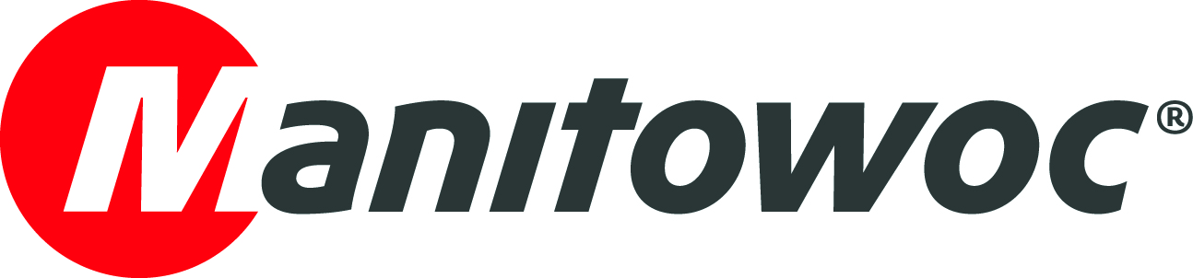
NEWS RELEASE
July 23, 2019

Grove GMK5250L advances crane fleet modernization in Colombia

- Colombian rental company Invertrac purchased the country’s first Grove GMK5250L and immediately enjoyed the higher efficiency its design offers.
- The company also purchased a second long-boom Grove all-terrain crane: a GMK6300L.

Since its arrival in Colombia last year, a Grove GMK5250L all-terrain crane has been kept busy almost continuously. One of the most modern cranes currently in the country, the machine has been used in several applications, especially infrastructure projects and for work in the oil industry. The all-terrain crane provides contractors with cutting-edge technology on the job site and ensures increased velocity and high efficiency in heavy lifting jobs.

After researching the market, Duitama, Colombia-based rental company Invertrac purchased the GMK5250L last year with the aim of bringing a modern addition into the country’s mostly aged crane population. The 250 t capacity crane offers class-leading capabilities, including the best reach and strongest load chart of any five-axle crane. It delivers improved roadability, which is enhanced by its innovative machine design that includes the VIAB turbo clutch. This unique addition improves driving performance and also delivers impressive fuel savings.

“There are only a few cranes in Colombia in this capacity range that could deliver the increased strength and stability we wanted. The GMK5250L is a fantastic machine — its Megatrak suspension performs impressively on rough terrain and it has excellent heavy lifting capacity,” said Alejandro Camacho, project manager for Invertrac. “Colombia really needed a high-tech crane like this. With great roadability and maneuverability, this Grove has also increased our velocity on the job site.”

In addition to the GMK5250L, Invertrac also purchased a Grove GMK6300L, one of the world’s best-selling all-terrain cranes. The 300 t capacity crane features Megatrak suspension, along with Manitowoc’s standard all-wheel steering. The GMK5250L and GMK6300L also share a number of parts and components, which is a great advantage for fleet owners.

“We have unique cranes in our fleet that no one else has in Colombia: versatile, with increased lifting capabilities and new technologies,” Camacho said. “Additionally, we like the great customer support we receive from Manitowoc.”

Currently, the GMK5250L is supporting oil drilling operations in Castilla de la Nueva, in central Colombia. The GMK6300L is helping with the assembly of beam bridges in Bogotá.

The GMK5250L has a main boom length of 70 m and a maximum tip height of 110 m. It is one of the most powerful and versatile five-axle cranes on the market, with the highest-rated capacity and the quickest set-up time in its class. The GMK6300L features a maximum tip height of 120 m when working with its full 80 m main boom and 37 m jib.

-END-

CONTACT
Leandro Moura
Manitowoc
T +55 11 98473-5851
leandro.moura@manitowoc.com

ABOUT THE MANITOWOC COMPANY, INC.
The Manitowoc Company, Inc. (“Manitowoc”) was founded in 1902 and has over a 116-year tradition of providing high-quality, customer-focused products and support services to its markets and its 2018 net sales were approximately $1.8 billion. Manitowoc is one of the world's leading providers of engineered lifting solutions. Manitowoc, through its wholly-owned subsidiaries, designs, manufactures, markets, and supports comprehensive product lines of mobile telescopic cranes, tower cranes, lattice-boom crawler cranes, and boom trucks under the Grove, Manitowoc, National Crane, Potain, Shuttlelift and Manitowoc Crane Care brand names.

THE MANITOWOC COMPANY, INC.
One Park Plaza – 11270 West Park Place – Suite 1000 – Milwaukee, WI 53224, USA
T +1 414 760 4600
www.manitowoc.com

