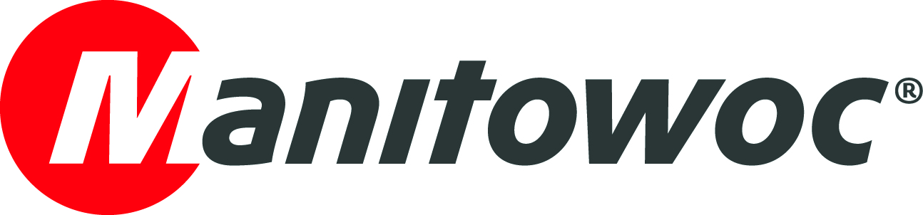
NEWS RELEASE
February xx, 2019

Manitowoc promotes its most innovative technologies at Colombia’s largest infrastructure event

Manitowoc showed its most innovative technologies and modern cranes at the 15th National Congress of Infrastructure in Cartagena, Colombia, the country’s largest infrastructure event. Visitors to Manitowoc’s booth learned about the benefits provided by some of the newest Grove crane models for jobs that require high capacity and compact maneuverability.

Manitowoc’s highlights at the congress were the all-terrain GMK5250L and the rough-terrain GRT8100 cranes, which have recently been purchased by customers in Colombia and are already working on job sites. Both cranes feature the most innovative technologies developed by Manitowoc over the last few years and reflect the latest improvements brought about by the Product Verification Center (PVC), where components are tested far beyond their lifecycle to ensure quality and durability.

The Manitowoc’s on-site team of experts also answered questions and presented cutting-edge products at the congress. They explained details of the MAXbase outrigger technology, which provides easier access to narrow sites while improving load capacities, and talked about the Crane Control System (CCS). With its user-friendly interface, full graphic display and ergonomic controls, CCS enables easier navigation while delivering increased performance.

More than 3,000 people attended the 15th National Congress of Infrastructure in Cartagena, which took place in November.

In 2018, Manitowoc’s experts had an intense agenda and participated in numerous events across Latin America to promote the company’s latest innovations in the construction industry. Many of these new solutions were created based on inputs from customers, in line with The Manitowoc Way.

-END-

CONTACT
Leandro Moura
Manitowoc
T +55 11 3103 0270
leandro.moura@manitowoc.com

ABOUT THE MANITOWOC COMPANY, INC.
Founded in 1902, The Manitowoc Company, Inc. is a leading global manufacturer of cranes and lifting solutions with manufacturing, distribution, and service facilities in 20 countries. In the United States, the Grove, Manitowoc, National Crane, Potain and Shuttlelift brands are sold and serviced by Grove US, LLC, a wholly owned subsidiary of The Manitowoc Company, Inc. In 2018, Manitowoc’s net sales totaled $1.8 billion, with over half generated outside the United States.

THE MANITOWOC COMPANY, INC.
One Park Plaza – 11270 West Park Place – Suite 1000 – Milwaukee, WI 53224, USA
T +1 414 760 4600
www.manitowoc.com

