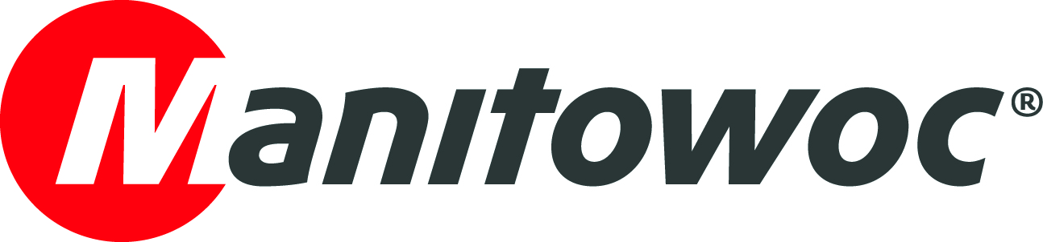
NEWS RELEASE

May 15, 2019

Manitowoc showcases new Potain MRH 125 at Vertikal Days

- The new Potain MRH 125, recently debuted at bauma, has come to Vertikal Days 2019.
- The innovative crane is the first in the European range to combine luffing jib and topless capabilities.
- The crane on the stand is the very first one purchased in Europe by UK rental company Skyline Arcomet (part of UPERIO) due to its superior return on investment.

Manitowoc is exhibiting at Vertikal Days 2019, taking place at Donington Park, UK between 15 and 16 May 2019. Vertikal Days is the largest lifting equipment event for the UK and Ireland and is centered firmly around lifting and access.

The tower crane star of the Manitowoc booth is undoubtedly the new Potain MRH 125, which was recently debuted at bauma 2019. The innovative crane is the first in the European range to combine luffing jib and topless capabilities. It also uses hydraulic power for the luffing movement, for greater efficiency.

Maximum capacity for the crane is 8 t while the maximum jib is 50 m, with a lift capacity of 2 t at the jib end. Users can configure the crane in freestanding heights of up to 57.9 m, while line speeds of up to 118 m/min are available with the 50LVF20 hoist winch.

Optimized for transport, both on and off site

The MRH 125 on display is owned by UK rental company Skyline Arcomet (part of UPERIO), which purchased the crane, and four more, at bauma 2019. Darren Whitford, managing director of Skyline Arcomet, commented on the recent investment.

“We chose the new MRH 125 because it provides a strong return on investment for owners,” he said. “The crane’s adaptable design makes it suitable for all kinds of congested urban job sites, while transport and assembly times have also been optimized. These traits will be greatly appreciated by our customers.”

Just four containers are required to transport the upper portion of the crane, with the counter jib and jib foot traveling as a single package. The unique VVH hydraulic luffing mechanism and cylinders are pre-connected at the factory, meaning no assembly is required on site.

“The MRH 125 has an optimized transport cost for a luffing jib crane in its capacity class,” Thibaut Le Besnerais, Manitowoc’s global product director for tower cranes, said. “It can also be mounted on our standard 1.6 m or 2 m K-masts for better optimization for fleet owners, and it offers lower power consumption than traditional luffing jib crane alternatives.”

Outstanding operating performance

A further advantage over traditional luffing jib cranes is that the hydraulic power of the VVH mechanism means there is no requirement to install luffing rope during installation. The hoisting winch, maintenance derrick and jib wind side plate are also pre-installed. Plus, there is no need to adapt the wind-sail plate on site, no matter what length of jib the crane is erected with.

On-site, the crane delivers outstanding operating performance, no matter how constrained the job site. The jib can be raised from the horizontal to near vertical (88°) in just two minutes, while the counterjib measures just 7 m and is simple to connect during assembly. The out-of-service weathervaning radius of just 10 m, whatever the jib length, adds to its impressive features for tight job sites, while the cab has the option to attach to either side of the mast to suit project conditions.

Also on the stand…

In addition to the Potain MRH 125, Manitowoc is also exhibiting a Grove GMK5250, owned by Southern Cranes & Access, and a Grove RT550E from Manitowoc’s UK rough terrain distributor Crowland Cranes.

Join Manitowoc at stand numbers 114, 115 and 116.

-END-

CONTACT
Cristelle Lacourt
Manitowoc
T +33 472 182 018
cristelle.lacourt@manitowoc.com

ABOUT THE MANITOWOC COMPANY, INC.
Founded in 1902, The Manitowoc Company, Inc. is a leading global manufacturer of cranes and lifting solutions with manufacturing, distribution, and service facilities in 20 countries. In the United States, the Grove, Manitowoc, National Crane, Potain and Shuttlelift brands are sold and serviced by Grove US, LLC, a wholly owned subsidiary of The Manitowoc Company, Inc. In 2018, Manitowoc’s net sales totaled $1.8 billion, with over half generated outside the United States.

THE MANITOWOC COMPANY, INC.
One Park Plaza – 11270 West Park Place – Suite 1000 – Milwaukee, WI 53224, USA
T +1 920 684 4410
www.manitowoc.com

