­ NEWS RELEASE

July 30, 2019

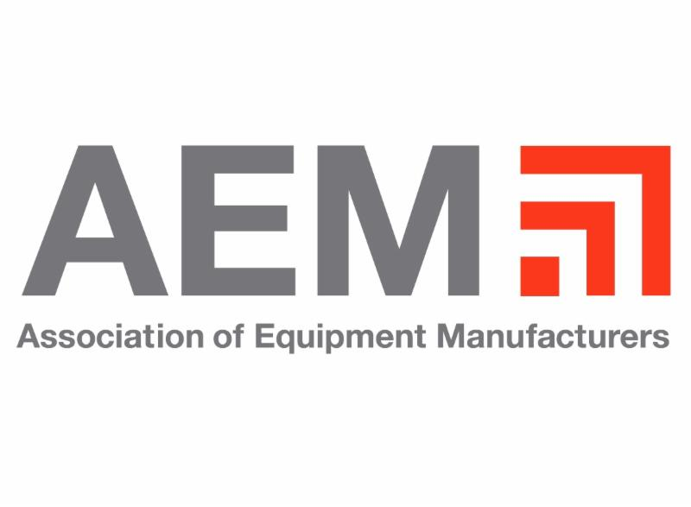

**Vice President Mike Pence to Visit the Manitowoc Company, Inc., Discuss USMCA**

FOR THURSDAY, AUGUST 1 (Washington, D.C) — The Association of Equipment Manufacturers and The Manitowoc Company, Inc., will host the Honorable Mike Pence, Vice President of the United States, at Manitowoc’s Shady Grove facility on Thursday, August 1, to discuss the USMCA and how this new trade deal will benefit Pennsylvania and all of America.

**WHAT**: Remarks by the Honorable Mike Pence, Vice President of the United States

**WHEN**: Thursday, August 1, 2019,

**TIME:** TBA

**WHERE**: The Manitowoc Company, Inc.

1565 Buchanan Trail E

Shady Grove, PA 17256

**Interested press should contact David Ward at 202-256-6180 or dward@aem.org. Media advisory with details and credentialing information to follow.**

The Honorable Mike Pence, Vice President of the United States, will address over 1,000 Manitowoc employees regarding the critical urgency to ratify the United States-Canada-Mexico Agreement (USMCA). Ratifying the USMCA will create jobs, secure access to the equipment manufacturing industry’s two largest export markets, and ensure North America’s manufacturing competitiveness.

Equipment manufacturers support 1.5 million jobs in the US and Canada. Overall, there are 12 million U.S. jobs across the country that are supported by trade with Canada and Mexico. A study by the United States International Trade Commission shows the USMCA would create an additional 176,000 U.S. jobs and add $68 billion to the U.S. economy.

-END-

CONTACT

**David Ward**

AEM

T +1 202-256-6180

[dward@aem.org](mailto:dward@aem.org)

ABOUT THE MANITOWOC COMPANY, INC.

The Manitowoc Company, Inc. (“Manitowoc”) was founded in 1902 and has over a 116-year tradition of providing high-quality, customer-focused products and support services to its markets and its 2018 net sales were approximately $1.8 billion. Manitowoc is one of the world's leading providers of engineered lifting solutions. Manitowoc, through its wholly-owned subsidiaries, designs, manufactures, markets, and supports comprehensive product lines of mobile telescopic cranes, tower cranes, lattice-boom crawler cranes, and boom trucks under the Grove, Manitowoc, National Crane, Potain, Shuttlelift and Manitowoc Crane Care brand names.

Visit www.manitowoccranes.com for more information.

ABOUT AEM

AEM is the North American-based international trade group representing off-road equipment manufacturers and suppliers, with more than 1,000 companies and more than 200 product lines in the agriculture and construction-related industry sectors worldwide. The equipment manufacturing industry supports 1.3 million jobs in the U.S., and 149,000 more in Canada. Equipment manufacturers also contribute $188 billion combined to the U.S. and Canadian economies. AEM is celebrating its 125th anniversary in 2019.

Visit www.aem.org/advocacy for more information.

THE MANITOWOC COMPANY, INC.

One Park Plaza – 11270 West Park Place – Suite 1000 – Milwaukee, WI 53224, USA

T +1 920 684 4410

[**www.manitowoc.com**](http://www.manitowoccranes.com/)**­**