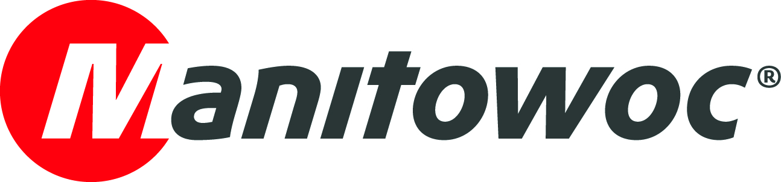
NEWS RELEASE

February 13, 2019

Manitowoc realigns European operations to enhance customer focus

- The realignment sees four members of top management move into new roles
- The changes were made to improve customer focus and accelerate innovation and velocity as part of The Manitowoc Way
- Customers will now benefit from one single customer-facing organization, covering all their needs from sales to product support

Following the example of its Americas and Asia-Pacific regions, Manitowoc is merging parts of its tower and mobile crane businesses in Europe. The two will remain independent in terms of operations and product management but will now have a single leader for sales, marketing, aftermarket and Crane Care. As a result, four members of top management have moved into new roles:

- Orlando Mota has been appointed senior vice president and is responsible for all customer facing activities of both tower and mobile cranes in Europe and some African countries. In this role, Mota will be responsible for all sales, marketing, Crane Care and aftermarket areas.
- Christophe Simoncelli has been appointed senior vice president of tower cranes and is responsible for all tower crane operations in Europe, as well the global product management of tower cranes.
- Giorgio Angelino has been appointed senior vice president of all-terrain cranes and is responsible for all mobile crane operations in Europe, as well the global product management of all-terrain cranes.
- Jean-Noel Gros has been appointed senior vice president of finance and administration for Europe and will be responsible for all finance and administration areas in the region.

The change in leadership has been made to reinforce the company’s focus on high-quality products, strong reliability, customer satisfaction, faster product development, market price, market growth and excellence in service support. As part of The Manitowoc Way, the company’s goals remain to increase its customer focus and accelerate innovation and velocity.

-END-

CONTACT
Cristelle Lacourt
Manitowoc
T +33 472 182 018
cristelle.lacourt@manitowoc.com

ABOUT THE MANITOWOC COMPANY, INC.
Founded in 1902, The Manitowoc Company, Inc. is a leading global manufacturer of cranes and lifting solutions with manufacturing, distribution, and service facilities in 20 countries. In the United States, the Grove, Manitowoc, National Crane, Potain and Shuttlelift brands are sold and serviced by Grove US, LLC, a wholly owned subsidiary of The Manitowoc Company, Inc. In 2018, Manitowoc’s net sales totaled $1.8 billion, with over half generated outside the United States.

THE MANITOWOC COMPANY, INC.
One Park Plaza – 11270 West Park Place – Suite 1000 – Milwaukee, WI 53224, USA
T +1 920 684 4410
www.manitowoc.com

