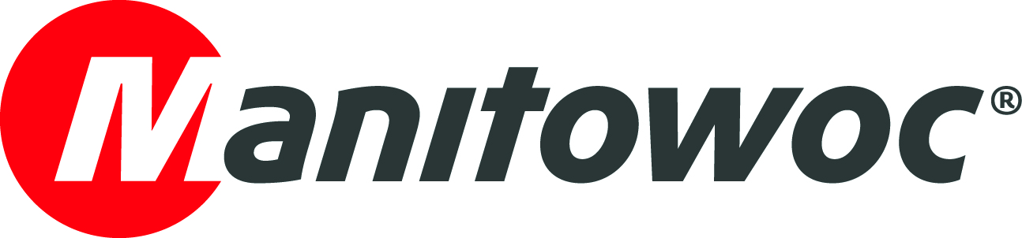
NEWS RELEASE
4 March, 2019

Grove GMK4100L installs major new footbridge in Manila

Steel Centre Philippines, a specialist in the design, fabrication and erection of steel structures, used a Grove GMK4100L all-terrain crane to install a 28 m footbridge in the Philippines. Working for Metropolitan Manila Development Authority, a government agency, the company positioned the 20 t bridge in just 30 minutes. The new footbridge sits in Ortigas Avenue, a major thoroughfare in Pasig City, located in Eastern Manila, where it serves as a walkway for pedestrians to cross the busy streets.

Irvin Ong, vice president of operations for Steel Centre Philippines, said:

“The GMK4100L is a very flexible crane that’s easy to mobilize and demobilize; it handled the bridge project with ease.”

Steel Centre Philippines has two GMK4100L all-terrain cranes, one GMK3055 all-terrain crane, plus a RT760 rough-terrain crane. The GMK4100L cranes are currently working on other projects for the company. One is constructing a new subway station, while the other is working on the Athletic Stadium in New Clark City. The new stadium is expected to feature in the upcoming South East Asian Games, which will take place in the Philippines this November.

The 100 t capacity GMK4100L has a 60 m main boom that can extend to a maximum height of 89 m when working with its jib. It has been replaced in the Grove line by the new generation GMK4100L-1. This unit has the same 100 t capacity and 60 m main boom, but is more compact than its predecessor with greater flexibility in configuration.

-END-

CONTACT
Michael P Macatangay Michael N Sanares
Manitowoc Manitowoc
T +63 9175430272 T +63 9175419541
Michael.Macatangay@manitowoc.com Michael.Sanares@manitowoc.com

ABOUT THE MANITOWOC COMPANY, INC.
Founded in 1902, The Manitowoc Company, Inc. is a leading global manufacturer of cranes and lifting solutions with manufacturing, distribution, and service facilities in 20 countries. In the United States, the Grove, Manitowoc, National Crane, Potain and Shuttlelift brands are sold and serviced by Grove US, LLC, a wholly owned subsidiary of The Manitowoc Company, Inc. In 2018, Manitowoc’s net sales totaled $1.8 billion, with over half generated outside the United States.

THE MANITOWOC COMPANY, INC.
One Park Plaza – 11270 West Park Place – Suite 1000 – Milwaukee, WI 53224, USA
T +1 414 760 4600
www.manitowoc.com

