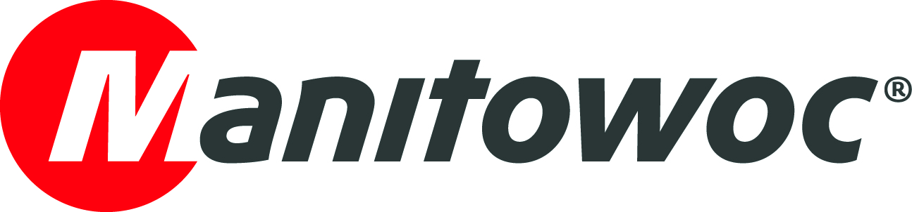
NEWS RELEASE
March 12, 2019

Metcalf Crane Services uses innovative integrated heavy-duty jib for Grove GMK5250L on Australian rail project

- An integrated heavy-duty jib allows the Grove GMK5250L to install heavy and fragile wall panels on a congested project site.
- The lifts were done as part of an AUS$6.9 billion government rail upgrade program.

Australian rental company Metcalf Crane Services utilized the integrated heavy-duty jib, (known locally as a ‘machinery runner’), on a Grove GMK5250L to handle the delicate unloading and installation of wall panels for a new rail corridor project in Seaford, Victoria. Using the machinery runner from the Grove all-terrain crane, which is integrated into the crane’s swingaway jib, allows the use of both main and auxiliary hoists for the operation of two hooks simultaneously. The design of the machinery runner provides greater distance between the two hooks, making it perfect for applications such as panel installations.

The crane served a vital function on the project, as the wall panels, which weighed up to 30.5 t, had to be rotated from their horizontal position on the delivery vehicle to a vertical position for installation. Ideally, this operation had to be completed by a single crane as the congested job site meant finding space for a second crane to assist was a challenge.

Adding to the complexity of the project was the delicate design of the precast deflection panels, which required all rigging equipment for the installation to be installed vertically to avoid imposing any potentially damaging side loads on the panels. To ensure this part ran smoothly, Metcalf Crane Services used its own modular spreader bars, designed and manufactured in-house by the company.

The installation of the eight precast deflection wall panels is part of the Seaford Road grade separation project, being managed under the Victorian state government’s AUS$6.9 billion Level Crossing Removal project. The project aims to remove 50 of Melbourne’s most dangerous and congested level crossings by 2022. Work on the Seaford Road section of the project is being managed by a consortium of Lendlease Group, Acciona and WSP Global.

The GMK5250L has a maximum capacity of 250 t, a main boom length of 70 m and a maximum tip height of 110 m. It is one of the most powerful and versatile five-axle cranes on the market, with the highest-rated capacity and the quickest set-up time in its class. In Australia, the crane remains one of the best-selling five-axle machines, with over 20 either working or on their way to the country.

-END-
CONTACT
Punitha Govindasamy
Manitowoc
T +65 6263 7863
punitha.govindasamy@manitowoc.com

ABOUT THE MANITOWOC COMPANY, INC.
Founded in 1902, The Manitowoc Company, Inc. is a leading global manufacturer of cranes and lifting solutions with manufacturing, distribution, and service facilities in 20 countries. In the United States, the Grove, Manitowoc, National Crane, Potain and Shuttlelift brands are sold and serviced by Grove US, LLC, a wholly owned subsidiary of The Manitowoc Company, Inc. In 2018, Manitowoc’s net sales totaled $1.8 billion, with over half generated outside the United States.

THE MANITOWOC COMPANY, INC.
One Park Plaza – 11270 West Park Place – Suite 1000 – Milwaukee, WI 53224, USA
T +1 414 760 4600
www.manitowoc.com

