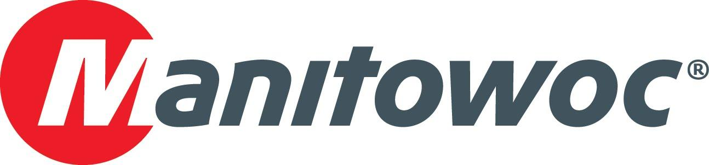
NEWS RELEASE
16 July 2019

IDP supplies over 35 Potain cranes for major new development in Egypt

- A mix of Potain tower cranes are working across various elements of the New El Alamein City project taking shape in Egypt
- The new purpose-built city will stretch over an area of 21,000 hectares and can accommodate a population of 3 million

Over 35 Potain tower cranes are working on the construction of the New El Alamein City, an urban development being built on Egypt’s northern coast. The cranes were sold by International Development Programmes (IDP), Potain’s dealer for Egypt. The high-profile project will offer year-round living and accommodate a population of over 3 million across an area of 21,000 hectares. The new city will house hotels, universities, sports clubs, entertainment outlets, residential units, business centers and even a scientific research center.

The fleet of Potain cranes onsite includes MCT 85, MCT 205, MC 235 C and MC 310 K12 models. All are built at the Potain factory in Zhangjiagang, China and selected for their reliability and performance. Two of the preferred choices for the site are the MCT 85 and MCT 205, both topless models. The MCT 85 is the successor to the hugely popular MCi 85 A. It offers a maximum jib length of 52 m and a tip load of 1.1 t. Its maximum capacity is 5 t. The MCT 205 is a topless crane with a maximum capacity of 10 t. It can lift 1.75 t at its maximum jib end of 65 m.

The cranes began arriving on site in 2018, and are configured at working heights of between 40 m and 180 m, with jib lengths ranging from 50 m to 70 m. The cranes work around the clock rotating between three shifts daily, lifting loads from 5 t to 12 t and are expected to be on site for at least five years.

Noreen Soliman, marketing and communications manager at IDP, said:

“Using Potain cranes gives the contractors the confidence they need to complete a project of this scale. To date, the feedback on their performance has all been positive. Potain is a trusted brand in Egypt, with the range, reputation and performance to keep a high-profile project like this on track. We also pride ourselves on the parts and service support that we provide to our customers and that means there’s one less thing to worry about on the job site.”

Contractors on site include Redcon and Red Sea Construction, SIAC Construction, The Arab Contractors, CRC Dorra, Orascom Construction and a joint venture between Hassan Allam Construction and Consolidated Contractors Company. The New El Alamein City is the first in a new generation of millennium cities in Egypt.

IDP has been a reliable supplier of Potain cranes to projects in Egypt for the past 44 years. Established in 1974, it is one of Egypt’s leading companies in the supply and service of heavy construction and industrial equipment.

-END-

CONTACT
Punitha Govindasamy
Manitowoc
T +65 6263 7863
punitha.govindasamy@manitowoc.com

ABOUT THE MANITOWOC COMPANY, INC.
The Manitowoc Company, Inc. (“Manitowoc”) was founded in 1902 and has over a 116-year tradition of providing high-quality, customer-focused products and support services to its markets and its 2018 net sales were approximately $1.8 billion. Manitowoc is one of the world's leading providers of engineered lifting solutions. Manitowoc, through its wholly-owned subsidiaries, designs, manufactures, markets, and supports comprehensive product lines of mobile telescopic cranes, tower cranes, lattice-boom crawler cranes, and boom trucks under the Grove, Manitowoc, National Crane, Potain, Shuttlelift and Manitowoc Crane Care brand names.

THE MANITOWOC COMPANY, INC.
One Park Plaza – 11270 West Park Place – Suite 1000 – Milwaukee, WI 53224, USA
T +1 414 760 4600
www.manitowoc.com

