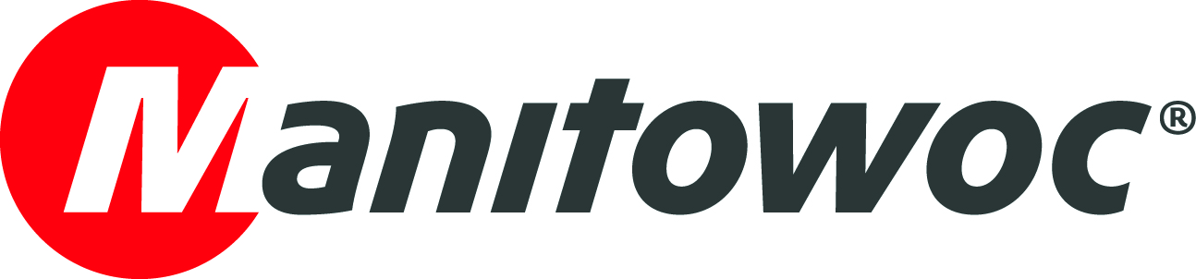
NEWS RELEASE
8 February 2019

Yau Lee chooses Potain MR 618 to build new medical facility in Hong Kong

A Potain MR 618 is building a new private hospital in downtown Hong Kong. Constructing any high-rise building in central Hong Kong poses challenges in terms of space limitations. So main contractor Yau Lee Building Construction and Decoration opted for the Potain luffing jib which has both the compact operating capabilities and capacity to handle the work.

Manta Engineering and Equipment rented the crane to the project. Manta is a long-standing partner of Potain in Hong Kong and has provided cranes to many Yau Lee Building Construction and Decoration projects. A spokesman for Yau Lee Building Construction and Decoration said:

“We have been using Potain cranes for many of our projects. As soon as we took on this project, we started talking to Manta about the right crane to use. We’ve always had a great relationship with the company and the guys make sure we stay on schedule by giving us excellent customer support.”

The MR 618 was erected at an initial working height of 32.8 m and will reach 101.8 m by the time the building is completed in September 2020. The 32 t capacity crane is fitted with 40 m of its 60 m jib. Its biggest lifts so far were 28 t loads handled at a 16 m radius.

The new medical center is located on Hong Kong Island and will be dedicated to cancer treatment.

-END-
CONTACT
Punitha Govindasamy
Manitowoc
T +65 6263 7863
punitha.govindasamy@manitowoc.com

ABOUT THE MANITOWOC COMPANY, INC.
Founded in 1902, The Manitowoc Company, Inc. is a leading global manufacturer of cranes and lifting solutions with manufacturing, distribution, and service facilities in 20 countries. In the United States, the Grove, Manitowoc, National Crane, Potain and Shuttlelift brands are sold and serviced by Grove US, LLC, a wholly owned subsidiary of The Manitowoc Company, Inc. In 2017, Manitowoc’s net sales totaled $1.6 billion, with over half generated outside the United States.

THE MANITOWOC COMPANY, INC.
One Park Plaza – 11270 West Park Place – Suite 1000 – Milwaukee, WI 53224, USA
T +1 414 760 4600
www.manitowoc.com

