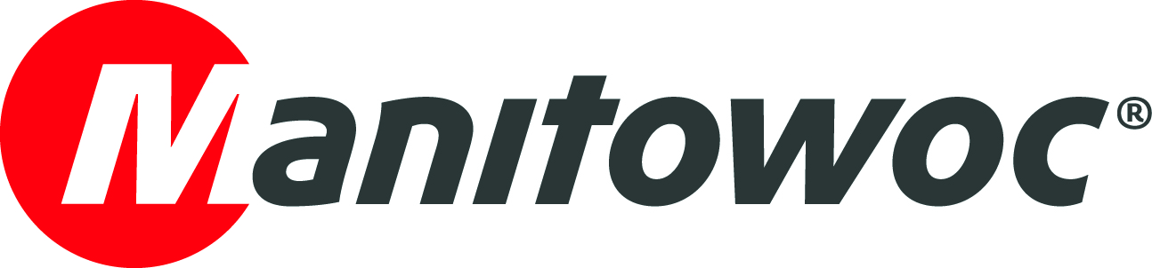
PICTURE CAPTION RELEASE

July 9, 2018

W.O. Grubb customers experience high performance of Manitowoc MLC300 with VPC-MAX

W.O. Grubb reported that the Manitowoc MLC300 is quickly gaining recognition among customers as the best crane in its class, often outperforming larger, wagon-equipped cranes. According to the Richmond, Virginia-based rental firm, the 386 USt crawler crane is now the most requested model in its 80-plus crawler crane fleet, and all its MLC300 units are already booked well into 2019.

Michelle Grubb-Solaimani, CFO of W.O. Grubb, said that the MLC300 is helping customers to save time and money on the job site for many kinds of work, including tilt-up construction.

“While performing tilt-up work, it’s very common to relocate a crane several times,” she explained. “By equipping the MLC300 with its VPC-MAX attachment, the crane travels easier on the job site and doesn’t have to be repeatedly re-set up for lifts. We used to have to use cranes with counterweight wagons for these jobs, but the MLC300 can handle the work without the additional costs of transporting a wagon and all the matting work that goes with it. There’s a good reason why our customers now request the MLC300 by name.”

-END-

CONTACT
Amy Marten
Manitowoc
T +1 920 683 6345
amy.marten@manitowoc.com

ABOUT THE MANITOWOC COMPANY, INC.
Founded in 1902, The Manitowoc Company, Inc. is a leading global manufacturer of cranes and lifting solutions with manufacturing, distribution, and service facilities in 20 countries. Manitowoc is recognized as one of the premier innovators and providers of crawler cranes, tower cranes, and mobile cranes for the heavy construction industry, which are complemented by a slate of industry-leading aftermarket product support services. In 2017, Manitowoc’s net sales totaled $1.6 billion, with over half generated outside the United States.

THE MANITOWOC COMPANY, INC.
One Park Plaza – 11270 West Park Place – Suite 1000 – Milwaukee, WI 53224, USA
T +1 414 760 4600
www.manitowoc.com

