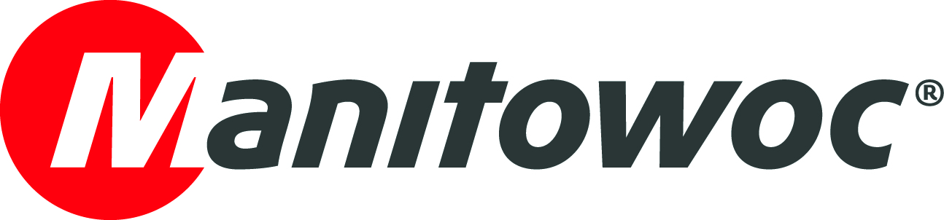
CAPTION RELEASE

March 23, 2018

Potain Hup range proves popular at Icelandic tradeshow

- Icelandic Potain dealer, Kraftvélar, exhibited at the construction tradeshow Verk og vit 2018 (Construct North).
- The company used the opportunity to highlight the new Potain Hup range, which garnered much interest from attendees.

Manitowoc’s Icelandic dealer, Kraftvélar, has showcased its broad range of crane solutions at Verk og vit 2018 (Construct North), a construction tradeshow that took place between March 8-11, 2018 in the country’s capital of Reykjavik.

Kraftvélar, which has represented Manitowoc in Iceland since April 2016, focused primarily on highlighting the new Hup range from Potain. Kraftvélar recently sold the country’s first Hup 32-27 to BYGG, a specialist in building residential real estate. BYGG has already placed the newest-generation, self-erecting crane on a job site in the capital.

Kraftvélar also erected a self-erecting Potain Igo M 14—with its class-leading lifting height and flexible configuration options—outside the main entrance of the tradeshow to enable attendees to see the crane up close. The dealership recently brought an Igo 21, Igo T 85 A and Igo 50 into the country.

Representatives from both Kraftvélar and Manitowoc were present at the booth to answer questions and discuss the benefits of the cranes. The new Hup range garnered much attention from attendees, as Viktor Karl Ævarsson, sales and marketing director at Kraftvélar, explained.

“We were very happy with the show and generated a lot of leads, from existing customers but also from new prospects,” he said. “The most popular request was for Potain’s Hup range, as well as for the Igo M range. We now have a busy couple of weeks ahead of us, sending out offers and continuing to build on the success Potain has had in Iceland so far.”

Verk og vit is a tradeshow dedicated to the construction industry, municipal planning and public works. The 2018 edition was the tradeshow’s fourth in Reykjavik. Around 100 exhibitors took part in what was the largest event of its type in Iceland.

-END-

CONTACT
Cristelle Lacourt Oliver Halls
Manitowoc SE10
T +33 472 182 018 T +44 (0) 20 79 235 860
cristelle.lacourt@manitowoc.com oliver.halls@se10.com

ABOUT THE MANITOWOC COMPANY, INC.
Founded in 1902, The Manitowoc Company, Inc. is a leading global manufacturer of cranes and lifting solutions with manufacturing, distribution, and service facilities in 20 countries. Manitowoc is recognized as one of the premier innovators and providers of crawler cranes, tower cranes, and mobile cranes for the heavy construction industry, which are complemented by a slate of industry-leading aftermarket product support services. In 2017, Manitowoc’s net sales totaled $1.6 billion, with over half generated outside the United States.

THE MANITOWOC COMPANY, INC.
2400 S. 44th Street - PO Box 66 - Manitowoc, WI 54221, USA

T +1 920 684 4410
www.manitowoc.com

