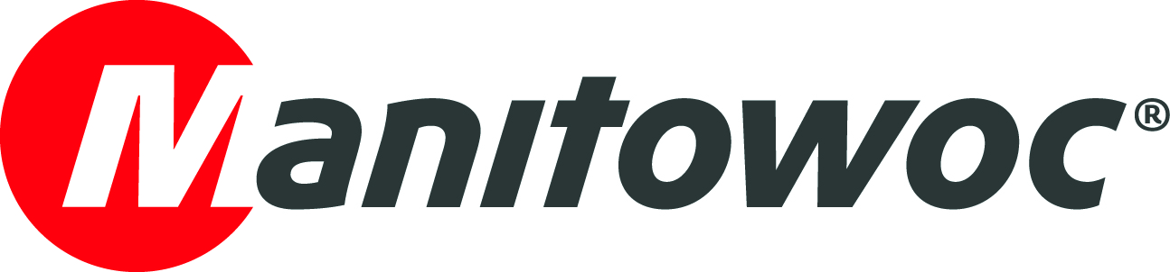
NEWS RELEASE

March 21, 2018

Manitowoc launches GMK6300L-1 as successor to groundbreaking Grove GMK6300L

- The Grove GMK6300L-1 will continue the legacy of its predecessor, which has sold over 400 units to date.
- Improvements include significantly enhanced load charts and Euromot 4/EPA Tier 4 final engines in the carrier and superstructure.

Manitowoc has announced that it will launch a follow-up to the hugely popular Grove GMK6300L all-terrain crane, which launched in 2010 and became an immediate worldwide hit. The new 300 t (350 USt) capacity model is the GMK6300L-1, and it will continue its predecessor’s legacy, bringing new levels of performance leadership to the six-axle category.

In line with other Grove launches of recent years, the GMK6300L-1 offers unique innovations and class-leading capabilities. Several improvements have been made to the structural strength of the crane, which have improved load charts when compared with the GMK6300L. Customers will be especially pleased with the increased capacity when working at height, with improvements of up to 16% in the boom length ranges of 70 m – 80 m (226 ft – 263 ft).

It features a maximum tip height of 120 m (394 ft) when working with its full 80 m (263 ft) main boom and 37 m (121 ft) of jib. When lifting with the main boom, it can lift up to 14 t (15.4 USt) at full height and can handle this within a 14 m - 28 m (46 ft – 90 ft) working radius, offering a flexible range for such applications as tower crane rigging. Overall capacities on the long boom will set a new benchmark for the industry.

The GMK6300L-1 is powered by a 430 kW (580 HP) Mercedes Benz (Euromot 4/EPA Tier 4 final) engine in the carrier that features improved fuel economy over its predecessor. This is paired with a reliable Allison torque converter transmission. A 210 kW (280 HP) Mercedes Benz (Euromot 4/EPA Tier 4 final) engine powers the superstructure.

Andreas Cremer, Manitowoc’s global product director for all-terrain cranes, took a moment to look ahead at the launch of the GMK6300L-1 while reflecting on the success of the GMK6300L.

“The GMK6300L, along with the GMK6400, effectively kick-started a new era of Grove all-terrain cranes, setting unprecedented industry standards in terms of reach, capacity and mobility,” he said. “The GMK6300L raced to sales of 100 units in just two years and to date more than 400 have been delivered. With its significantly improved load charts and specifications, we expect the GMK6300L-1 to prove just as popular.”

Like its predecessor, the GMK6300L-1 features Megatrak suspension, along with Manitowoc’s standard all-wheel steering. Its counterweight slabs and auxiliary hoist are interchangeable with the GMK5180-1, GMK5200-1, GMK5250L and GMK6300L, making it a particularly attractive investment for existing Grove customers.

-END-

Andreas Cremer Damian Joseph
Manitowoc SE10
T +49 4421 294 4276 T +1 312 548 8441
andreas.cremer@manitowoc.com damian.joseph@se10.com

ABOUT THE MANITOWOC COMPANY, INC.
Founded in 1902, The Manitowoc Company, Inc. is a leading global manufacturer of cranes and lifting solutions with manufacturing, distribution, and service facilities in 20 countries. Manitowoc is recognized as one of the premier innovators and providers of crawler cranes, tower cranes, and mobile cranes for the heavy construction industry, which are complemented by a slate of industry-leading aftermarket product support services. In 2017, Manitowoc’s net sales totaled $1.6 billion, with over half generated outside the United States.

THE MANITOWOC COMPANY, INC.
2400 S. 44th Street - PO Box 66 - Manitowoc, WI 54221, USA

T +1 920 684 4410
www.manitowoc.com

